Liberalized Energy Markets and the Limits of a Just Green Transition: Greece’s Electricity Target Model after the Energy Crisis
Costas Mylonas, ENA Institute for Alternative Policies, kosmylo@gmail.com
Sotiris Petrou, ENA Institute for Alternative Policies, sotirispe96@gmail.com
Yannis Eustathopoulos, ENA Institute for Alternative Policies, y.eustathopoulos@enainstitute.org
Abstract
This paper examines Greece’s electricity Target Model as a critical case of Europe’s socio-ecological transformation under high energy costs and gas dependence. It asks how far renewable expansion has mitigated price pressures after the energy crisis, and why its benefits have not reached households under the existing market design. It combines energy-justice and market-design debates in a quantitative political economy of a peripheral EU market, using 2019–2026 monthly data from HEnEx, ADMIE, RAAEY, ENTSO-E, Eurostat, FRED/IMF and EEX. Three findings emerge. First, because the most expensive plant needed, usually gas, sets the price for all, each euro on the European gas price (TTF) was associated with about 1.66 euros on the wholesale price, and gas accounts in the estimates for almost all of the 2022 surge and the decline since. Second, more wind and solar lowered prices, but modestly: each additional point of their share came with a price about 1 EUR/MWh lower, so their near doubling offset only a small fraction of the gas effect. Third, the gap between pre-tax retail and wholesale prices widened from 68 to 89 EUR/MWh, retail prices have barely fallen since 2023, crisis protection ran through state subsidies on bills, and vulnerability remains far above the EU average. Greece thus illustrates a wider European contradiction: liberalized market integration can accelerate renewable deployment while leaving consumers exposed to fossil price shocks. The paper concludes by assessing alternatives: public-interest PPAs, two-way CfDs, regulation of market power, energy communities, grid/storage investment and targeted social protection.
Keywords: electricity market design, Target Model, just transition, energy justice, wholesale-retail pass-through

1. Introduction
Between 2019 and 2026 Greece carried out one of the fastest transformations of a generation mix in Europe. Wind and solar rose from roughly a quarter of generation to close to half, lignite fell to a residual role, and the country became a midday exporter of cheap solar power. Over the same years Greek consumers lived through the sharpest price shock in the history of the European electricity market and its aftermath. The wholesale price, computed from ENTSO-E data, averaged 64 EUR/MWh in 2019, peaked at 436 in August 2022 and still stood near 92 in the first half of 2026. Meanwhile, the pre-tax household retail price in 2025 remained more than half above its pre-crisis level, about one in five of the population reported being unable to keep the home adequately warm, roughly twice the EU average, and arrears on utility bills ran above 30 percent, more than four times the EU rate (Eurostat, 2026). Record deployment and persistent deprivation arrived together. This paper asks why.
The puzzle is not only Greek. In a fragmenting world Europe has folded energy into security policy, swapped pipeline dependence for globally priced liquefied natural gas, and reframed energy costs as a problem of industrial competitiveness rather than of social reproduction, while rearmament competes with transition spending precisely where fiscal space is thinnest. Greece is a critical case for what this configuration does on the ground: a small, gas-dependent peripheral market that applies the common European design, the Target Model, in its purest recent form, fully coupled with neighbouring markets, pricing all output at a single marginal price, and with only a small share of consumption shielded by long-term contracts.
Two questions organize the analysis. First, how far has renewable expansion mitigated price pressures after the energy crisis. Second, why have the benefits of renewable electricity, which is almost free to produce once built, not reached households under the existing market design.
The answer developed here is that the decisive variable is not how fast capacity was built but the rules that decide who pays and who gains: how the price is formed, who carries price risk, where the profits of cheap generation go, and through which charges the costs of the system are recovered. Three results carry the argument. Because the most expensive plant needed, usually gas, sets the price for all, each euro on the gas market was associated with 1.66 additional euros on the Greek wholesale price. According to the regression estimates, gas explains almost the entire rise to the 2022 peak. Of the 344 EUR/MWh decline since that peak, the same estimates attribute 318 to cheaper gas and only about 22 to the doubling of the wind and solar share. The fall in wholesale prices after 2022, driven mainly by cheaper gas, largely stopped before it reached household bills. The gap between the pre-tax household retail price and the wholesale price widened from 68 to 89 EUR/MWh and has not narrowed in any half-year since 2023. At the peak, protection came not from the market but from the state, through subsidies credited on electricity bills that reached 212 EUR/MWh. Meanwhile the costs of managing the new mix are charged back to consumers. Growing volumes of usable wind and solar power are switched off because the system cannot absorb them, 8.5 percent of their output in 2025 and 13 percent in the first half of 2026, and the balancing charges on electricity bills stand at record levels. The design, not the technology, decides who benefits.
The contribution is threefold. Substantively, the paper offers a quantitative political economy of a peripheral EU electricity market after the crisis, meaning an account of how the market’s rules allocate costs and profits, grounded in measurement rather than argument alone. Conceptually, it joins two literatures, energy justice, which supplies the criteria for judging outcomes, and market design, which supplies the mechanisms that produce them. Practically, everything rests on public data processed with an open pipeline, the code and the processed dataset are available, and the estimated inputs are documented separately.
The paper proceeds as follows. Section 2 sets out the analytical framework, Section 3 the Greek institutional setting, and Section 4 the data and methods. Section 5 presents the results in three steps, what sets the wholesale price, how the transformed mix reorganized exposure within the day, and who pays and who gains. Section 6 generalizes the case to the European contradiction, Section 7 develops the alternatives as one package, and Section 8 concludes.

2. Analytical framework: just transition, energy justice and market design
Two bodies of literature frame the analysis. The first is the debate on just transition and energy justice. Just transition originated in the labour movement as a demand that the workers of declining industries not bear the costs of environmental policy, and it has since broadened into a research programme on the fairness of the energy transformation as a whole (Newell and Mulvaney, 2013). Energy justice gave that programme analytical structure through three tenets, distributional justice, procedural justice and recognition justice (Jenkins et al., 2016), with applications ranging from siting and participation to affordability (Sovacool and Dworkin, 2015), and later work integrated climate, energy and environmental justice into a single frame (McCauley and Heffron, 2018). All three tenets have Greek content. Procedural justice would ask who is heard when the regulator and the ministry write the market’s rules, and recognition justice would ask which households the system counts as vulnerable and protects accordingly, questions this paper does not examine empirically. The paper focuses instead on the distributional dimension, which is where a market design can be held to account with data, and takes it in its most material form: the prices that households and small firms pay, the margins that stand between them and the wholesale market, and the arrears and deprivation that follow. In the European periphery these outcomes were already unequal well before the crisis (Bouzarovski and Tirado Herrero, 2017).
The second body of literature concerns the political economy of electricity liberalization. The standard model unbundled generation from networks and retail and organized wholesale competition around short-run marginal cost bidding with a single clearing price paid to every accepted offer, on the promise that prices would guide both operation and investment. The assessment literature recognized early that the model performed better at short-run efficiency than at delivering investment and consumer benefits (Joskow, 2008). The European Union codified it in successive legislative packages, from the third package of 2009 to the clean energy package, culminating in the internal market regulation that defines the coupled day-ahead, intraday, balancing and forward markets which Greece adopted as the Target Model (Regulation (EU) 2019/943). Renewables at scale strain this model from within, most visibly through the value or capture problem (Hirth, 2013). Wind and solar cost almost nothing to run and produce at the same hours, so as their capacity grows, supply concentrates in those hours and the price they earn falls with their own success. The contradiction follows. The transition needs ever more of this capacity, yet the market revenues it can earn shrink as it expands, which has pushed real markets toward contracts, capacity payments and regulation that secure revenues outside the hourly price (Joskow, 2019). One family of proposals would make the drift deliberate, splitting supply into two markets, low-carbon generation on long-term contracts at cost-reflecting prices and only the flexible fuel-burning residual priced at the margin (Keay and Robinson, 2017). The Green Power Pool extends this to consumers, selling the pooled contracted output first to households at its average cost (Grubb, Drummond and Maximov, 2022).
The energy crisis of 2021 and 2022 turned this academic debate into a political one. When gas set the price for the whole system, every low-cost generator earned the gas price, and the distribution of the resulting inframarginal rents became the central question of European energy policy. The Union’s regulatory assessment defended marginal pricing as efficient while conceding that consumers had been left exposed (ACER, 2022). The emergency response capped inframarginal revenues and taxed fossil windfalls temporarily (Council Regulation (EU) 2022/1854). The reform debate that followed asked how much of the design should change (Fabra, 2023), with an outcome assessed in Section 6. In that debate the positions ranged from defending the existing price signal while compensating the losers to restructuring how the price itself is formed, and it fixed the vocabulary that returns in Section 7, decoupling consumer prices from the marginal gas price, recovering part of the windfall rents for the public, and contracts for difference that stabilize what generators receive around an agreed price. A more heterodox reading concludes that the deeper problem is that investment follows profits rather than prices, so cheap renewable electricity does not become cheap power for consumers under these institutions without deliberate design (Christophers, 2024).
This paper joins the two literatures through one proposition. Market design is a distributional institution, that is, a set of rules that decides who gains and who loses from the electricity system. The rules that determine which plant sets the price, who carries price risk between wholesale and retail, who keeps the inframarginal rents, and through which charges the costs of flexibility are recovered are not merely technical arrangements. Each of them creates winners and losers, and energy justice supplies the criteria for judging the outcomes. From this perspective a gas-dependent peripheral market under the Target Model should behave in specific ways. Fuel shocks should transmit into wholesale prices almost fully, the benefits of renewable expansion should accrue upstream unless contracts pass them on, savings should travel to retail slowly if at all where competition is thin, and the costs of variability should be socialized through bills. Sections 5 and 6 examine these propositions for the Greek case, and Section 7 builds the alternatives on what they find.

3. The Greek Target Model in context
Greece entered the crisis with a market architecture completed only months earlier. From 2005 the wholesale market operated as a mandatory pool in which a single system marginal price cleared day-ahead scheduling, and the reorganization toward the European Target Model was legislated in 2016 (Law 4425/2016). The new architecture went live on 1 November 2020. The HEnEx operates the day-ahead, intraday and forward markets, the transmission system operator ADMIE runs the balancing market and the system, and the sector is supervised by the regulator RAE, renamed RAAEY when its remit widened in 2023 (Law 5037/2023). Coupling followed quickly, with the day-ahead market joining Italy in December 2020 and Bulgaria in May 2021 and thereby the single European day-ahead coupling, and trading moved to fifteen-minute intervals in January 2026. Greece therefore shows the common European design working in full, in a small, fully coupled and gas-dependent market. Three features of this setting matter for what follows, the concentration of the industry, the dependence on imported gas, and the interventions created during the crisis.
The first feature is concentration. The Public Power Corporation remains by far the largest generator and supplier, holding the entire large hydro fleet, the legacy lignite plants and about half of the retail market, and the state remains the largest shareholder with about a third of the shares. Lignite itself has moved from about a fifth of generation in 2019 to a residual share of a few percent, so the incumbent’s thermal position now rests on gas alongside hydro. The private companies competing with PPC are not small newcomers but vertically integrated groups, each combining gas-fired plants, growing renewable portfolios and its own retail supplier. Retail switching is limited and supply is concentrated among a handful of integrated firms.
The second feature is gas dependence, together with the country’s electricity trade with its neighbours. Gas has supplied roughly two fifths of Greek electricity over 2019 to 2026, yet under marginal pricing it has set the price in far more hours than that share suggests. Gas supply arrives through the Trans Adriatic Pipeline and through liquefied natural gas at Revithoussa, joined by the Alexandroupolis floating terminal in 2024, so the marginal fuel is priced on world markets whatever its route. Electrically, Greece interconnects with Italy, Albania, North Macedonia, Bulgaria and Turkey, historically importing a modest net share of its demand, though the solar expansion increasingly turns midday flows outward. Greece therefore sits at the edge of the wider European market but at the centre of the Southeast European region. Its prices are formed with the rest of Europe through coupling, while its midday solar surplus flows to its Balkan neighbours.
The third feature is the set of interventions created during the crisis. The Energy Transition Fund was created in the autumn of 2021 to finance bill support, drawing first on carbon auction revenues (Law 4839/2021), and its subsidies were credited through the levy component of electricity bills, which is why Eurostat records them as negative levies, at the peak up to 212 EUR/MWh. From July 2022 a temporary mechanism recovered the part of day-ahead revenues above administratively set, technology-specific reference costs and channelled it to the Fund (Law 4951/2022). Suppliers were required to announce their tariffs monthly from the summer of 2022, and from January 2024 retail supply was reorganized into standardized tariff categories, with a monthly announced special tariff as the default option, defined by common regulated rules so that offers can be compared. The setting for the results is therefore neither a free market from the textbook nor a state-planned system. It is a liberalized design on which, since the crisis, one ad hoc correction after another has been layered.

4. Data and methods
The analysis rests entirely on public data, assembled into a single monthly dataset covering January 2019 to June 2026, ninety months in all, with daily, hourly and fifteen-minute detail used where the argument requires it. Table 1 lists the sources. Wholesale prices, demand, generation by technology, cross-border flows come from the ENTSO-E Transparency Platform (ENTSO-E, 2026), the exchange results of HEnEx add cleared volumes per technology portfolio (HEnEx, 2026), and the IPTO bulletins of ADMIE supply the balancing and related charges, and the published schedule-based estimates supply curtailment (ADMIE, 2026, The Green Tank, 2026). Carbon prices are the EEX primary auction results (EEX, 2026), gas prices combine the TTF front-month future (ICE Endex, 2026) with the monthly index carried by FRED (Federal Reserve Bank of St. Louis, 2026), retail prices and vulnerability indicators come from Eurostat (Eurostat, 2026), and the decisions of RAAEY frame the institutional reading of Section 3 (RAAEY, 2026). All series were collected and processed with an open data pipeline built for this paper, documented in Appendix A.
Table 1. Data sources, content used and native resolution.
Source | Content used | Native resolution
ENTSO-E Transparency Platform | Day-ahead prices, load, generation by technology, cross-border flows, installed capacity | Hourly and 15-minute
HEnEx | Day-ahead market results and cleared sell volumes per technology portfolio | From November 2020, hourly, 15-minute from 2026
ADMIE | Weighted Average Market Price bulletins, uplift rates and consumption | Monthly
EEX | EUA primary auction clearing prices | Per auction
ICE Endex via Yahoo Finance | TTF front-month gas futures | Daily
FRED | Gas and oil price indices and exchange rates | Monthly and daily
Eurostat | Household and non-household retail prices, energy vulnerability indicators | Semi-annual and annual
RAAEY | Regulatory decisions and the tariff framework | Documents
The Green Tank / RAAEY | Published monthly RES curtailment estimates from ADMIE scheduling | Monthly from 2024, 2023 annual

The analysis proceeds in two main steps. The first step asks what moves the Greek wholesale price and by how much. It is a monthly regression of the day-ahead price on the TTF gas price, the EUA carbon price, electricity demand, the combined wind and solar share and the net import share of demand, estimated in levels, that is, with the variables in their original units rather than as logarithms or changes, and with Newey-West standard errors (Newey and West, 1987). Levels are used so that the fitted price splits additively into the contribution of each driver, which allows the rise and the fall of the price to be attributed across gas, carbon, demand, renewables and imports. A logarithmic variant and attributions over separate episodes serve as robustness checks, and the estimating equation with the full robustness results is collected in Appendix A.
The second step asks whether the movements of the wholesale price reached households. The semi-annual Eurostat household series for the 2500 to 5000 kWh band, with and without taxes and levies, is compared, half-year by half-year, with the mean wholesale price of the same periods. The comparison yields the gap between the two prices and shows whether retail follows wholesale both upward and downward. Because crisis subsidies were credited on bills as negative levies, the same series also show how much of the crisis cost the state absorbed. Three further computations complete the picture. Prices and traded volumes are summarized by hour of the day, to show how the level and the technology mix of the market differ between midday and evening. Curtailed renewable energy is the published national estimate based on ADMIE’s day-ahead scheduling, compiled monthly by The Green Tank. And the monthly balancing and related charges multiply the balancing capacity and financial neutrality uplift rates of the IPTO bulletins by monthly consumption, with both series documented in Appendix A.

5. Results

5.1 What sets the wholesale price
Figure 1 plots the monthly average day-ahead price in Greece against the TTF gas price from January 2019 to June 2026. The two series move together across the whole period. The Greek price averaged around 64 EUR/MWh in 2019, peaked at 436 EUR/MWh in August 2022 and settled near 92 EUR/MWh in the first half of 2026, still well above its pre-crisis level. Over the same years the generation mix was transformed, as Figure 2 shows. The combined share of wind and solar rose from roughly a quarter of generation in 2019 to close to half by 2025, while lignite retreated to a residual role. The price, however, tracked the fuel that sets the margin, not the mix that supplies the energy.
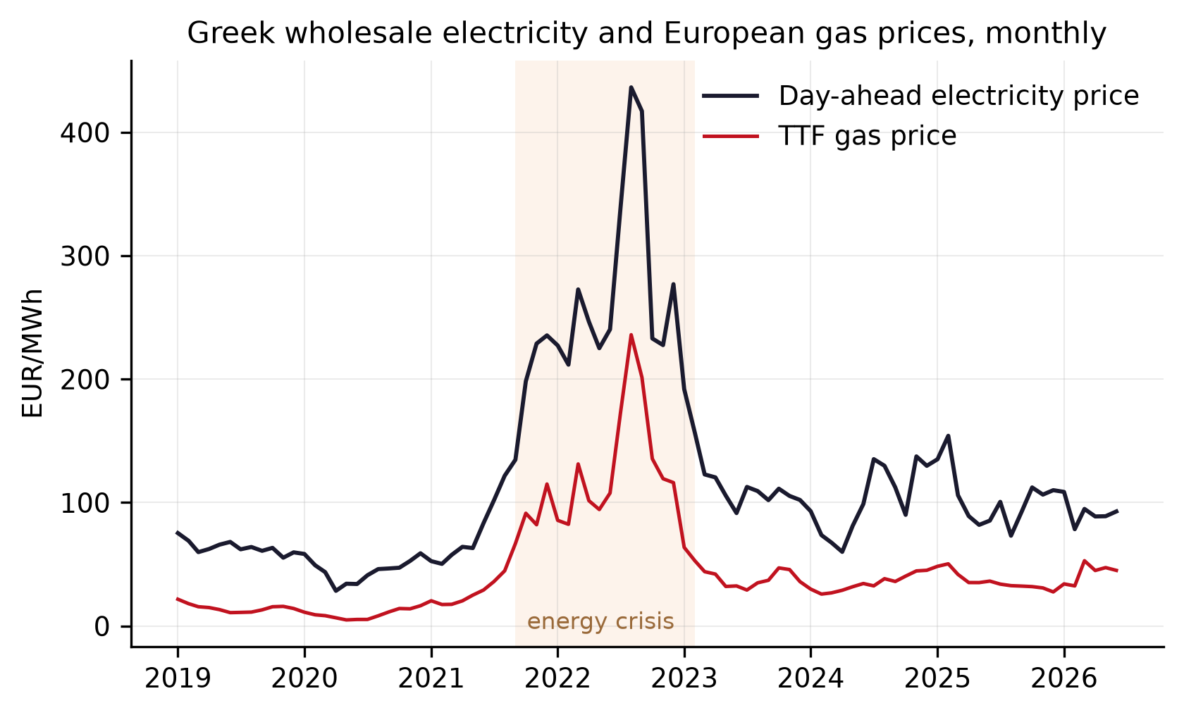
Figure 1. Day-ahead electricity price in Greece and the TTF gas price.
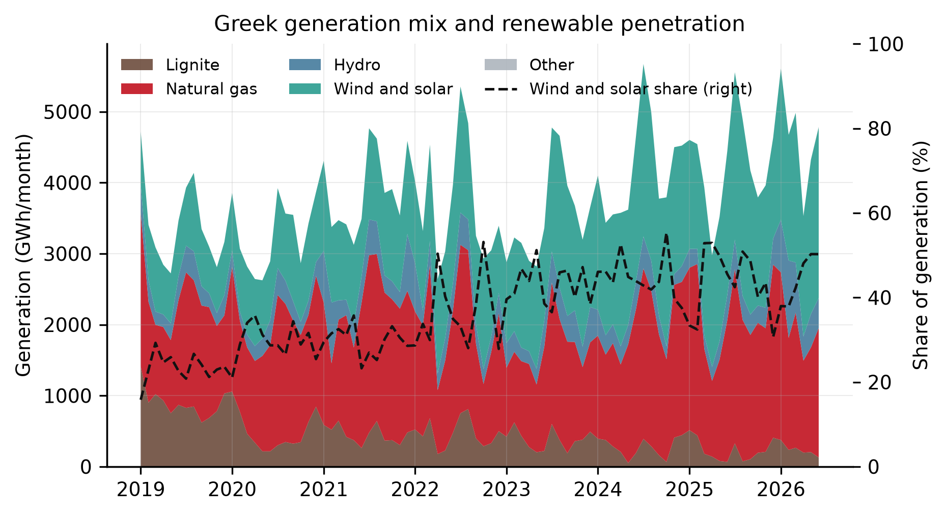
Figure 2. Monthly generation by technology and the combined wind and solar share.
Table 2 quantifies how the wholesale price moves with its main drivers, the gas price, the carbon price, electricity demand, the combined wind and solar share and the net import share of demand. Each row is one driver. The first column reports the estimated coefficient, the change in the monthly price, in EUR/MWh, associated with a one unit change in that driver, the second column its standard error, and the third the t statistic, the coefficient divided by its standard error, whose absolute value above about two marks an estimate unlikely to arise by chance. The regression explains 97 percent of the price variation over the ninety months. Each euro on the TTF is associated with 1.66 additional euros on the wholesale price. The size of this coefficient is plausible, since a modern gas plant needs about 1.7 units of gas energy to produce one unit of electricity, so a euro of gas cost becomes about 1.66 euros of electricity cost when such a plant sets the price. The carbon price also matters. Its coefficient of 0.77 sits between what a gas plant and a lignite plant would pass through per tonne of carbon, consistent with lignite still setting the price in some hours, especially before 2022, when lignite still held a substantial share of generation. Each additional percentage point of wind and solar in the mix comes with a monthly price about 1 EUR/MWh lower, the merit order effect. Demand raises the price as expected, but its coefficient is the least precisely estimated, because monthly demand moves in a narrow seasonal band that gives the regression little variation to work with. The coefficient on net imports is positive, but this does not mean that imports raise prices. Greece imports more when domestic supply is tight and prices are already high, so the estimate reflects this pattern and is not read as a causal effect.
Table 2. Regression of the monthly day-ahead price on its main drivers.
Variable | Coefficient | HAC s.e. | t
TTF gas price (EUR/MWh) | 1.664 | 0.043 | 38.60
EUA carbon price (EUR/tCO2) | 0.773 | 0.122 | 6.35
Electricity demand (TWh) | 6.538 | 3.759 | 1.74
Wind and solar share (pp) | -0.969 | 0.270 | -3.59
Net import share of demand (pp) | 0.644 | 0.173 | 3.71
Constant | 0.321 | 20.236 | 0.02

Figure 3 uses these estimates to attribute the monthly price to its drivers, showing how much of each rise and fall came with gas, carbon, demand, renewables and imports. Of the 361 EUR/MWh increase between January 2019 and the August 2022 peak, the fitted model attributes 357 to the gas price and 50 to the carbon price, with the rising renewable share offsetting only about 12. Of the 344 EUR/MWh decline since the peak, it attributes 318 to the gas price and about 22, roughly six percent, to the further growth of the renewable share. The merit order effect of renewables is therefore statistically robust and economically real, but an order of magnitude smaller than the gas channel that marginal pricing transmits to every megawatt hour traded.
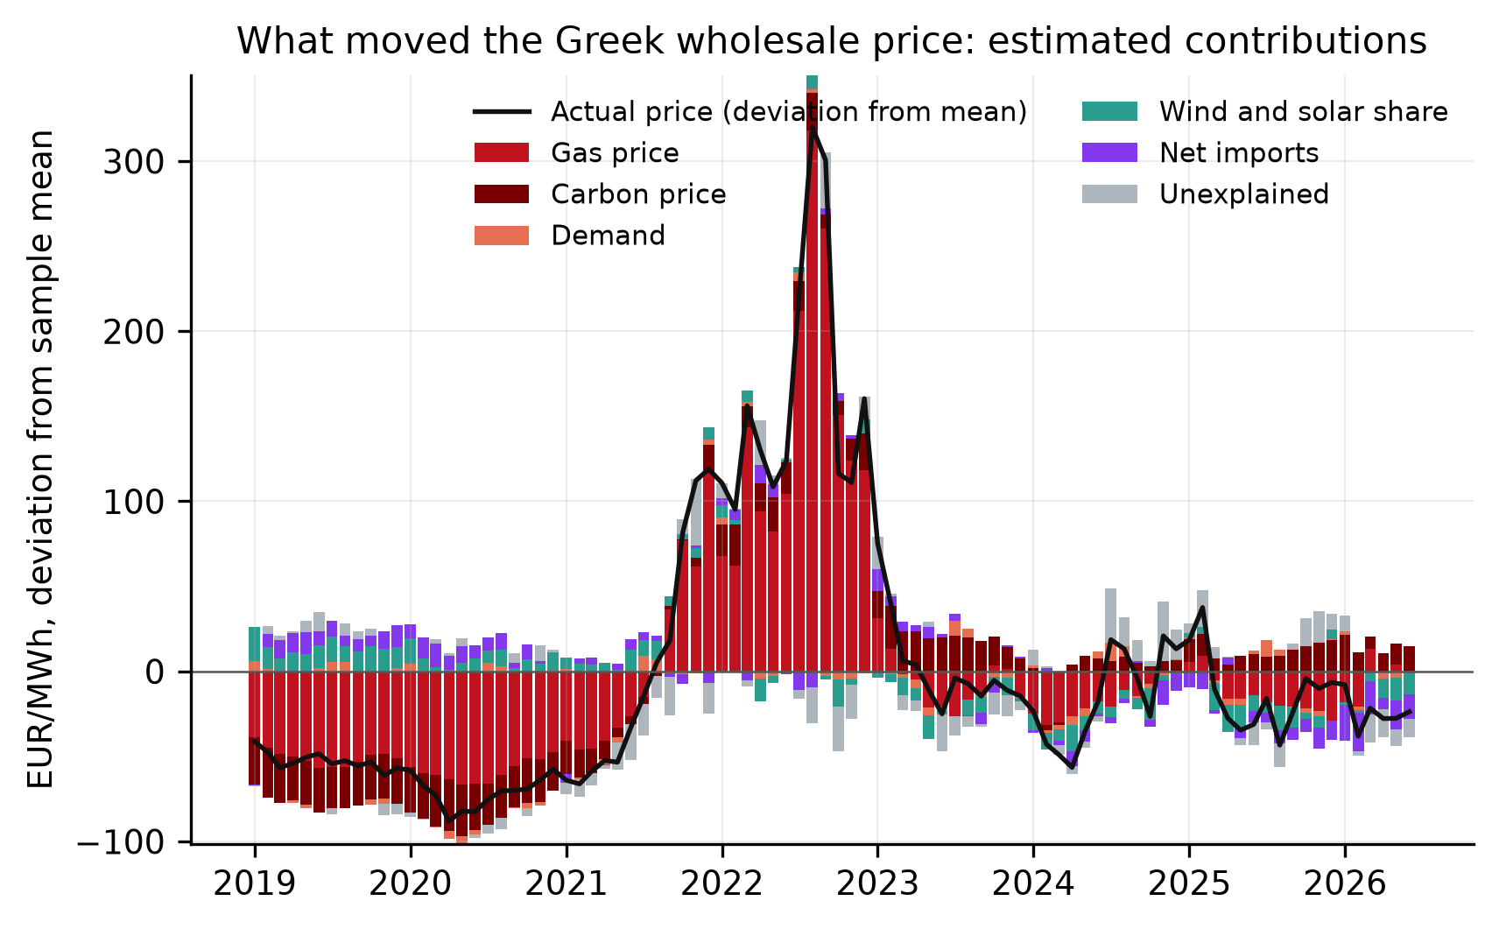
Figure 3. Estimated driver contributions to monthly deviations of the day-ahead price from its sample mean, based on the regression of Table 2.
The model slightly overpredicts the extreme peak, consistent with the temporary revenue recovery mechanism of July 2022 muting pass-through at the height of the crisis. What the transformation of the mix did change is the shape of the trading day, with abundant renewable output at midday and continued gas exposure in the evening, the subject of the next section.

5.2 The renewables paradox
The transformation of the generation mix did not remove the exposure to gas documented in the previous subsection, it reorganized it within the trading day. Solar output is concentrated around midday, so the growth of the wind and solar share to about half of generation created hours of abundance in the middle of the day while the evening remained priced by gas. In 2025 the average day-ahead price between 10:00 and 16:00 was 56 EUR/MWh against 158 EUR/MWh between 18:00 and 23:00, and the share of hours clearing below 5 EUR/MWh reached 6.6 percent, up from 0.4 percent in 2021. The evening premium, the ratio of the average price in the evening hours to the average price of all hours, widened from 1.10 in 2019 to 1.55 in 2025.
The market results per technology portfolio published by HEnEx show the same split between midday and evening from the side of the sellers. In 2025 renewable portfolios provided 69 percent of cleared sell volume between 10:00 and 16:00 but only 27 percent between 18:00 and 23:00. For producers this asymmetry erodes the revenue of every additional solar megawatt, since new capacity sells into the hours it has already made cheap, while consumers continue to buy their evening demand at gas-set prices. Curtailment is the physical side of the same mismatch. When midday supply exceeds what the system can absorb, wind and solar output is switched off. The national estimate of this rejected energy, published monthly on the basis of ADMIE’s day-ahead scheduling and compiled by The Green Tank, puts curtailment at 228 GWh in 2023, quadrupling to 899 GWh in 2024 and doubling again to 1,867 GWh in 2025, equal to 4.0 and 8.5 percent of wind and solar output in the last two years, and the 2025 increase alone matched almost the entire growth of renewable generation that year. The first half of 2026 reached 1,601 GWh, 13.0 percent of output, with a winter record of 208 GWh in February and the largest month of the series, April 2026, at 475 GWh. Monthly figures exist from 2024 and the 2023 total is 228 GWh, the estimate is schedule based, so realized curtailment can differ, and on these numbers the physical waste of clean energy is accelerating even as the evening remains gas-priced.
Beyond curtailment, the steeper daily profile also costs money to manage. The system must ramp other plants down through the midday solar peak and back up for the evening, and it must hold reserves against forecast errors, so balancing needs grow with the variable share. Figure 4 shows both series together, the estimated curtailment in the upper panel and the monthly balancing and related charges in the lower panel. The charges are measured as what consumption was billed, the balancing capacity and financial neutrality uplifts of the IPTO bulletins multiplied by monthly consumption, a proxy documented in Appendix A. They averaged 37 MEUR per month in late 2021, ranged between 32 and 66 MEUR through 2022 with the peak in October, and never returned to pre-crisis levels, January 2024 still carried 50 MEUR. The annual total has risen every year since 2023, from 489 MEUR to 729 in 2024 and 922 in 2025, 1.6 times the crisis year, and the record of the whole series is July 2025 at 99 MEUR. In the first half of 2026 the charges rose every single month, from 46 MEUR in January to 89 in June, the highest June on record. The descriptive series does not isolate the contribution of renewable variability from fuel prices, reserve requirements or market rule changes. The recent move to fifteen-minute market time units has made the intra-day differentiation finer still. Balancing costs are recovered through charges that end up in retail bills, so the system costs of variability are socialized while the midday price relief accrues to whoever is positioned to buy at those hours. The next section asks who gained from these prices and who paid for these costs.
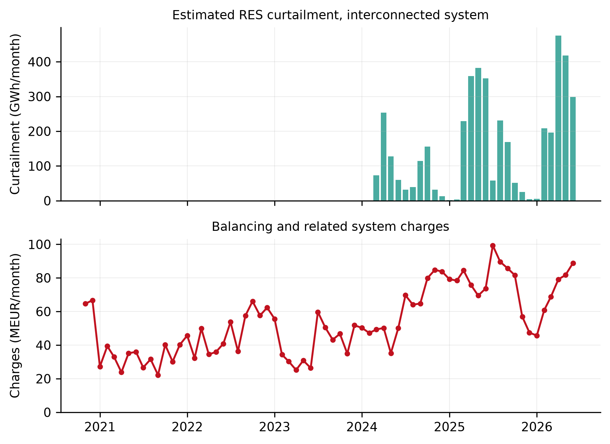
Figure 4. Estimated curtailment of renewable output and the monthly balancing and related charges.

5.3 Who pays and who gains
Figure 5 places the half-yearly household retail price of Eurostat next to the wholesale series. Before the crisis the pre-tax retail price exceeded the half-year wholesale average by 68 EUR/MWh on average, a wedge covering network charges, supply costs and margins. After the crisis the same wedge averaged 89 EUR/MWh. The wholesale comparator is an unweighted day-ahead average rather than a household load profile weighted procurement cost, and the gap includes network, balancing, profile, hedging and supply costs, so it should not be read as a supplier profit margin. The wholesale price used for this comparison is an unweighted day-ahead average and the gap includes network, balancing, profile, hedging and supply costs, so it should not be read as a supplier profit margin. The clearest single comparison is the first half of 2024, when the wholesale average fell to 79 EUR/MWh, within reach of pre-crisis levels, while the pre-tax retail price stood at 189 EUR/MWh against 124 before the crisis. The retail analysis covers the household band, the corresponding non-household series are collected in the pipeline and reserved for the extended version.
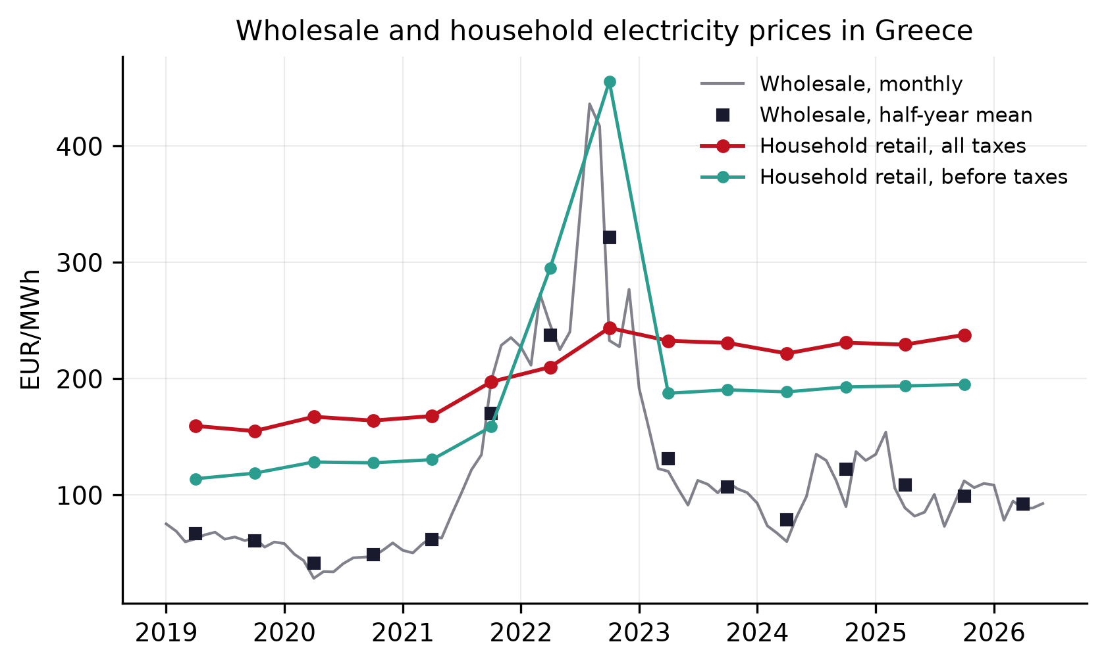
Figure 5. Wholesale day-ahead prices and household retail prices for the 2500 to 5000 kWh band.
Retail prices followed wholesale prices up during the surge and did not follow them down. Between the second half of 2023 and the second half of 2025 the wholesale average declined from 107 to 99 EUR/MWh while the pre-tax retail price rose from 190 to 195. In no half-year since the unwinding of the crisis subsidies has the pre-tax retail price fallen. Since the crisis subsidies ended, the pre-tax retail price has not fallen in any half-year. The half-yearly changes show the same asymmetry. When the wholesale price rose, retail rose by roughly 0.7 euros per euro of increase, but when the wholesale price fell, retail hardly moved.
The crisis itself was absorbed fiscally rather than through the market. In 2022 the Eurostat series excluding taxes and levies rises above the series including them, because the subsidies of the Energy Transition Fund were credited through the levy component of the bill and are recorded as negative levies, reaching about 85 EUR/MWh in the first half of 2022 and about 212 EUR/MWh in the second. The state, financed in part by the recovery of inframarginal rents, stood between wholesale prices and households at the peak. When the subsidies ended, the wider gap remained. The extraordinary costs of the crisis were thus carried by the public budget, while the gap between retail and wholesale settled at a durably higher level, a gap that contains network charges, supply costs and margins and whose composition the aggregate series cannot separate.
The distributional outcome is visible in the vulnerability indicators of Figure 6. The share of the Greek population unable to keep the home adequately warm stood at 19.0 percent in 2024 against 9.2 in the EU, roughly twice the average, and arrears on utility bills, which had eased to 26.3 percent by 2021, jumped to 34.2 percent in 2022 and have remained near 32 percent since, more than four times the EU rate. These indicators show how widespread deprivation already is among Greek households. They cannot by themselves say how much of that deprivation the market design caused, but they show what it lands on. A design that transmits gas shocks fully, passes savings on slowly if at all, and protects households only through discretionary subsidies is operating on an already vulnerable population. What this implies for the design itself is taken up in the discussion and the alternatives that follow.
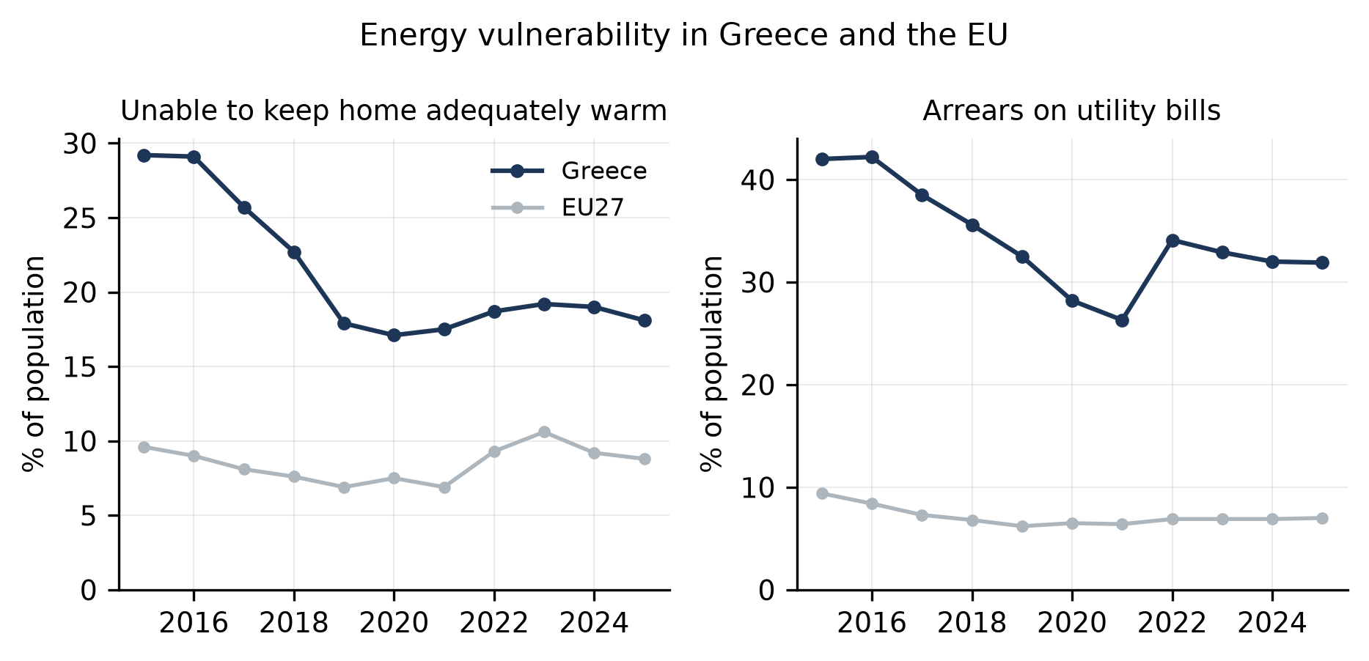
Figure 6. Share of the population unable to keep the home adequately warm and with arrears on utility bills.

6. Greece as a European contradiction
The Greek case is extreme but not exceptional, because the mechanisms documented in Section 5 operate in every member state of the Union. Gas plants set the price in a large share of hours across the Union during the crisis while supplying a much smaller share of the energy (ACER, 2022). What varies between member states is not the pricing rule but the exposure to it. Gas-dependent price formation, import dependence, weak interconnection and thin retail competition concentrate in the South and East of the Union, where energy poverty already ran highest before the crisis, a pattern the literature knows as the energy divide of the European periphery (Bouzarovski and Tirado Herrero, 2017). The Greek combination of a gas plant at the margin, a retail wedge that widened through the crisis and vulnerability at a multiple of the EU average can therefore be read as the sharpened form of a general condition rather than a local anomaly.
The crisis response showed what was politically possible, and at which level. The Union legitimized rent recovery with a temporary cap on inframarginal revenues and a solidarity contribution from fossil fuel companies, and it allowed both to expire (Council Regulation (EU) 2022/1854). The Iberian exception demonstrated that partially decoupling gas from power prices inside the single market was feasible when member states insisted on it (Fabra, 2023). Everywhere else protection ran through national budgets, so the depth of a household’s protection depended on the fiscal space of its state, and the periphery paid twice, in prices and in debt. The 212 EUR/MWh of negative levies that stood between Greek wholesale prices and Greek households at the peak is what improvised protection costs when the design does not provide it.
The 2024 reform of the electricity market design adopts the instruments while refusing their logic. It requires two-way contracts for difference for new publicly supported generation from 2027, promotes power purchase agreements, strengthens hedging and supplier obligations, and creates a framework for declaring a price crisis with temporary regulated prices (Regulation (EU) 2024/1747). It leaves marginal pricing itself untouched, applies the new contracts only to future plants, so the existing fleet keeps earning the marginal price and the rents that come with it, lets rent recovery remain an expired emergency rather than a standing institution, and leaves retail margins to national discipline. The contradiction documented in this paper, namely record renewable expansion alongside households still priced by gas, therefore persists by design.
European policy since the crisis has moved in directions that sharpen this contradiction rather than ease it. Since 2022 energy policy has folded into security policy, and dependence has been swapped from pipeline gas to globally priced liquefied natural gas rather than removed. At the same time the competitiveness agenda treats energy costs as a problem of industrial inputs rather than a social one, most explicitly in the report on the future of European competitiveness (Draghi, 2024). Rearmament and fiscal consolidation now compete with transition and social spending across the Union, as the EuroMemo Group’s own annual analysis documents (EuroMemo Group, 2026), and the burden of that competition falls hardest where fiscal space is thinnest. In this configuration climate justice is subordinated twice, at the European level to competitiveness and security, and at the national level to fiscal space. The alternatives of the next section are therefore not technical adjustments to a sound design but a different answer to the question of who the transformation is for.

7. Alternatives
The findings of Section 5 define the design problem that alternatives must solve. Marginal pricing transmits gas shocks into every megawatt hour at an estimated rate of 1.66, the relief from renewable expansion is real but an order of magnitude smaller than the effect of gas, savings that do reach the wholesale market stop at the retail wedge, and the costs of managing variability are socialized through bills while the midday abundance accrues to whoever can reach it. The measures below are therefore presented as one package rather than a menu: they change what sets the price consumers pay, who captures the margins, who owns the infrastructure of flexibility, and who is protected as of right. The 2024 reform of the EU electricity market design opens space for several of them while leaving marginal pricing and retail conduct untouched, so most of the package lies within national discretion (Regulation (EU) 2024/1747).
The first measure decouples what households and small firms pay from the marginal gas plant. Two instruments can do this. Two-way contracts for difference pay contracted generators a stable strike price and return everything above it, converting inframarginal rent into consumer relief automatically rather than through ad hoc taxation. Public-interest power purchase agreements do the same for public buyers who resell at cost. The Green Power Pool proposal takes this further (Grubb, Drummond and Maximov, 2022). It builds on the idea of separating contracted low-carbon energy from the marginal market (Keay and Robinson, 2017), pools such contracts into a public portfolio, and supplies essential household and small business consumption first. A growing share of demand would then be priced at the average cost of the contracted fleet instead of the system margin. Under a pool that sells the contracted output first, the cheapness of renewables would no longer be a small statistical effect but the basis on which household prices are set. The 2024 reform points the same way by requiring two-way contracts for new publicly supported generation from 2027. For Greece, where wind and solar already supply close to half of generation, auctioning even part of the existing fleet into such a portfolio would have capped the exposed share of the bill during the crisis, achieving ex ante and self-financing what the Energy Transition Fund achieved ex post with 212 EUR/MWh of negative levies at the peak.
The second measure disciplines the wedge. The pre-tax retail wedge over wholesale widened from 68 to 89 EUR/MWh across the crisis and has not narrowed since, and no half-year since 2023 has seen the pre-tax retail price fall. European assessments reached the same conclusion. Emergency interventions substituted for the structural discipline that retail markets lacked (ACER, 2022), and the academic work on the reform debate agrees (Fabra, 2023). Greece already has early forms of the needed instruments. The standardized tariff scheme introduced in 2024 gives the regulator a reference against which supplier offers can be compared, and the temporary revenue recovery mechanism of 2022 proved that inframarginal rents can be measured and recovered. Making rent recovery permanent, tying supplier pricing to a monitored pass-through standard with the regulated product as the default rather than the exception, and using the state’s position as the largest shareholder of PPC to anchor a cost-based basic supply offer would convert episodic crisis management into standing market discipline, with recovered rents financing the contract portfolio of the first measure.
The third measure treats flexibility as infrastructure. Estimated curtailment doubled from 899 GWh in 2024 to 1,867 GWh in 2025 and reached 1,601 GWh in the first half of 2026 alone, 13 percent of wind and solar output, while the balancing and related charges on bills set records without any gas crisis, and the 56 against 158 EUR/MWh gap between midday and evening is the price of storing nothing. Price gaps of that size should attract private storage investment on their own. In practice financing costs, the risk that the gap narrows as storage grows, and long connection queues slow that investment exactly where it is most needed, a familiar weakness of energy-only markets (Joskow, 2019). Treating grid reinforcement, interconnection and a first block of storage as regulated system assets, procured by the operators and paid through the network tariff, would let planning rather than market appetite set the pace of flexibility. Every stored midday megawatt hour then replaces an evening megawatt hour priced by gas, attacking the gas exposure physically rather than fiscally.
The fourth measure widens who owns the transition. Greece legislated energy communities early and revised the framework toward the EU definitions in 2023 (Law 4513/2018, revised by Law 5037/2023), and European experience shows that such schemes deliver bill relief and local acceptance where grid access and financing are secured (Caramizaru and Uihlein, 2020). In practice Greek communities queue behind commercial portfolios for connection capacity. Reserving grid capacity for community and municipal projects, giving them priority access to the contract auctions of the first measure, and enabling the sharing of midday output through virtual net metering would route part of the 56 EUR/MWh hours directly to households that can never trade on an exchange.
The fifth measure protects the vulnerable as of right. About one in five cannot keep the home adequately warm, twice the EU average, and arrears on utility bills run above 30 percent, more than four times the EU rate. The crisis response was large but, as across the EU, mostly untargeted (Sgaravatti et al., 2023). A social tariff that prices an essential block of consumption at the cost of the contracted portfolio, financed by permanent rent recovery rather than the general budget, together with disconnection protections and efficiency retrofits targeted at energy-poor households, replaces discretionary subsidies with an entitlement and attacks the arrears stock rather than chasing it.
Taken together the package reallocates risk from households to producers and the state, which can bear it, and re-links the growth of low-cost generation to the bills of those who finance it. It would turn the merit order effect from a second-order statistical result, 22 against 318 EUR/MWh in the post-crisis decline, into the organizing principle of retail pricing. That, rather than the pace of installation alone, is what a just transformation of the Greek electricity system requires, and the concluding section returns to what the case implies for the European debate.

8. Conclusion
The first question admits a precise answer. Renewable expansion has mitigated price pressures measurably but modestly under the existing design. Each percentage point of wind and solar share lowers the monthly average price by about one euro per megawatt hour, yet over the entire decline from the crisis peak this contributed roughly 22 EUR/MWh against 318 from the gas price itself. The transformed mix reorganized exposure within the day, with 2025 midday prices of 56 EUR/MWh against 158 in the evening, rather than removing it.
The answer to the second question lies in the rules of the market rather than in the technology. At the household level the evidence is consistent with four mechanisms working together. Marginal pricing carries the gas price into every traded megawatt hour at an estimated rate of 1.66. Retail prices adjust slowly and asymmetrically in a concentrated market. The windfall profits of low-cost generators accrued upstream and were recovered only through a temporary emergency mechanism. And the costs of variability, curtailment and balancing, were socialized through bills while protection remained a discretionary fiscal transfer booked as negative levies.
Market design is therefore a distributional institution, a set of rules deciding who gains and who loses, and the Greek record can be read as the sharpened form of a general European condition rather than an anomaly. The 2024 reform adopts the instruments of an alternative, contracts, hedging and crisis frameworks, while refusing its logic, leaving marginal pricing, existing rents and retail margins in place. The consequence documented here will persist wherever gas remains at the margin of a liberalized peripheral market.
The alternatives of Section 7 form a coherent national answer within that constraint, decoupling essential consumption through contracts, disciplining margins, socializing flexibility, widening ownership and protecting the vulnerable as of right. Whether Europe’s socio-ecological transformation deserves the name will be decided less by how fast capacity is installed than by whom it is for.

References
ACER (2022) Final Assessment of the EU Wholesale Electricity Market Design. Ljubljana: European Union Agency for the Cooperation of Energy Regulators.
ADMIE (2026) Operation and Market Data and Monthly Weighted Average Market Price Bulletins [datasets]. Athens: Independent Power Transmission Operator. Accessed July 2026.
Bouzarovski, S. and Tirado Herrero, S. (2017) The energy divide: integrating energy transitions, regional inequalities and poverty trends in the European Union. European Urban and Regional Studies, 24(1), 69-86.
Caramizaru, A. and Uihlein, A. (2020) Energy Communities: An Overview of Energy and Social Innovation. JRC Science for Policy Report. Luxembourg: Publications Office of the European Union.
Christophers, B. (2024) The Price is Wrong: Why Capitalism Won’t Save the Planet. London: Verso.
Draghi, M. (2024) The Future of European Competitiveness. Report to the European Commission. Brussels: European Commission.
EEX (2026) EUA Primary Market Auction Reports [dataset]. Leipzig: European Energy Exchange. Accessed July 2026.
ENTSO-E (2026) Transparency Platform [dataset]. Brussels: European Network of Transmission System Operators for Electricity. Accessed July 2026.
EuroMemo Group (2026) EuroMemorandum 2026: Aspects and Implications of EU Militarising. Alternatives for a Progressive Agenda. Brussels: EuroMemo Group.
European Union (2019) Regulation (EU) 2019/943 of the European Parliament and of the Council of 5 June 2019 on the internal market for electricity. Official Journal of the European Union.
European Union (2022) Council Regulation (EU) 2022/1854 of 6 October 2022 on an emergency intervention to address high energy prices. Official Journal of the European Union.
European Union (2024) Regulation (EU) 2024/1747 of the European Parliament and of the Council of 13 June 2024 amending Regulations (EU) 2019/942 and (EU) 2019/943 as regards improving the Union’s electricity market design. Official Journal of the European Union.
Eurostat (2026) Electricity Prices for Household and Non-Household Consumers and EU-SILC Deprivation Indicators, datasets nrg_pc_204, nrg_pc_205, ilc_mdes01 and ilc_mdes07. Luxembourg: European Commission. Accessed July 2026.
Fabra, N. (2023) Reforming European electricity markets: lessons from the energy crisis. Energy Economics, 126.
Federal Reserve Bank of St. Louis (2026) FRED Economic Data, including IMF primary commodity price series [dataset]. St. Louis: Federal Reserve Bank of St. Louis. Accessed July 2026.
Grubb, M., Drummond, P. and Maximov, S. (2022) Separating Electricity from Gas Prices through Green Power Pools: Design Options and Evolution. UCL Institute for Sustainable Resources Working Paper. London: University College London.
Hellenic Republic (2016) Law 4425/2016 on the reorganization of the Greek energy markets and other provisions. Government Gazette A 185.
Hellenic Republic (2018) Law 4513/2018 on energy communities and other provisions. Government Gazette A 9.
Hellenic Republic (2021) Law 4839/2021 establishing the Energy Transition Fund and other provisions. Government Gazette A 181.
Hellenic Republic (2022) Law 4951/2022 on emergency measures in the electricity market, including the temporary revenue recovery mechanism. Government Gazette A 129.
Hellenic Republic (2023) Law 5037/2023 on the Regulatory Authority for Waste, Energy and Water, energy communities and other provisions. Government Gazette A 78.
HEnEx (2026) Day-Ahead Market Results and Archives [dataset]. Athens: Hellenic Energy Exchange. Accessed July 2026.
Hirth, L. (2013) The market value of variable renewables: the effect of solar wind power variability on their relative price. Energy Economics, 38, 218-236.
ICE Endex (2026) Dutch TTF Natural Gas Front-Month Futures, retrieved through Yahoo Finance [dataset]. Accessed July 2026.
Jenkins, K., McCauley, D., Heffron, R., Stephan, H. and Rehner, R. (2016) Energy justice: a conceptual review. Energy Research and Social Science, 11, 174-182.
Joskow, P.L. (2008) Lessons learned from electricity market liberalization. The Energy Journal, 29(SI2), 9-42.
Joskow, P.L. (2019) Challenges for wholesale electricity markets with intermittent renewable generation at scale: the US experience. Oxford Review of Economic Policy, 35(2), 291-331.
Keay, M. and Robinson, D. (2017) The Decarbonised Electricity System of the Future: The Two Market Approach. OIES Energy Insight. Oxford: Oxford Institute for Energy Studies.
McCauley, D. and Heffron, R. (2018) Just transition: integrating climate, energy and environmental justice. Energy Policy, 119, 1-7.
Newell, P. and Mulvaney, D. (2013) The political economy of the just transition. The Geographical Journal, 179(2), 132-140.
Newey, W.K. and West, K.D. (1987) A simple, positive semi-definite, heteroskedasticity and autocorrelation consistent covariance matrix. Econometrica, 55(3), 703-708.
Sgaravatti, G., Tagliapietra, S., Trasi, C. and Zachmann, G. (2023) National Fiscal Policy Responses to the Energy Crisis. Bruegel Datasets. Brussels: Bruegel.
Sovacool, B.K. and Dworkin, M.H. (2015) Energy justice: conceptual insights and practical applications. Applied Energy, 142, 435-444.
The Green Tank (2026) Trends in Electricity Production, Monthly Analyses of ADMIE Data [dataset]. Athens: The Green Tank. Accessed July 2026.

Appendix A. Data and econometric detail
The monthly panel spans January 2019 to June 2026, ninety observations, and carries the day-ahead price level, its within-month standard deviation and the 18:00 to 23:00 evening peak average, electricity demand, generation and shares by technology, net imports over demand, the TTF front-month price, the FRED gas index and the EUA auction price. Prices are aggregated as hourly means and quantities as energy sums, and the current partial month is dropped.
The estimating equation is price(t) = a + b1 gas(t) + b2 carbon(t) + b3 demand(t) + b4 renewable share(t) + b5 net import share(t) + u(t). The regression of Table 2 is estimated in levels with Newey-West standard errors at four lags, and the logarithmic variant replaces the price, the gas price and the carbon price with their logarithms while keeping the remaining regressors in levels, giving a gas elasticity of 0.64 and a carbon elasticity of 0.21. Two caveats condition the reading. Trending series flatter the fit of a levels regression, which is why the elasticities and the attributions over separate episodes are reported alongside it, and the net import coefficient is read as an association because flows respond to scarcity. The 95 percent interval of the gas coefficient, 1.58 to 1.75, brackets implied efficiencies of 0.57 to 0.63. Marginal pricing predates the Target Model within the sample, since the mandatory pool also cleared at a system marginal price, so the estimated relationship spans both regimes. The association is stable across specifications: 1.56 in first differences, 1.68 with month-of-year dummies, standard errors of 0.04 to 0.05 across HAC lags of one to twelve months, 1.81 before and 1.66 after the Target Model launch with an insignificant interaction term, and alternative episode definitions preserve the ordering of gas first, renewable share second, for example 2019 to 2022 annual averages give an actual change of +216 EUR/MWh with +195 attributed to gas and -13 to the renewable share, and 2022 to 2025 give -175 with -159 to gas.
Curtailment is the published national estimate of the renewable energy surplus of the interconnected system, computed from the ISP2 and ISP3 schedules of ADMIE’s integrated scheduling process and compiled monthly by The Green Tank (2026), with the RAAEY dashboard carrying the same series. Monthly values exist from 2024, the 2023 total of 228 GWh has no monthly split, January and February 2024 are reported zeros, June 2026 is derived from the published second quarter aggregate, and the estimate is schedule based, so realized curtailment can differ.
Balancing and related charges are a proxy built from the monthly Weighted Average Market Price bulletins of ADMIE, the UA2 balancing capacity uplift plus the UA3 financial neutrality uplift multiplied by monthly consumption. UA3 also carries other reconciliation residuals, the two observations of late 2020 include the transmission loss uplift and read as upper bounds, and the figures are provisional until final settlement. Both manual series ship in the replication package under data/manual, with the source publication recorded for every month.
All code to download the data, build the panel, estimate the models and produce every figure and table in this paper is openly available at https://github.com/kosmylo/euromemo.

