Rearmament and Critical Raw Materials vs Social and Green Transformation
A Definition of EU Security

Petrou Sotiris, ENA Institute for Alternative Policies, sotirispe96@gmail.com
Costas Mylonas, ENA Institute for Alternative Policies, kosmylo@gmail.com
Yannis Eustathopoulos, ENA Institute for Alternative Policies, y.eustathopoulos@enainstitute.org

Table of Contents
1. Introduction 3
2. Analytical Framework and Literature 4
3. The Material Footprint of Militarism 6
4. The Relationship between Green and Military Investments 9
5. Fiscal and Financial Implications of Rearmament 14
6. Alternatives to Rearmament 18
7. Conclusion 20
Appendix I: Critical Minerals in Military Production 22
Appendix II Barroso Lithium Mine Production Chain and Site Plan 25
Bibliography 27

August 2026

Introduction
The current geopolitical landscape is defined by crises such as the Russian – Ukrainian war, the destruction in Gaza, the civil war in Sudan and the recent Iran war. Against this background, major powers around the globe strive to acquire the necessary resources to ensure national security and boost national resilience, be environmental, military or industrial.
Pivotal to defence and security are the resources called critical raw materials. Their importance stems from their wide application, from clean energy and low—carbon technologies to military capabilities and technological development. However critical raw material extraction, processing and trade are unevenly distributed across the world. For example, while the EU is dependent on imports, especially for minerals useful in low-carbon technologies and digitalization (Zhou & Månberger, 2024), China holds almost 90% of rare-earth processing (Depraiter et al., 2025). Consequently, this uneven distribution of the raw materials supply chain is causing chokepoints and bottlenecks, which states define as strategic vulnerabilities that must be addressed and combated. Be it “strategic” or “critical”, raw materials are placed in the epicentre of policies, which may be very much overlapping. When critical raw materials are needed for both green transition and military applications, the question that arises is where to divert these finite resources. Contemporary state policies, in the face of current geopolitical conflicts, are actively shifting towards rearmament and high military spending (Vezzoni, 2025). Social and green initiatives are increasingly treated as issues falling under the mantle of national security, understood not as policies aiming to bring about resilient communities into a sustainable environment, rather than, for example, issues of supply security and infrastructure resilience.
The study recognises that a resurgence of rearmament is taking place within the EU and Critical Raw Materials are viewed as central resources for the development of necessary military technologies, apart from their importance for civilian and environmental applications. It attempts to analyse the material aspect of rearmament, including from the perspective of Critical Raw Materials and asks whether the finite nature of resource and capital creates a crowding out effect in favour of rearmament. Next, it explores the fiscal and financial implications of rearmament and possible alternatives. Taking the above into consideration, the main hypotheses set for this study are that there is a contradictory relationship between rearmament and the social and green transformation and, consequently, that resource and capital is shifted from the latter to the former. The findings suggest that rearmament may be a competitor and overshadow civilian and environmental initiatives regarding resource and capital allocation; whether this is not the case, governments may face budgetary strains. Not denying the importance of defence capabilities, this study wishes to serve as a reminder that security is also defined by social and environmental resilience, which EU communities and states should not neglect to strengthen.

Analytical Framework and Literature
The study employs a structured qualitative synthesis of academic research, policy documents, and institutional reports. Zhou and Månberger (2024), Depraiter et al. (2025), and Vezzoni (2025) are utilized in the introduction, connecting import dependence and geopolitical risks to critical mineral supply and the shift towards rearmament.
In Section 3 the material requirements of green transition and militarisation are brough together. Rietveld et al. (2022) point out the importance of CRMs for decarbonisation, with Johnstone and Marín (2025), Hackett et al. (2025), Meng (2025), and Zhou and Månberger (2024) analysing military demand, defence technologies and strategic supply chain. Complementary analysis by Parkinson (2019), Parkinson and Cottrell (2022), Ahmad (2023), Crawford (2022), and Abolfathi & Kinney (2025) demonstrate the carbon intensity of militarisation.
Section 4 draws upon Samuelson’s guns vs butter model through Waszkiewicz et al. (2025). Matelly (2026), Chakraborty (2026), and Markó (2026) examine tensions between military expenditure, civilian investment and green innovation. To examine real-life implications of critical raw materials projects the Barroso Lithium Mine project is analysed through databases, official UN documents and news articles, highlighting the tensions between strategic raw material policies, environmental objectives and local community are herein illustrated, complemented by Riquito (2025), Riquito (2026), Dorn (2021), Calafate-Faria et al. (2025), and Fahlbusch & Walschot (2025).
Section 5 shifts the focus to fiscal literature. Marzian & Trebesch (2025) and Carter et al. (2020) investigate how military buildup is financed and their relationship with debt, welfare expenditure, taxation and economic growth. Byrialsen (2025) touches the issue of fiscal sustainability in the context of higher NATO expenditure, while Jones et al. (2022), D’Aprile et al. (2025), De Lemos Peixoto et al. (2025), and Koch & Biegon (2025) conduct EU-focused analyses showing how military expenditure interacts with existing social, environmental and public-investment requirements.
Finally, Section 6 draws on industrial-policy literature of Raza et al. (2026), Raza (2026), Campbell et al. (2025), Kapczynski and Michaels (2024), Aiginger and Rodrik (2020), Juhász et al. (2024) and Bärnthaler et al. (2025), which conceptualise government intervention and a democratically governed industrial policy towards social goals. Pianta & Lucchese (2020) and Criscuolo et al. (2023) discuss the economic dimension, while the arms conversion is discussed through Smith (2014a), Rogaly (2024), Smith (2014b), Schofield (2007), Akkerman et al. (2022), Garfinkel (1990), and Ball (1986).
This study does not attempt to quantify aggregated volumes of Critical Raw Materials diverted from civilian to military production. It instead asks whether the available evidence suggests the existence of material, fiscal, technological and regulatory mechanisms that constrain the social and green transformation in favour of rearmament. The sources used in the analysis contain different indicators and use different periods and geographical units. The findings should be thus treated as indications of plausible and interconnected pressures, rather than a definitive estimate of a causal relationship.

The Material Footprint of Militarism
Critical Raw Materials today are mostly understood as catalysts and tools for the twin transition, the combined adoption of clean energy and digital technologies. As is evident by the EU Green Transition, the planned targets in the EU Green Deal, that is a 55% emissions reduction by 2030 and climate neutrality by 2050, require large-scale deployment of energy storage systems, renewable electricity grids and production mechanisms, as well as digital infrastructure, which depend on Critical Raw Materials like lithium, cobalt and graphite (Rietveld et al., 2022). Hydrogen technologies, for example, rely on iridium and platinum, while solar PV requires silicon panels and wind turbines depend on rare earth elements and boron. A much more classic example is the correlation between lithium and batteries.
However, the recent surge in defence spending and rearmament amidst contemporary global conflicts highlights the importance of Critical Raw Materials as military drivers (Johnstone & Marín, 2025). Critical Raw Materials have been included in official lists of NATO and the EU, while states ramp up military expenditure and replace policies, such as market-oriented procurement with strategic friendshoring and stockpiling. This shift represents a growing concern for acquisition and control of specialized minerals, also required by new technologies and innovations in the field of defence (Hackett et al., 2025). Be it aviation, land forces or weapons manufacturing, critical minerals provide the essential raw resources needed to develop high-end defence systems. In a very insightful study by Hackett et al. (2025), critical minerals are linked to uses according to sector. The case studies include minerals in last-generation Main Battle Tanks, FREMM-type frigates and submarines, F-35 advanced aircraft and the METEOR air-to-air missile. A breakdown to respective tables is found in Appendix I. The following table consolidates the relevant information:
Sector | System | Relevant Materials
Land | MBT (Main Battle Tank) | tungsten, titanium, antimony, chromium, nickel
Naval | Frigates; Submarines | lithium, cobalt, graphite, rare earths, titanium
Aerospace | F-35 Fighter Jet | titanium, gallium, lithium, samarium, neodymium
Guided Weapons | METEOR Missile System | gallium, germanium, tungsten, tantalum, rare earths
Table 1 Dual - Use Minerals in Military Sector
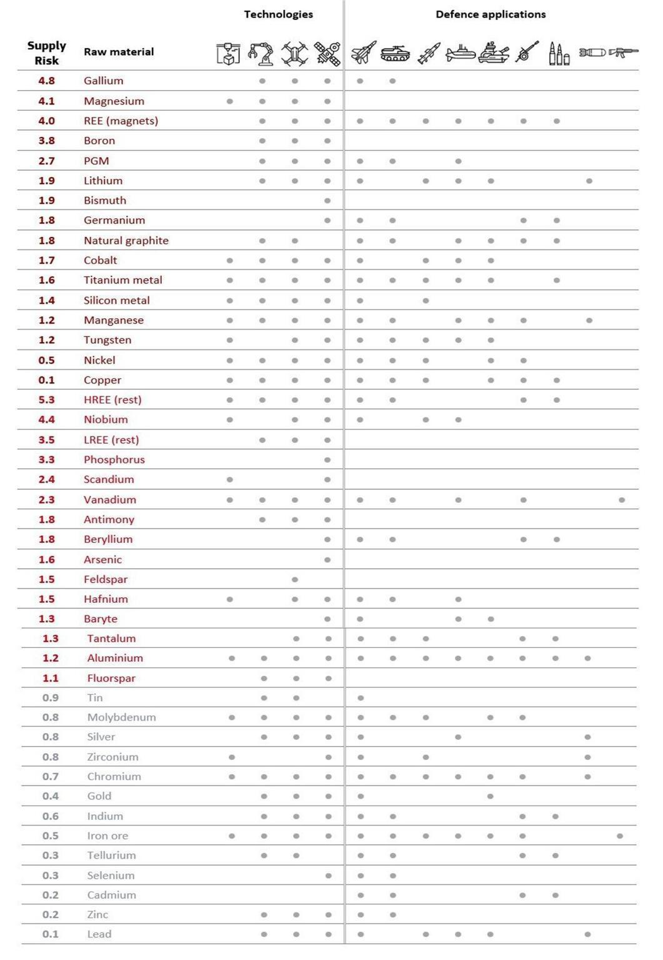
By analysing the consolidated table above, it is understood that resource-intensity is not specific to climate technologies. Development of defence technologies also relies heavily on resources, making the strategic control of those resources a primary political and geostrategic target. Military mobilization has long been an overlooked factor, which nowadays is increasingly determinant for issues such as extraction and management of CRMs and governance structures, even under the mantle of dual technologies. As depicted in the Picture below, the EU has also recognized that a wide variety of critical raw materials is essential for manufacturing, not only for civilians but also for military technologies:
Picture 1 EU-recognised strategic raw materials
The importance of these critical raw materials does not only stem from their wide application, but also from control of production and supply chains. As Meng (2025) critically points out by comparing the US military capabilities with the Chinese – arguably the top two superpowers of today, an F-35 aircraft contains about 418kg per frame of rare earths, a Virginia-class submarine about 4173kg per ship of rare earths. However small the demand for critical minerals for defence purposes may be as of now and in contrast to civilian applications, it must be noted that the lack of alternative resources and the need for high-purity materials required for production in this specific sector should not be overlooked (Zhou & Månberger, 2024). The resource-intensity of the defence sector may lead to competition and friction between great powers over extraction, processing and production capacities. Control over production and supply chains of critical raw materials could provide state and non-state actors with leverage to exert actual strategic influence around the globe today.
Finally, it is also important to mention that rearmament is not only resource- but also carbon-intensive. Although the Kyoto Protocol introduced emissions reduction targets and while the Paris Agreement introduced tighter reporting guidelines, military emissions were mostly either excluded or allowed to be under-reported by nations (Parkinson, 2019). Further reports depict that the global military carbon footprint amounts to almost 5.5% of the global GHG emissions and that all the top ten GHG emitters except Indonesia are among the top 20 military spenders (Parkinson & Cottrell, 2022). In this context, militarization intensifies carbon emissions through weapons systems manufacturing, fossil-fuel dependence and military infrastructure development (Ahmad, 2023). Global military spending reached almost US$2.7 trillion in 2024. Continued increase of military budgets can be expected to create a “deep-cycle phenomenon”, where military investments create a form of lock-in, that makes climate targets more difficult to achieve (Crawford, 2022; Abolfathi & Kinney, 2025).
From the above discussion, the evidence strongly implies that critical raw materials are imperative for rearmament and that defence spending is also carbon intensive. In the next chapter, this resource-intensity of defence technology development will be studied in conjunction with climate technologies and initiatives.

The Relationship between Green and Military Investments
As discussed in the previous chapter, critical raw materials are very important resources, not only for climate related technologies, but also for military applications. Their importance for both sectors, bearing in mind that there may be no alternative to their utilization for development of both climate and military technologies, could eventually lead to bottlenecks, where a question of mutual exclusion arises. To better understand this dilemma, the crowding out effect or the guns vs butter trade-off models will be utilized.
The Guns versus Butter model was firstly introduced as an economic allegory by Paul Samuelson in the textbook “Economics” back in 1948, which Waszkiewicz et al. (2025) identify in their analysis. In simple words, it represents the fundamental trade-off a nation faces when deciding resource allocation between civilian and social welfare (butter) and military defence (guns). Waszkiewicz et al. (2025) have identified this debate within the broader NATO’s 2% Defence Investment Pledge. They categorize EU-27 countries according to fiscal position, defence spending and commitment to welfare, treating countries such as Greece and Luxembourg as exceptional cases. Their findings suggest that states aiming to meet the 2% Target, may face having to choose between reduction of the welfare state or higher taxation, to fund military expenditure. However, this is reliant on two factors, proximity to geopolitical conflicts and capacity to hold public debt and increase their tax capacity and existing welfare conditions. The findings are visualized in the following table:
S/N | CLUSTER | COUNTRIES | FISCAL POSITION | DEFENSE SPENDING (REL. TO 2%) | RESULTS
1 | Low defence, high debt and tax | Austria, Belgium, Slovenia | High debt and high tax burden | 0.91% of GDP | Must raise defence from a very low level, but has little room to borrow or tax more
2 | High defence, low debt | Estonia, Latvia, Lithuania, Poland | Low debt and low tax burden | 1.94% of GDP | Close to 2%, can finance further defence through debt or taxation
3 | Insufficient defence, high welfare | Denmark, Finland, Germany, Sweden | Strong welfare and some capacity to hold debt | 1.27% of GDP | Needs to raise defence, but can avoid welfare cuts due to fiscal space
4 | Insufficient defence, low welfare | Croatia, Czechia, Hungary, Netherlands, Romania, Slovakia | Moderate debt/tax space, lower welfare level | 1.44% of GDP | Needs to raise defence, but raising public debt will be most likely preferred than social cuts
5 | Medium defence, heavily indebted | France, Italy, Portugal, Spain | Very high public debt and relatively high tax burden | 1.60% of GDP | Defence is closer to target, but further increases may require cuts elsewhere
Table 2 Defence spending, fiscal position and social welfare interaction for NATO countries
According to the above, countries that face geopolitical pressure and ought to raise defence expenditure will most likely have to face the dilemma of social cuts or raising public debt. As a result, when fiscal constraints are present, cutting welfare-oriented spending is a one-way choice. The 2% commitment has been amended at the 2025 NATO Summit in The Hague, where member-states have pledged a 5% defence investment commitment. Based on the above findings, this new target may present budgetary pressures, particularly in members with high debt, limited taxation capacity or extensive welfare commitments..
With the crowding out effect the situation where investment in one field minimizes investment in another field is described. Recent studies report an inverse relationship between defence spending and green investment (Matelly, 2026; Chakraborty, 2026; Markó, 2026). Markó (2026) analyses OECD Patent data and associates a rise in military spending with a 10% reduction of green patenting. A separate analysis of samples from 20 NATO countries from 1970 to 2016 implies a roughly 25% decline. The case with the EU follows a similar pattern (Matelly, 2026). Since 2022 and the Russo-Ukrainian War, rearmament is increasingly treated by the EU as a priority with the rest of the policies effectively being reframed as supplementary, especially as the White Paper for European Defence – Readiness 2030 shows. In both NATO and the EU climate change is viewed as a security issue, in the sense that sustainability and low-carbon economies are sovereignty and security factors.
The primacy of defence policies is also prevalent when analysed as hurdled by environmental reporting standards and regulations. Environmental reporting for defence-military applications, such as production, is viewed as an obstacle to rearmament and security, thus certain exemptions should be introduced or, as the Defence Readiness Omnibus package proposes, environmental procedures should be simplified. Taking into consideration that rearmament is highly resource-intensive, investment in defence and climate may be regarded as competing. In this sense, it is probable that since climate investment is viewed as less urgent or easily postponed, a crowding out effect in favour of rearmament is highly possible. Moreover, as Chakraborty (2026) notes, militarization is very likely to crowd out civilian investment in general, including climate investment. Defence investment may encourage defence-oriented innovation and R&D. However, a “war economy” may develop, where excessive militarization in favour of specific firms, political actors and military institutions diverts resources away from civilian priorities and distorts priorities, locking resources into less socially productive sectors. The evidence suggests a constraint of civilian investment due to the prioritization of rearmament. These include the diversion of resources from civilian applications, and the introduction of regulatory exemptions. However, the volume of critical raw materials already diverted from civilian to military uses is not clearly quantified.
Such is the case with the Barroso Lithium Mine, an EU-designated Strategic Project, which threatens local communities and the environment under the pretext of critical mineral extraction and economic development (Riquito, 2025; Riquito, 2026; Calafate-Faria et al., 2025; Dorn, 2021). The Barroso mine is a lithium-extracting project, owned by the British company Savannah Resources through a Portuguese subsidiary and is developed in Northern Portugal. On a on the Project zone of 6.5km by 2.5km, a total of about 39.1 metric tonnes of near to 1% grade lithium to the market, next to an additional 14.4 metric tonnes of 33,4% grade Quartz and 4,71 metric tonnes of 42.6% grade Feldspar is expected to be produced. The mining method to be implemented is the Truck & Shovel / Loader (excavators and dump trucks), with drilling and blasting (where necessary) wet processing taking place before further processing. The total cost of the project, including royalties and income taxes, is about $3,49 billion against gross total revenue of about $4,15 billion. Production is expected to start at the 3rd Quarter of 2025 for about 14 years.
The Portuguese government promoted the project through public communications, emphasizing its expected strategic and economic benefits. The project is being pushed as enhancing the local economy by creating new jobs and local development, as well as promoting national independence on lithium and, under the provisions of the Critical Raw Materials Act and the EU Green Deal, critical for renewable energy storage systems and electric vehicle development. However, the region on which the project is situated has been recognized by FAO as a World Agricultural Heritage Site since 2017 due to its sustainable land use and communal management of lands. Critics also argue that these communications campaigns portrayed local opposition as insufficiently informed. Furthermore, the government introduced administrative exemptions and easements to facilitate access to private land and classified it as a Project of National Interest to strengthen its legal and political case against local opposition. The opposition also states that mining will take place some 200 meters from the nearest homes, while concerns have been raised over the project itself. The open pit type of the mine, waste piles, washing plants and water-related-infrastructure that need building residents state will permanently alter the landscape and local ecosystem and endanger their agricultural way of life. Furthermore, they indicate that the proposed water tailings storage facility and rain concerns over water contamination, since during heavy rainfall a structural failure could lead to contamination of the Covas River and the Douro system from which the area is supplied its water. Last but not least, they support that the project suffers from inadequate public participation and consultation. Fundação Montescola took the case to UN Economic Commission for Europe against the Portuguese government, arguing that crucial Environmental Impact Assessment-related documents were denied or withheld, failed to provide information in time for an effective public consultation and was in effect breaching the Aarhus Convention's Articles 4 and 6 concerning public participation in environmental decision-making. The findings adopted by UNECE on 22/08/2025 show non-compliance of Portugal to the Aarhus Convention regarding time allowed for public participation, access to environmental information, handling of information and the Portuguese legal framework.
This case study illustrates how securitized raw-material policy can subordinate local social and environmental interests, raising the question of cost and benefit distribution from mineral extraction. As is the case with similar projects (Fahlbusch & Walschot, 2025), EU designated 47 strategic projects located within the EU and 13 non-EU projects within 2025, in a move to further strengthen and diversify access to strategic/critical materials. However, a variety of stakeholders including MEPs have been criticizing the process, among others, due to its limited public consultation and civil involvement. The above evidence introduces the notion of extractivism and neocolonialism. In what could be described with the words, extractivism and green neocolonialism, local communities and natural habitats are forced to bear the cost for climate goals, as they are exploited and sacrificed in what could be described as resource removal and domineering behaviour by firms and governments. As Fahlbusch & Walschot (2025) point out, the fact that critical raw materials used for military applications may be extracted under the guise of clean technologies hides a possible source of disagreement and dissension of the citizens.
From the analysis above, it is evident that the dilemma of resource allocation between civilian/climate and military applications is existent and can be understood through the lens of the guns versus butter trade-off and the crowding out effect models. The choice between guns and butter is conditional on factors such as current military capabilities, the extent of welfare state and the fiscal capacity. Geopolitical factors and political priorities set by governments also influence how countries respond to the above constraints. The evidence strongly suggests that states will choose to either pursue a “guns and butter” policy or undercut social and climate investment, rather than lower military spending. What is more, a strong correlation between rising defence spending and diminishing climate-oriented investments is observed. Prioritization of rearmament points to a trend indicating that climate-oriented investments, technologies, even reporting standards may be bent to serve security targets and military goals. The above findings strongly suggest that the growing security and rearmament agenda may divert resources, including critical raw materials, militarization and away from social and green transformation, downgrading it to a supplementary policy goal.

Fiscal and Financial Implications of Rearmament
As stated in the previous chapter, the relationship between military spending and social and green investment can be better analysed by turning the guns vs butter trade-off into guns and butter. As explained, governments face what could be described as a trilemma; they can choose only two options at the same time, either budgetary discipline, lower social and green spending or lower defence spending. Since governments eventually choose to expand the fiscal state, by raising public debt and taxation, this chapter delves deeper into the fiscal consequences of the unwillingness to limit rearmament to levels that allow socially and environmentally beneficial policies to be funded, as well as explores possible implications for the EU.
In the context of a growing economy, especially nowadays where rearmament is a prevalent policy, the interconnection between military spending, social investment and economic growth begs the question of how military expenditure is financed. To examine this statement, studies have addressed the financing of military booms, both during peace and war (Marzian & Trebesch, 2025) and US financial data, such as military expenditure, government social benefits, tax revenue and debt from 1947 to 2007 (Carter et al., 2020). They find that war booms are mostly financed through public debt and increased military spending, peacetime booms are mostly reliant on balanced financing, which is utilization of both debt and taxation, while spending cuts are rare. What must be highlighted is that tax revenues mostly come from income and consumption taxes and not wealth or other similar levies on the rich. However, even if public debt accumulated during war may decline due to postwar adjustment, debt relief, or default - the latter not being positive, tax policies seem to remain in place even after military buildups. Similarly, it is understood that military and social spending are substitutes when governments aim for a low taxes or low debt policy but may be complementary when governments protect welfare spending (Carter et al., 2020, p. 8-10). Complementary to Chapter 2, Carter et al. (2020) find that in the US military spending and GDP do not have the positive relationship Military Keynesianism supports. While initially GDP is reduced by military spending, due to diversion of resources or borrowing for example, after about one year GDP rises, which is attributed to increase in defence production, employment and revenues. However, after two years and in the long run, GDP and military spending do not have a significant positive impact on GDP.
According to the above analysis, there is no clear proof correlating military spending to a rise in GDP and better performance than alternative public investments. Even though higher military expenditure does not necessarily produce immediate cuts in social spending, government taxation or borrowing may lead to buildup of public debt or taxes persistent. In this context, Byrialsen (2025) studies Denmark’s fiscal position against the 2% and 5% NATO GDP Targets and uses a Post-Keynesian Stock-Flow-Consistent modelling approach, associated with Wynne Godley, finding that a military spending increase of 2%, financed through debt and not taxes or cutting other spending, produces a larger expansionary effect. Although households keep their disposable income, public finances are pressured over time. In the tax-financed scenario, governments contain a 3% increase of military spending by reducing household disposable income and consumption. The subsequent effect may cause lower demand, investment and growth. What is concerning, however, is that a rise to 5% puts real pressure on the fiscal capacity of the state. With an increasing public debt, military spending must be funded by diversion of funds from other areas, such as welfare or climate spending, as explained in previous chapters. Simply put, Byrialsen suggests that when military spending rises too much, it may have a negative effect even in fiscally healthy and stable economies and a consequent possibility of civilian investment being crowded out.
The above explained fiscal pressure to public finance and the possible crowding out of civilian investment is alarming, when considering the wider military-oriented budget priorities of the EU. Jones et al. (2022) show that the current budgets are heavily pro-rearmament while civilian spending is sidelined. In Multiannual Financial Framework 2021-2027 around €43.9 billion is allocated to security, border management and defence spending in total and can be broken down in the following table:
Fund or programme | 2021–2027 allocation | Approx. share of €43.9bn
Asylum and Migration Fund (AMF) | €9.9bn | 22.6%
Decentralised EU agencies | €9.6bn | 21.9%
European Defence Fund (EDF) | €8bn | 18.2%
Integrated Border Management Fund — Border Management and Visa Instrument | €6.2bn | 14.1%
European Peace Facility (EPF) | €5.7bn | 13.0%
Internal Security Fund (ISF) | €1.9bn | 4.3%
Civil Security for Society | €1.6bn | 3.6%
Integrated Border Management Fund — Customs Control Equipment Instrument | €1bn | 2.3%
Total | €43.9bn | 100%
Table 6 MFF 2021-2027 Budgetary breakdown for security purposes
From the above table important results can be extracted. Firstly, the EPF is intentionally coloured, since it technically falls outside of the MFF and is thus not subject to budgetary restrictions and parliamentary scrutiny, and accounts for about 13% of the total security-allocated budget. Secondly, also important is the imbalance between civilian and military expenditure. While almost €45 billion are allocated to rearmament, security, defence etc., only about €1.4 billion is allocated to the Citizens, Equality, Rights and Values Programme. Furthermore, the LIFE programme, Just Transition Fund and related NextGenerationEU resources together provide around €22.8 billion for environmental and climate action (D’Aprile et al., 2025). This shift towards defence and security is also implied by deliberately seeking synergies between military and civilian, dual technology development and favouritism towards firms that have are military and defence oriented. What is more, the White Paper for European Defence and Readiness 2030 mentioned above also proposes measures such as €150 billion in EU-backed SAFE loans, fiscal exemptions potentially enabling €650 billion in additional national spending and defence use of funds from Cohesion accounts under the ReArm Europe initiative (De Lemos Peixoto et al., 2025). Finally, the Defence Omnibus suggests faster permits and environmental exemptions for defence production, which is not the case for civilian and climate industrial investments.
The information presented above implies that in the EU a shift of focus is happening, from civilian and climate expenditure towards military spending. Further to already noted EU-level public-investment gap of €321 billion, of which €120 billion for health, €57 billion for affordable housing and €15 billion for education, a national public investment gap of €442 billion and a private-investment gap of €512 billion per year is estimated (D’Aprile et al., 2025; Koch & Biegon, 2025). Investment gaps are rising for defence to €250 billion annually, for decarbonization to €533 billion annually, for digitalization to €125 billion and environmental protection and biodiversity to €130 billion. It is worth noting that the budget proposals in the new MFF 2028-2034 include the rise to €131bn for defence, security and space and the reduction of the Common Agricultural Policy from €386.6bn to €300bn and the European Social Fund Plus from €142.7bn to €121bn.
In this chapter the fiscal and financial implications of rearmament were discussed. The evidence suggests that too much a rise in rearmament may negatively impact even stable and fiscally healthy economies. Also, the examination of the MFF 2021-2027 and EU budgeting documents a shift from climate and civilian expenditure to military investment within the EU, with a reduction of the former and a rise in the latter.

Alternatives to Rearmament
Rearmament, under the conditions examined above, may be considered resource-intensive, heavily reliant on CRMs and an antagonist to civilian and climate initiatives. Possible negative fiscal and financial implications are also identified. To tackle these issues, social and climate-oriented industrial policies are proposed. Industrial and production initiatives similar to the Lucas and Barrow Plans are proposed, complemented by a reduction of military spending and diversion of financing towards social and green investments.
Especially in the EU, the above-identified transfer of resources from the so-called “twin transition” towards military rearmament through programs such as ReArm Europe and Readiness 2030 begs the risk of negligence of climate and social security in favour of military security. In order to combat climate-related threats and promote social cohesion, a new industrial policy must be put forth (Raza et al., 2026; Raza, 2026). What is important is to understand that industrial policy is not simply an instrument supporting production, rather than a process of achieving overall economic development. It is thus necessary that in this procedure governments actively intervene to steer production towards socially desirable and necessary investments, rather than staying a purely regulatory mechanism. Governments need to clearly define socially acceptable and necessary production targets - meaning what goods and services need to be produced, coordinate private and public sector investments especially when it comes to critical infrastructure, such as transportation, and provide financial assistance to curb investment uncertainty.
However, industrial policy cannot be successful by relying solely on firms and governmental initiatives; a democratization procedure must take place, where structured dialogue with actors such as trade unions, workers, civil society and academia should take place. Their long-term support not only ensures industrial policy’s success industrial policy but also reduces information asymmetries, aligns incentives and creates reciprocal accountability within policy making and monitoring (Campbell et al., 2025). This democratization procedure also provides necessary democratic distribution of both benefits and costs along all social strata, protection of civil liberties and transparency against extensive corporatization (Raza et al., 2026; Raza, 2026; Kapczynski & Michaels, 2024). This study proposes that the social and climate transformation of societies to achieve resilience, welfare and security is also taken into consideration and must not be neglected in the face of competitiveness and military capabilities (Aiginger & Rodrik, 2020; Juhász et al., 2024; Bärnthaler et al., 2025).
On the financial side, expansionary macroeconomic conditions are necessary for the investment gaps to be covered (Raza, 2026). States and the EU can support investment through subsidies, loan guarantees, tax incentives and creating dedicated funding mechanisms. However, public ownership and regulations must be implemented, to ensure that financing mechanisms are not simply de-risking tools for private corporations, while the negative effects are borne by public institutions. Especially on green transition, monetary policies must support the real economy and not only financial markets, since green transition could create EU-wide inequalities between firms, regions and states (Pianta & Lucchese, 2020). Liquidity provided under the European Central Bank must be translated into capital used to expand green investment, complemented by expansionary fiscal policy, rather than enrich banking accounts and inflation. Furthermore, a general upskill of workers and support of technological innovation is needed (Criscuolo et al., 2023). Apart from the aforementioned demand side and supply side tools, upskilling, reskilling and training will reduce the social costs of the green transition, while creating the necessary workforce to implement policies and develop technological innovations. In the wider framework of green industrial policy, support of new firms, with innovative solutions and technological breakthroughs must be complemented by strong public presence in the form of regulation, ensuring competition and supporting diffusion of technologies and R&D findings along the production chain.
The above suggestions were formulated about 50 years ago, in the so-called the Lucas Aerospace Shop Stewards Alternative Corporate Plan (Smith, 2014a; Rogaly. 2024). In 1976, in the company Lucas Aerospace in Britain, a military equipment manufacturer, the workers faced threat of mass redundancies due to restructuring, competition and technological change. The workers, instead of accepting the job losses, created the Lucas Plan, proposing that the company uses its assets, including workforce, towards socially and environmentally useful production, in what could be called an early “arms conversion”. Instead of military equipment, the workers proposed wind turbines, hybrid cars and heat pumps be produced, among others. The plan also introduced notions of democratic production, meaning the company would be run by workers councils in non-hierarchical teams, with priorities being decided with the workers’ opinion taken into consideration. Overall, the Plan aimed to address early issues of clean energy, transport, employment and health and inspired the later Technology Networks, which promoted the idea that technology is systemically connected to social priorities and power relations and as a result workers and communities ought to be included in decision-making (Smith, 2014b). The main target of the Technology Networks established in London by the then socialist-led Council was to democratize innovation, by promoting sharing of tools, technical advice, prototyping and links between communities, trade unions and polytechnic schools. Through cooperation of these stakeholders, Product Banks were created, where designs and prototypes for socially useful purposes were stored and made available for further use by workers and communities. These Networks eventually declined due to commercial pressure and private sector distrust. However, they demonstrated that workers, local communities and experts could cooperate in production of socially useful products, highlighting the importance of central and local assistance and public funding for the prolongation of such initiatives. Similarly to the Lucas Plan, the Barrow Alternative Committee, also in the UK, their own plan in 1987 (Schofield, 2007). The Barrow Alternative Employment Committee sought to diversify the knowledge and skills of engineers employed at VSEL shipyard in Barrow-in-Furness into civilian marine engineering. It was proposed that a marine technology research centre be created, as well as offshore wind, wave power and tidal barrier technologies be explored. Although the management rejected the idea, the Barrow proposal implies that the technical skills are there; what is needed is political will and dedication to social production.
Last but not least, this study wishes to briefly propose the reduction of military spending and diversion of resources to climate and social applications (Akkerman et al., 2022; Garfinkel, 1990; Ball, 1986). Even since the Cold War, reduction of armament and an arms conversion have been proposed. Instead of rearmament, diplomacy, reduced military spending in favour of climate finance and just transition planning must be prioritized. What is now defined as military security, in the face of climate crises across the globe, must be redefined as climate security. Reductions in military expenditure could release funding required for climate adaptation and just transition initiatives. In addition, investment could be redirected away from carbon-intensive production towards low-carbon climate solutions and social resilience.

Conclusion
This study aimed to examine the relationship between rearmament and social and green transition. The findings show that rearmament is resource intensive and a competition with social and environmental initiatives may develop. As evidence suggests, the trend is that governments pursue both initiatives, by allowing for budgetary strains. In the above context, the Barroso Lithium Mine case study demonstrates the social dimension of strategic mineral extraction and raises concerns over fast-track approval of strategic extraction projects. Although the study did not find that a rise in armament expenditure causes a proportional rise of GDP, it observed negative financial and fiscal consequences that burden national economies. Furthermore, a shift of budgetary focus in EU policy towards military spending is identified, while gaps in social, climate and public investment remain. Last but not least, the study found that, instead of focusing solely on rearmament, governments could support a different industrial policy model, where policies that include social and green targets are structured, financial support and incentives to social-oriented investments are provided and democratic participation in industrial production is ensured.
The topic under discussion herein is new; rearmament formally started in March 2025, when the ReArm Europe Plan was officially proposed. As a result, literature and data directly discussing the relationship between military and civilian/environmental applications are not available on a large scale. The new Multiannual Financial Framework, is to be approved by the end of 2027, meaning this study discusses relevant proposals and projections. It is thus recommended that future research continues to monitor the negotiations on the new MFF, to draw conclusions on possible policy and priority shifts within the EU. Furthermore, it would be beneficial that more data are gathered and analysed, regarding the plausibility of the crowding out effect as expressed herein and the financial implications of rearmament. Finally, it is strongly suggested that the focus of future research is directed at identifying the intensity of factor of production allocation for military applications, as well as at quantifying the material needs of rearmament. In this way, the opportunity and material cost of rearmament against civilian and environmental investments could be more clearly addressed.

Appendix I: Critical Minerals in Military Production
The following tables illustrate minerals used in last-generation Main Battle Tanks, FREMM-type frigates and submarines, F-35 advanced aircraft and the METEOR air-to-air missile system. These minerals are also used in civilian production, as shown in Chapter 2.
The tables are compounded with information, as included in the study of Hackett et al. (2025).
System / component | Critical raw materials | Used in production of
Sensors: optical glass and mirrors | Silicon; ceramics | Glass, mirrors and basic optical sensor elements used for battlefield awareness.
Infrared and night-vision sights | Mercury; cadmium telluride; germanium; copper; tantalum | Low-visibility target detection, recognition and identification systems.
Laser rangefinders and muzzle reference sensors | Indium; neodymium; yttrium; aluminium; erbium | Laser rangefinders and systems that accelerate firing-solution generation and gun alignment.
Communications and battlefield-management systems | Copper; gallium arsenide; gallium nitride; beryllium; silicon; silver; indium | Radios, secure communications and command-and-control systems for multi-domain operations.
Main gun, barrel and armament | Antimony; carbon; manganese alloys; chromium; nickel; molybdenum; vanadium; graphite; tungsten | Gun barrels, liners, high-pressure firing components, vibration/heat-resistant parts and weapon-related components.
Hull and structural body | Beryllium alloys; light aluminium alloys; very-high-hardness steel | Structural hull elements designed to support systems, resist combat stress and protect crew and components.
Passive armour systems | Tungsten alloys; titanium; boron carbide; composites including ceramic-filled plastics | Armour packages designed to absorb or dissipate energy from explosive projectiles and kinetic-energy penetrators.
Table 3 Land Sector: Main Battle Tanks and Infantry Fighting Vehicles

System / component | Critical raw materials | Used in production of
Hull, decks, superstructure and internal compartments | Aluminium; aluminium alloys; iron/steel; titanium; chromium; cobalt; copper; nickel | Decks, superstructure, internal compartments, fittings, wiring and structural ship components.
Propulsion systems | Cobalt; copper; titanium; nickel; samarium and other rare-earth elements | Diesel engines, gas turbines, thrusters, gearboxes, shafts, propellers and electric propulsion components.
Electric motors and advanced batteries | Lithium; graphite; copper; silicon; aluminium; cobalt; manganese; nickel | Battery electrodes, wires, conductive parts, coatings, packaging and future submarine power systems.
Sensors and high-frequency systems | Graphite; gallium; gold; rare-earth elements; silicon | Radar, sonar, high-frequency components, optoelectronic devices and sensor electronics.
Weapons and mechanical systems | Titanium; nickel; chromium; manganese; molybdenum; vanadium; steel; aluminium | Naval guns, torpedo tubes, missile bodies, valves, heat exchangers and other mechanical components.
IT, communications and combat systems | Rare-earth elements | Microchips, data-storage devices, fibre-optic cables, display screens, magnets, optical lenses and lasers.
Table 4 Naval Sector: Surface Combatants (Frigates) and Submarines

System / component | Critical raw materials | Used in production of
Engine and high-temperature propulsion components | Titanium; nickel-based superalloys | Engine structures, disks, blades and vanes in advanced combat-aircraft propulsion systems.
STOVL/lift-system components | Aluminium; titanium | F-35B lift-system vane box and related airflow-control components.
Integrated power package and reserve power | Samarium-cobalt magnets; lithium | Turbomachine magnets and lithium-ion batteries providing emergency power to control surfaces and electrical systems.
Electric motors and permanent magnets | Dysprosium; neodymium; praseodymium; terbium | High-performance magnets used in aircraft electric motors.
Radar and distributed sensor systems | Gallium arsenide; gallium nitride | AESA radar components, including AN/APG-81 and likely AN/APG-85 radar technologies, plus related sensor systems.
Electro-optical targeting and laser systems | Beryllium-aluminium alloy; sapphire; europium; terbium; yttrium | Electro-optical targeting-system housings/windows and laser-designator-related components.
Communications, navigation and identification | Silicon | Radio-frequency hardware and computer processors in CNI avionics.
Airframe, skin and lightweight structures | Composites; carbon fibre/epoxy; bismaleimide composites; carbon nanotubes; aluminium; titanium | Fuselage, skin, tail, flaps, wingbox, pylons, bulkheads and other lightweight structural components.
Connectors, fasteners, coatings and primers | Copper-beryllium alloys; cadmium; zinc-nickel; chromium; zinc chromate | Electrical connectors, fasteners, stabiliser assemblies, landing-gear plating, coatings and primers; some materials are being replaced for environmental or health reasons.
Table 5 Aerospace Sector: Advanced Combat Aircraft (F-35)

System / component | Critical raw materials | Used in production of
Radio-frequency seekers | Gallium arsenide; gallium nitride | Monolithic microwave integrated circuits and RF seeker electronics for terminal guidance.
Seeker radomes | Silicon nitride; magnesium aluminosilicates; titania | Ceramic radomes for high-speed, supersonic and hypersonic missile applications.
Infrared seeker mirrors and windows | Beryllium; nickel; germanium; magnesium; yttria; lanthanum-doped yttria | IR seeker mirrors and signal-receiving windows.
Weapon-control units and electronics | Gallium; silicon; tantalum | Weapon-control electronics and missile computing components.
Airframe and structural components | Iron/steel; nickel; niobium; vanadium; titanium; molybdenum; tantalum; tungsten | Missile airframes, ramjet structural components and high-strength alloyed structures.
Propulsion systems | Boron; titanium; zirconia/zirconium; nickel-based superalloys; aluminium alloys; cobalt; silicon | Ramjet propellant additives, air intakes, thermal-barrier coatings, turbojet components and compressor stator blades.
Thermal batteries and electrical power supply | Lithium; silicon; iron disulfide | High energy-density thermal batteries used to power missile electronics.
Actuators and generators | Samarium; cobalt; neodymium; dysprosium; terbium; praseodymium | Permanent-magnet generators and actuator systems.
Warheads and penetrators | Tungsten; molybdenum; tantalum; copper; zirconium | Blast-fragmentation sleeves, shaped-charge liners and dense metal fragmentation or penetration components.
Table 6 Guided Weapons: METEOR missile system

Appendix II Barroso Lithium Mine Production Chain and Site Plan
The following pictures illustrate the Production Chain and the Site Plan, as found in the Project’s official website, accessible at https://savannahresources.com/project/barroso-lithium-project-portugal/ (Accessed on 12/08/2026).
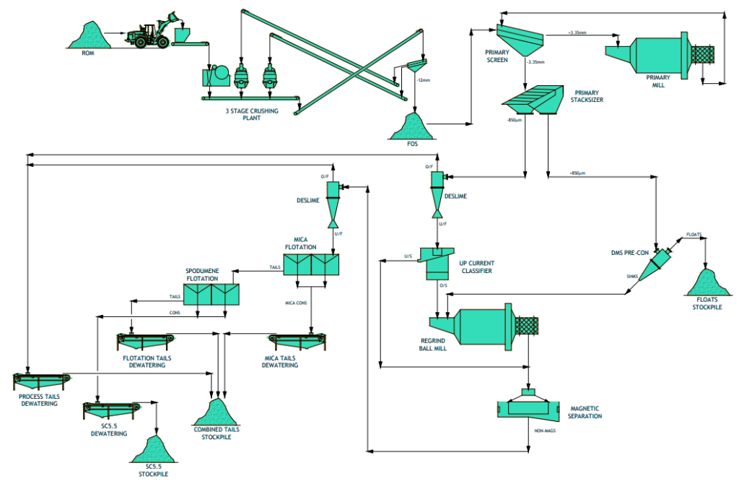
Picture 2 Barroso Lithium Mine Production Chain

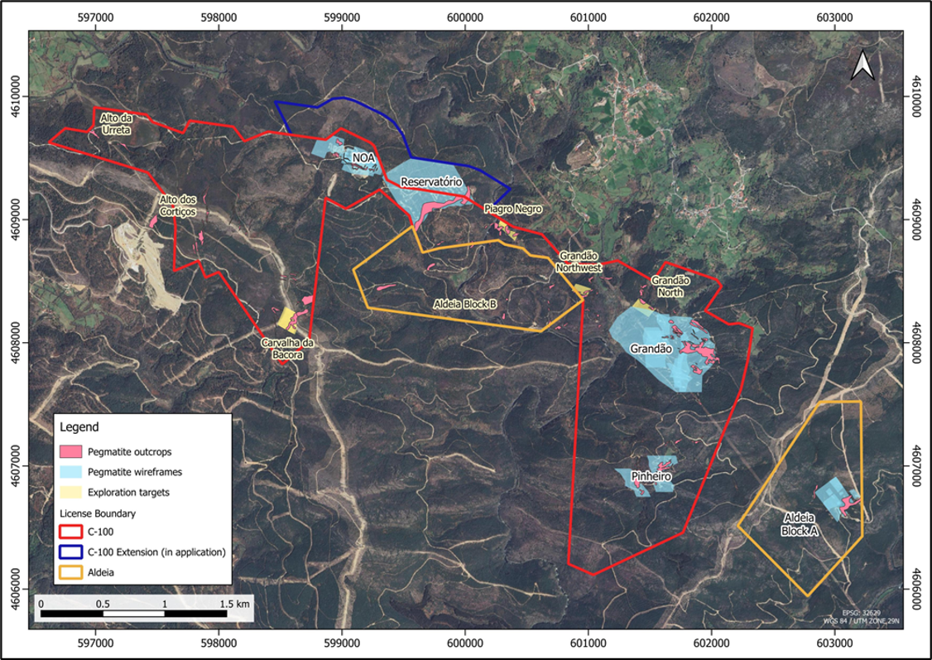
Picture 3 Barroso Lithium Mine Site Plan

Bibliography
Vezzoni, R. (2025). From REPower to ReArm Europe: A lopsided Geopolitics Foretelling Ecological Breakdown. Intereconomics, 60(6), 323–328. https://doi.org/10.2478/ie-2025-0064
Depraiter, L., Goutte, S., & Porcher, T. (2025). Geopolitical risk and the global supply of rare earth permanent magnets: Insights from China’s export trends. Energy Economics, 146, 108496. https://doi.org/10.1016/j.eneco.2025.108496
Rietveld, E., Bastein, T., van Leeuwen, T., Wieclawska, S., Bonekamp, N., Peck, D., Klebba, M., Le Mouel, M. & Poitiers, N. (2022). Strengthening the security of supply of products containing Critical Raw Materials for the green transition and decarbonisation. Policy Department for Economic, Scientific and Quality of Life Policies Directorate-General for Internal Policies, European Parliament. https://www.europarl.europa.eu/RegData/etudes/STUD/2022/740058/IPOL_STU(2022)740058_EN.pdf (Accessed on 12/08/2026)
Johnstone, P., & Marín, A. (2025). Beyond the twin transition: military drivers of critical minerals’ expansion. The Extractive Industries and Society, 26, 101836. https://doi.org/10.1016/j.exis.2025.101836
Hackett, J., Sabatino, E., Bint, M., Naradichiantama, D., Gjerstad, M., Bentham, J., Fischbach, J., Bearn, L., & Clavilier, Y. (2025). Critical Raw Materials and European Defence. The International Institute for Strategic Studies Critical Raw Materials and European Defence. https://www.iiss.org/globalassets/media-library---content--migration/files/research-papers/2025/03/iiss_critical-raw-materials-and-european-defence_25032025.pdf (Accessed on 12/08/2026)
Meng, W. (2025). Modeling the Path of Structural Strategic Deterrence: A Sand Table Simulation and Research Report on China’s Military-Industrial Capability System against the United States Based on Rare Earth Supply Disconnection. arXiv (Cornell University). https://doi.org/10.48550/arxiv.2505.21579
Zhou, J., & Månberger, A. (2024). Critical Minerals and Great Power Competition: an Overview. Stockholm International Peace Research Institute. https://doi.org/10.55163/wemj9585
Parkinson, S. & Cottrell, L. (2022). Estimating the Military’s Global Greenhouse Gas Emissions. Scientists for Global Responsibility, Conflict and Environment Observatory. https://ceobs.org/wp-content/uploads/2022/11/SGRCEOBS-Estimating_Global_MIlitary_GHG_Emissions_Nov22_rev.pdf (Accessed on 12/08/2026)
Parkinson, S. (2019). The carbon boot-print of the military. Scientists for Global Responsibility, Conflict and Environment Observatory. https://www.sgr.org.uk/sites/default/files/2020-08/SGR-RS02-Military-carbon-boot-print.pdf (Accessed on 12/08/2026)
Ahmad, N. (2023). Military Climate Emissions. Nevada Law Journal, Vol. 24, No. 3, p. 845. http://dx.doi.org/10.2139/ssrn.4553318
Crawford, N. C. (2022). The Pentagon, climate change, and war: Charting the Rise and Fall of U.S. Military Emissions. p. 100-123. MIT Press.
Abolfathi, S., & Kinney, E. (2025). The War On Climate: Closing the Military's Emissions Gap. Conflict and Environment Observatory (CEOBS) / Climate War Research Report. https://cwrrr.org/opinions/the-war-on-climate-closing-the-militarys-emissions-gap/ (Accessed on 12/08/2026)
Waszkiewicz, G., Kutasi, G., & Marton, Á. (2025). The Socio-Economic perspective for the Guns vs. Butter Trade-Off in the European Union countries. Folia Oeconomica Stetinensia, 25(1), 337–353. https://doi.org/10.2478/foli-2025-0017
Markó, B. (2026). The Green Peace Dividend: The effects of militarisation on emissions and the Green Transition. Environmental and Resource Economics, 89(6). https://doi.org/10.1007/s10640-026-01089-y
Matelly, S. (2026) Reconciling European Defence and the Energy Transition, Sovereignty and Sustainability: A Strategic Imperative for Europeans. Institut Jacques Delors, Policy Paper N. 321, https://institutdelors.eu/content/uploads/2026/03/PP321_Study_Defence_Climate_Matelly.pdf (Accessed on 12/08/2026)
Chakraborty, A. (2026). The Economics of War: Militarization and Growth in an AK economy. arXiv (Cornell University). https://doi.org/10.48550/arxiv.2603.23980
Riquito, M. (2025). “Barroso is Not to Be Sold, it is to Be Loved and Defended:” Affective Mobilizations for Land and Life in the Context of Green Extractivism. Capitalism Nature Socialism, 36(4), 27–51. https://doi.org/10.1080/10455752.2025.2562631
Riquito, M. (2026). “We are also the colonized:” The green transition’s colonial matrix of power at Europe’s rural peripheries. The Extractive Industries and Society, 26, 101861. https://doi.org/10.1016/j.exis.2026.101861
Dorn, F. M. (2021). Inequalities in resource-based global production networks: resistance to lithium mining in Argentina (Jujuy) and Portugal (Região Norte). Journal Für Entwicklungspolitik, 37(4), 70–91. https://doi.org/10.20446/jep-2414-3197-37-4-70
Calafate-Faria, F., Laschefski, K., De Freitas, B. V., Leme, F. S., Barbosa, R., & Sulzbacher, A. (2025). Energy Expansion at the Global Peripheries: The End of Territories. IDS Bulletin, 56(2). https://doi.org/10.19088/1968-2025.136
Fahlbusch, M. & Walschot, M. (2025). The EU Critical Raw Materials Act and the defence industry. International Peace Information Service. https://ipisresearch.be/weekly-briefing/the-eu-critical-raw-materials-act-and-the-defence-industry/ (Accessed on 12/08/2026)
Marzian, J. & Trebesch, C. (2025). Guns and Butter: The Fiscal Consequences of Rearmament and War. Kiel Institut. Working Paper No. 2310. https://www.kielinstitut.de/fileadmin/Dateiverwaltung/IfW-Publications/fis-import/8ee4bbb6-6bde-481c-bc43-1455f0e45fd7-KWP_2310.pdf (Accessed on 12/08/2026)
Carter, J., Ondercin, H. L., & Palmer, G. (2020). Guns, Butter, and Growth: The Consequences of Military Spending Reconsidered. Political Research Quarterly, 74(1), 148–165. https://doi.org/10.1177/1065912919890417
Byrialsen, M. R. (2025). Military spending, financing, and fiscal sustainability: the universal welfare state under pressure? Journal of Post Keynesian Economics, 49(1), 85–127. https://doi.org/10.1080/01603477.2025.2579262\
Jones, C., Kilpatrick, J. & Maccanino. Y. (2022). At what cost? Funding the EU’s security, defence, and border policies, 2021–2027. Statewatch & Transnational Institute. https://www.tni.org/en/publication/at-what-cost-EU-security (Accessed on 12/08/2026)
De Lemos Peixoto, S., Giacomo, L. & Mazzochi, R. (2025). Implementing defence financing and spending under the Economic Governance Framework. European Parliament. https://www.europarl.europa.eu/RegData/etudes/IDAN/2025/764381/ECTI_IDA(2025)764381_EN.pdf (Accessed on 12/08/2026)
D’Aprile, F., Koehler, M., Maranzano, P., Pianta, M., & Strazzari, F. (2025). Europe’s military programmes: strategies, costs and trade-offs. Laboratory of Economics and Management. Institute of Economics. Scuola Superiore Sant’Anna. https://doi.org/10.57838/sssa/r1fr-jd35
Koch, C. & Biegon, D. (2025). Public investment in the proposed 2028-2034 EU budget. Foundation for European Progressive Studies. https://feps-europe.eu/wp-content/uploads/2025/11/Public-investment.pdf (Accessed on 12/08/2026)
Raza, W. (2026). Strategic Outlook, Legitimacy, and Directionality: Tackling Key Institutional Deficits of EU Industrial Policy. In Progressive Industrial Policy in Europe. Routledge. p. 123-151. ISBN 9781041251965
Raza, W., Schlager, C., Skyrman, V. & Soder, M. (2026) Introduction: The Why, How, and for Whom of Industrial Policy for the Twin Transformation? In Progressive Industrial Policy in Europe. Routledge. p. 1-10. ISBN 9781041251965
Campbell, D., Kim, K. B., & Clayton, T. (2025). The return of the visible hand: Social dialogue and the making of 21st-century industrial policy (ILO Working Paper No. 153). International Labour Organization. https://doi.org/10.54394/SIMS1312
Kapczynski, A., & Michaels, J. (2024). Administering a democratic industrial policy. Harvard Law & Policy Review, 18, 279–344. SSRN: https://ssrn.com/abstract=4711216
Aiginger, K., & Rodrik, D. (2020). Rebirth of industrial policy and an Agenda for the Twenty-First Century. Journal of Industry Competition and Trade, 20(2), 189–207. https://doi.org/10.1007/s10842-019-00322-3
Juhász, R., Lane, N., & Rodrik, D. (2024). The new economics of industrial Policy. Annual Review of Economics, 16(1), 213–242. https://doi.org/10.1146/annurev-economics-081023-024638
Bärnthaler, R., Mang, S., & Hickel, J. (2025). Toward a post-growth industrial policy for Europe: navigating emerging tensions and long-term goals. Globalizations, 22(6), 1124–1148. https://doi.org/10.1080/14747731.2025.2501821
Criscuolo, C., Dechezleprêtre, A. & Lalanne, G. (2023). Industrial strategies for Europe’s green transition. In SPARKING EUROPE’S NEW INDUSTRIAL REVOLUTION A policy for net zero, growth and resilience. Blueprint Series 33. p. 123-152. Bruegel. https://www.bruegel.org/sites/default/files/private/2023-08/Bruegel%20Blueprint%2033_chapter%207.pdf (Accessed on 12/08/2026)
Pianta, M., & Lucchese, M. (2020). Rethinking the European Green Deal. Review of Radical Political Economics, 52(4), 633–641. https://doi.org/10.1177/0486613420938207
Smith, A. (2014a). The Lucas Plan: What can it tell us about democratising technology today?. The Guardian. https://www.theguardian.com/science/political-science/2014/jan/22/remembering-the-lucas-plan-what-can-it-tell-us-about-democratising-technology-today (Accessed on 12/08/2026)
Rogaly, K. (2024). A Lucas Plan for the Twenty First Century: From Asset Manager Arsenal to Green Industrial Strategy. Common Wealth. https://www.common-wealth.org/publications/a-lucas-plan-for-the-twenty-first-century-from-asset-manager-arsenal-to-green-industrial-strategy (Accessed on 12/08/2026)
Smith, A. (2014b). Technology Networks for Socially Useful Production. Journal of Peer Production. 5. 1-12. https://www.researchgate.net/publication/268486274_Technology_Networks_for_Socially_Useful_Production (Accessed on 12/08/2026)
Schofield. S. (2007). Oceans of Work: Arms Conversion Revisited. British American Security Information Council. https://basicint.org/wp-content/uploads/2018/06/oceans_0.pdf (Accessed on 12/08/2026)
Garfinkel, M. (1990). The Economic Consequencesof Reducing Military Spending. In Federal Reserve Bank of St. Louis Review. Vol. 2. No. 6. p. 48-58. https://fraser.stlouisfed.org/title/review-federal-reserve-bank-st-louis-820/november-december-1990-24555 (Accessed on 12/08/2026)
Akkerman, M., Burton, D., Buxton, N., Lin, H-C., Al-Kashef, M. & de Vries, W. (2022). Climate Collateral: How military spending accelerates climate breakdown. Transnational Institute; Stop Wapenhandel; Tipping Point North South; Global Campaign on Military Spending (CGOMS). https://www.tni.org/files/2022-11/Climate%20Collateral%20Report%20-%20TNI%20-%20final%20web.pdf (Accessed on 12/08/2026)
Ball, N. (1986). Converting the workforce: defence industry conversion in the industrialised countries. International labour review, Vol.125(4), pp.401-422. https://researchrepository.ilo.org/esploro/outputs/journalArticle/Converting-the-workforce--defence-industry/995274988202676/filesAndLinks?index=0 (Accessed on 12/08/2026)

For more information regarding the link between critical raw materials and twin transition technologies exclusively, the study by Rietveld et al. (2022) is providing deep analysis and can be found here: https://www.europarl.europa.eu/RegData/etudes/STUD/2022/740058/IPOL_STU(2022)740058_EN.pdf.
The NATO Critical Raw Materials List can be found here: https://www.nato.int/en/news-and-events/articles/news/2024/12/11/nato-releases-list-of-12-defence-critical-raw-materials. The EU Critical Raw Materials List can be found here: https://single-market-economy.ec.europa.eu/sectors/raw-materials/areas-specific-interest/critical-raw-materials_en.
For more information visit the respective EU Joint Research Centre webpage at https://rmis.jrc.ec.europa.eu/techprofiles/ind/16
It is important to note that, although referenced frequently, this study will not focus on geopolitics and great power competition per se, for example the competition between US and China for control over critical minerals.
Some countries, for example Greece, are excluded from the above categorization, due outlier values, exceptional defence burdens or geographical factors.
More on the 5% and the earlier 2% Defence Commitment may be found on NATO’s official website at https://www.nato.int/en/what-we-do/introduction-to-nato/defence-expenditures-and-natos-5-commitment
The White paper for European Defence - Readiness 2030 aims to strengthen EU defence infrastructure against geopolitical risks and threats, mainly by raising 800€ billion for investments in the defence sector.
This does not mean that 39.1 metric tonnes of Lithium are to be extracted, but 39.1 metric tonnes of rock, about 1% of which is Lithium.
For information on the project the respective website page can be accessed at https://savannahresources.com/project/barroso-lithium-project-portugal/. Furthermore, through the database Mining Data Online (free registration required) relevant documentation from the first Feasibility Study (https://minedocs.com/20/Savannah_Resources_Plc_Mina_do_Barroso_Lithium_Project_FS_06142018.pdf) to the latest Corporate Presentation (https://minedocs.com/32/Savannah-Resources-CP-042026.pdf), as well as comprehensive tables regarding the project may be found. In Appendix II the Site Plan is presented for reference.
This effectively means that water
The latest Definitive Feasibility Study is available on the London Stock Exchange website at https://www.londonstockexchange.com/news-article/SAV/barroso-li-project-definitive-feasibility-study/17688993.
A comprehensive article of the reasons local communities oppose the project can be found at Hands Off Nature’s webpage at https://handsoffnature.eu/resource/case-study-covas-do-barroso-lithium-mine/. Hands Off Nature is a collective campaign co-funded by the EU and launched by groups such as WWF, ClientEarth and the European Environmental Bureau.
The independent study by Steven Emerman was submitted to the UN Economic Commission for Europe (UNECE) by Fundação Montescola and can be found at https://unece.org/sites/default/files/2021-10/frCommC186_15.10.2021_annex1.pdf
The full communication can be accessed at UNECE’s respective page at https://unece.org/env/pp/cc/accc.c.2021.186_portugal.
The English document regarding findings and recommendations can be accessed at https://unece.org/sites/default/files/2026-01/ECE.MP_.PP_.C.1.2025.19.E.pdf.
Especially regarding the Barroso Project, Associação Unidos em Defesa de Covas do Barroso (UDCB) and ClientEarth sued the EU Commission and took the matter to the EU Court of Justice, stating that the body breached a key obligation by not thoroughly assessing the sustainability of the project, despite labelling it strategic. Relevant information can be accessed at https://www.clientearth.org/latest/press-office/press-releases/eu-commission-sued-by-ngos-and-communities-over-barroso-lithium-mine-decision/ and https://www.climatechangenews.com/2026/02/05/green-groups-sue-eu-over-inclusion-of-portuguese-lithium-mine-on-priority-list/.
MEPs Majdouline Sbai (Verts/ALE), Maria Ohisalo (Verts/ALE), Ana Miranda Paz (Verts/ALE) and Sara Matthieu (Verts/ALE) submitted a Question for Written Answer to the Commission on May 2025 regarding how strategic projects under the Critical Raw Materials Act (CRMA) are financed. The formal Question can be accessed at https://www.europarl.europa.eu/doceo/document/E-10-2025-002595_EN.html.
The theory of Military Keynesianism suggests that governments boost aggregate demand through increased defence and military spending, thus stimulating economic growth, since military personnel are hired and government defence contracts bring profit to firms, which is then translated to a rise in wages and consumption. For more information visit Dr. Mark Harrison’s lecture on Military Keynesianism at the University of Warwick (2019) at https://warwick.ac.uk/fac/soc/economics/staff/mharrison/war_and_economy/.
The Post-Keynesian Stock-Flow-Consistent modelling approach, associated with Wynne Godley that Byrialsen uses, is a macroeconomic modelling approach that essentially integrates production, consumption and jobs to money, debt and assets, in order to show how the latter influence the former. Built on the premise that every asset of one sector is a liability to another and every monetary flow has a sender and a receiver - or that money does not simply appear or disappear, the model aims to spot inconsistencies, blind spots and effects in the economy, before it crashes. For more information Yannis Dafermos’ and Maria Nikolaidi’s presentation on the matter is recommended, found here.
These loans are better known as the National Escape Clause, a mechanism part of ReArm Europe with which the European Commission aims to balance defence spending and the new Stability and Growth Pact, by allowing states to deviate from budgetary limits up to 1.5% of the GDP, financed by SAFE-backed loans. More information can be found on the EU Council’s webpage at https://www.consilium.europa.eu/en/policies/national-escape-clause-for-defence-expenditure-nec/ .
The OECD has also published an interesting Report which highlights that involving academia, businesses, civil society and citizens helps in identifying realistic objectives, local capacity and generates new partnerships, in regard to industrial transition policies. The Report is accessible at https://www.oecd.org/en/publications/regions-in-industrial-transition-2023_5604c2ab-en/full-report/component-4.html.

