Title: European Employment Policy and Human Capital Attraction Tools from Third Countries: Challenges and Contradictions in the Greek Labour Market
Author: Efstratios Adalis
Institution: Panteion University

Content
Chapter 1. Introduction 4
Chapter 2. Theoretical Framework: Economic Paradigms and Labour Market Fragmentation 8
Chapter 3. The Greek Case: Needs Assessment and National Employment Policies 11
Needs Assessment 11
Labour Market Tightness 13
Public Workforce Management Policies 18
Νational Temporary Labour Schemes and Administrative Barriers 18
Brain Gain Policy: The Greek «Talent Pool» 22
Chapter 4. European Policies for Augmenting Labour Supply Through Workforce Attraction 23
The New Pact on Migration and Asylum 24
Guideline 6 as a Regulatory Catalyst 25
EU Talent Pool: Bridging Migration and Employment 26
Chapter 5. Conclusions and Policy Proposals 28
Bibliography 32

List of Figures

Figure 1 Migrant Share (%) in Key Production Sectors (2021) 12
Figure 2: Distribution of Employed Persons by Citizenship and Occupational Category in Greece (2021) 13
Figure 3: Job Vacancy Rate (JVR %) Evolution Across Key Economic Sectors in Greece (2021–2025) 14
Figure 4: The Greek Beveridge Curve: Relationship Between Job Vacancy Rate and Unemployment Rate (2014 Q1–2023 Q4) 17
Figure 5: BPMN 2.0 Process Model of the Administrative Procedure for the national temporary labour scheme (Migration Code L. 5038/2023) 20

List of Tables
Table 1: Job Vacancy Rate (JVR %) in Key Economic Sectors: Greece (EL) vs. European Union Average (EU-27) 12

Abstract
This paper examines the strategies of European and Greek Employment Policies in addressing structural labour shortages. Specifically, it analyses the efficacy of institutional mechanisms designed to bolster labour supply via two distinct flows: the importation of human capital from third countries, and the repatriation of the domestic scientific workforce (Brain Gain) to Greece.
The methodology synthesises a critical analysis of the institutional framework (the external dimension of the New Pact on Migration and Asylum, the Guideline 6 of the European Employment policy, the EU Talent Pool, and the National Temporary Labour Schemes) with an empirical investigation of macroeconomic demand indicators. The objective is to evaluate the compatibility of supranational designs with the actual requirements of the Greek economy.
The findings substantiate a clear structural mismatch between European policy and domestic demand. The Greek labour market urgently requires a large volume of low- and medium-skilled personnel. Bilateral agreements currently bridge this gap in a fragmented manner. Conversely, the EU prioritises the EU Talent Pool. This instrument operates de jure-and even more so, de facto- as a mechanism to attract highly skilled "talents". Furthermore, a strategic paradox emerges for Greece. The policy of importing specialised professionals conflicts with the urgent need to halt the Brain Drain, thereby rendering repatriation policies a central priority.
In conclusion, the study maintains that the horizontal implementation of European tools proves inadequate. Employment Policy requires systemic recalibration. Primarily, the state must establish legal migration pathways for vocational and low-skilled labour, concurrently strengthening the administrative capacity of competent authorities. Furthermore, for highly skilled professionals, bolstering repatriation incentives constitutes the optimal national strategy.
Keywords: Employment Policy, Human Capital, EU Talent Pool, Temporary Labour Schemes, Repatriation (Brain Gain), Labour Shortages.

Chapter 1. Introduction
The Greek economy, currently recovering from a prolonged crisis, features a dual productive reality that diverges structurally from core European planning. The domestic productive paradigm remains heavily dependent on labour-intensive and low-value-added sectors (Tourism, Accommodation and Food Services, Construction, and Agriculture). Consequently, the manifested demand among Greek employers does not primarily target highly skilled human capital oriented towards the Fourth Industrial Revolution, instead, it requires a massive volume of unskilled or semi-skilled labour.
Concurrently, regarding highly skilled human capital, Greece suffers the consequences of a massive scientific outflow (brain drain). Therefore, the strategic objective for the Greek state is not exclusively the importation of new, foreign "talents", which the domestic market already struggles to absorb, but rather halting this outflow and achieving the repatriation of the domestic scientific workforce (brain gain).
Based on the above, the research problem of this study centres on a structural contradiction, questioning the extent to which supranational tools, such as the EU Talent Pool, can find functional application in the Greek labour market. These tools were primarily designed to supply cutting-edge industries. Conversely, Greece fills its primary and secondary sector vacancies with migrant workers through institutional Temporary Labour Schemes or informal pathways, while simultaneously seeking to repatriate its own scientists.
The primary objective of this research is to evaluate the degree of compatibility between the European strategy for attracting talent -as a core pillar of Employment Policy- and the actual, structural needs of the Greek labour market. The analysis is guided by the following four central research questions:
1. Identifying the Nature of Demand: What are the qualitative and quantitative characteristics of labour demand within the Greek economy, as reflected in the Job Vacancy Rate (JVR) and official employer requests (Temporary Labour Schemes)? To what extent does this demand target highly skilled competencies -the primary focus of the EU- rather than the unskilled, labour-intensive workforce currently dominating the domestic market?
2. Institutional Compatibility of the Talent Pool Regulation: Given the design of the EU Talent Pool as a voluntary mechanism, to what extent can this instrument achieve effective implementation in Greece? Does it provide a sustainable solution for the Greek productive paradigm, or does it constitute a profound institutional mismatch?
3. National Strategy. Brain Gain vs Brain Drain: Greece currently operates as an exporter of scientific personnel (brain drain). Considering this reality, should the substantive implementation of a "talent policy" focus on repatriating the domestic workforce (Brain Gain) rather than importing third-country nationals?
4. Critical Assessment: To what extent does the EU emphasis on attracting specialised personnel and establishing a platform align with the actual, existing needs of the labour market? Given that the highest recorded demand within the Greek labour market concentrates on low-skilled and unskilled positions, the study analyses the institutional and social impacts of this mismatch.
The central hypothesis of this study identifies a fundamental structural mismatch between European Employment Policy -institutionalised through the EU Talent Pool- and the actual requirements of the Greek economy. This hypothesis is structured along two prongs:
Firstly, while the EU strategy aims to attract highly skilled human capital to bridge the technological gap, the Greek productive paradigm (tourism, agriculture) requires a massive volume of low- and medium-skilled labour. Consequently, the elitist architecture of the EU Talent Pool proves functionally inadequate. This institutional asymmetry traps Greece in the fragmented solution of national temporary labour schemes for unskilled personnel via bilateral agreements.
Secondly, a strategic paradox emerges. Instrumentalising migration to import foreign "talents" contradicts the reality of a country exporting scientific personnel (brain drain). For Greece, the priority does not lie in importing third-country nationals. Rather, it lies in halting this outflow and actively repatriating domestic human capital (brain gain), while simultaneously mobilising the diaspora.
To substantiate this structural mismatch, the study adopts a mixed-methods approach. The research strategy synthesises institutional analysis, quantitative processing of macroeconomic data, and qualitative field research, developing across three distinct axes:
A. Institutional and Policy Analysis (Desk Research): This axis critically examines the European and national regulatory frameworks (the New Pact, the guideline 6, and the EU Talent Pool) to map strategic objectives. At the national level, it evaluates the Reports of the Bank of Greece and the Labour Market Needs Diagnosis Mechanism (DYPA, 2023).
B. Quantitative Analysis of Secondary Data: The second axis focuses on empirically substantiating the nature of demand, involving the collection and statistical processing of data from three primary sources:
- Eurostat (Job Vacancy Statistics - JVS): The Job Vacancy Rate (JVR) was analysed by economic activity sector (NACE Rev. 2) over a four-year period to comparatively evaluate demand between high-technology sectors (ICT) and labour-intensive sectors (Construction, Tourism).
- ELSTAT Microdata (2021 Census): This data captures horizontal segregation and the concentration of migrants per sector.
- Joint Ministerial Decisions on Temporary Labour Schemes, 2023-2024 and 2025-2026, (Ministry of Labour, 2024): These serve as a direct indicator of manifested employer demand.
C. Qualitative Field Research - Administrative Procedures: This involves a primary investigation of the national system of Temporary Labour Schemes to identify the implementation gap. The research focuses on bureaucratic complexity, the role of Consular Authorities, and visa delays. In practice, these systemic bottlenecks negate the efficacy of legal migration pathways.
The study is structured into five chapters, following a deductive trajectory from theoretical foundation to policy evaluation.
- Chapter One: Introduction. This chapter introduces and delineates the research problem.
- Chapter Two (Theoretical Framework): This section examines dominant economic paradigms, notably human capital and the neoclassical model, highlighting Piore’s dual labour market theory as the primary interpretive key for the Greek case.
- Chapter Three (The Greek Reality): This chapter maps domestic market needs via quantitative indicators. It evaluates national institutional tools, specifically temporary labour schemes and repatriation policies (brain gain).
- Chapter Four (The European Dimension): This section analyses the architecture of the New Pact through the lens of Guideline 6. It focuses on a critical review of the EU Talent Pool and its compatibility with national requirements.
- Chapter Five (Conclusions): This final chapter summarises the findings regarding the structural mismatch between European planning and domestic demand. Furthermore, it formulates targeted policy proposals to resolve this asymmetry.

Chapter 2. Theoretical Framework: Economic Paradigms and Labour Market Fragmentation
This chapter examines the theoretical paradigms interpreting the complex interaction between migration and the labour market. The analysis is structured as follows: a) human capital theory (R. Solow, R. Lucas), b) the neoclassical supply/demand model (G. Borjas), c) the demographic and institutional approach to the European Social Model (T. Boeri), d) the structural approach of dualism (M. Piore) combined with the Greek reality (M. Karamesini), and e) the sociology of capital (P. Bourdieu).
To understand the underlying rationale of European employment policy, Robert Solow’s (1956) neoclassical economic growth model serves as the analytical baseline, correlating long-term growth with technological progress. Expanding upon this premise through endogenous growth theory, Robert Lucas (1988) highlights the concept of human capital. The accumulation of knowledge and skills generates positive externalities (spillover effects), thereby enhancing overall productivity. This approach elucidates the strategic pivot of the EU towards attracting "talent"; in a knowledge-based economy, human capital constitutes the paramount determinant of competitiveness.
George Borjas (2016) approaches migration both as a "supply shock" and as an investment in human capital. According to the competitive equilibrium model, the influx of migrants expands the labour supply, consequently compressing wages in the short term. However, this impact depends heavily on the “skill mix”. Substitution (possessing identical skills to natives) intensifies competition, driving wages downwards. Conversely, complementarity (possessing distinct or missing skills) elevates both wages and aggregate productivity.
The Roy model and the concept of "self-selection" serve as a critical interpretive framework. Positive selection involves highly skilled individuals migrating to markets characterised by substantial wage dispersion. Conversely, negative selection concerns low-skilled individuals seeking security within compressed wage structures.
The neoclassical synthesis approach, as articulated by Tito Boeri, serves as a fundamental framework for comprehending the intersection of migration, demographic aging, and welfare state viability (Boeri, 2021, pp. 367–419). Primarily, Europe faces rapid demographic aging, directly threatening the sustainability of pay-as-you-go pension systems. Boeri contends that workforce contraction, driven by this aging process, significantly diminishes competitiveness and economic growth. Consequently, migration operates as an indispensable demographic replacement mechanism for the working-age population (Boeri, 2021, pp. 185–186).
However, policymakers confront a critical dilemma regarding "who and what kind of migrants" are required. The salient question is no longer whether migration is necessary, but whether states should facilitate an influx of third-country workers or prioritise the repatriation of domestic human capital. As Boeri and Brücker (2005) analyse, European nations systematically favour highly skilled individuals. These professionals function as net fiscal contributors, mitigating the prevailing fear that low-skilled migrants might overburden the welfare state.
Furthermore, European institutional rigidities, such as minimum wages and collective agreements substantially impede the labour market absorption of low-skilled migrants. Within this analytical paradigm, the outflow of domestic human capital (brain drain) constitutes a "double fiscal loss", depriving the state of both educational investments and tax revenues. Conversely, human capital repatriation (brain gain) emerges as the optimal policy solution; this strategy minimises cultural adaptation costs while simultaneously maximising net fiscal contributions to the social security system.
In stark contrast to the neoclassical model, Michael Piore (1970) introduces dual labour market theory. The market structurally bifurcates into the primary sector (stability, high wages) and the secondary sector (precarity, low wages). The demand for migrant labour is structural; native workers reject secondary positions due to social status implications. In Greece, according to Karamesini and Ioannidis (2023), as well as recent academic analyses (Karamesini, 2024) this institutional fragmentation divides the workforce into protected "insiders" and unprotected "outsiders." Internal devaluation expanded the secondary sector, consequently trapping the migrant workforce within the lowest echelons of the occupational hierarchy (Piore, 1979).
However, interpreting the incompatibility of migrants with modern European digital institutions, such as the EU Talent Pool, requires Pierre Bourdieu’s (1986) sociological theory. Cultural capital now encompasses "digital capital" (Ragnedda, 2018), namely the ability to navigate algorithmic structures and applicant tracking systems (ATS). Precisely here lies the digital divide: the class habitus of migrants directed towards Greece is adapted to manual labour, rendering them incompatible with the immaterial rationality of European platforms (Ignatow & Robinson, 2017). Excluded de facto -even if de jure entitled to participate- they are forced to rely exclusively on their social capital, depending heavily on informal ethnic networks to secure employment.

Chapter 3. The Greek Case: Needs Assessment and National Employment Policies
This chapter undertakes an empirical mapping of the Greek labour market and an evaluation of national institutional tools, specifically national temporary labour schemes (employer-led guest-worker invitations) and brain gain initiatives. It aims to highlight the structural mismatch between manifested employer demand and domestic supply.

Needs Assessment
Synthesising statistical indicators (ELSTAT Census, 2023a;2023b) confirms the profound dichotomy of the Greek economy, empirically validating M. Piore’s dual labour market paradigm. A clear horizontal segregation based on citizenship emerges; while natives dominate highly skilled services and the broader public sector, third-country nationals are massively overrepresented in five labour-intensive industries: tourism, agriculture, construction, trade, and manufacturing.
Specifically, the data reveal a high degree of structural dependency within the domestic production sector on the migrant workforce. In the primary sector (Agriculture), foreigners constitute 15.4% of the workforce (55,107 individuals). In construction, they cover 26.3% (49,481 individuals). A notable demographic inversion occurs in domestic services (11,897 foreign women versus 9,045 native women). This reality highlights the dominant role of female migrants in the "care economy", compensating for the systemic gaps of the national welfare state.
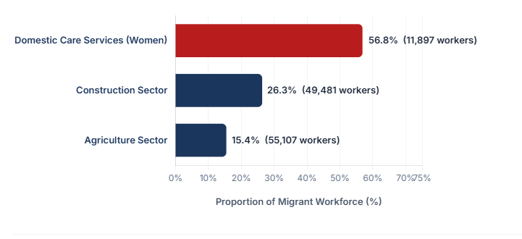
Figure 1 Migrant Share (%) in Key Production Sectors (2021)
Source: Author's elaboration based on ELSTAT Census (2021) Microdata. The chart illustrates the heavy reliance on foreign nationals in manual sectors and the demographic inversion in domestic services.

Regarding occupational stratification (skills gap), 40% of foreigners operate in manual or unskilled positions, compared to a mere 8% of Greeks. Conversely, 20.1% of the native population (730,313 individuals) hold highly skilled positions. Such evidence dismantles the narrative that Greece primarily requires a massive influx of "talents" for white-collar roles. The actual deficit manifests distinctly at the base of the occupational pyramid. Furthermore, the labour market exhibits strong ethnic specialisation exemplified by Albanians in construction, South Asians in agriculture, and Georgian and Filipina women in care services.

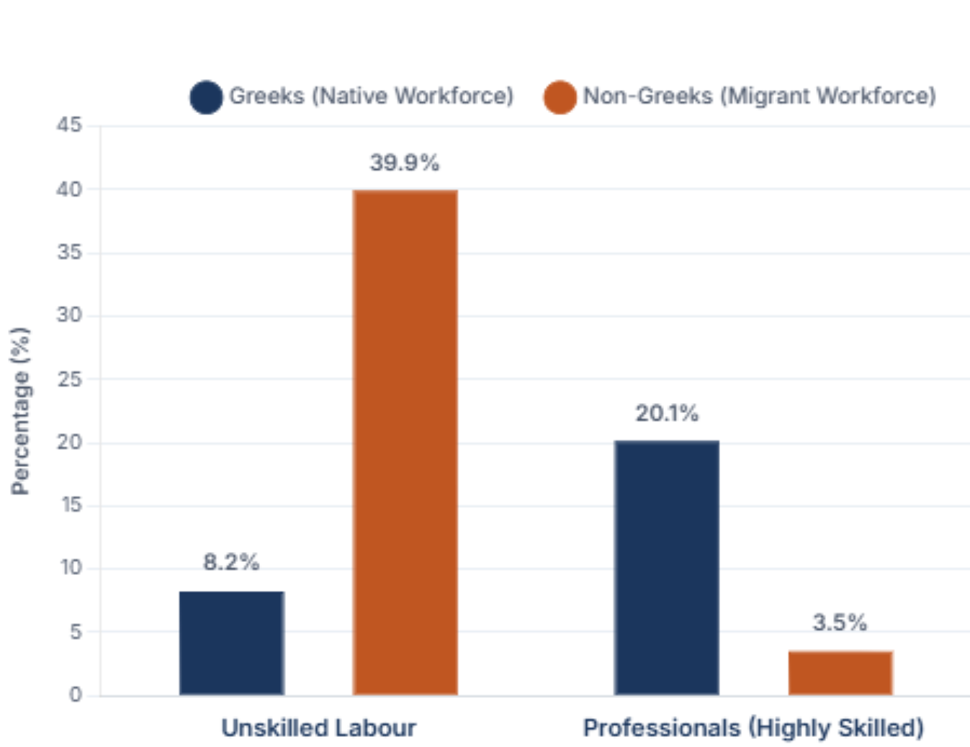
Figure 2: Distribution of Employed Persons by Citizenship and Occupational Category in Greece (2021)
Source: Researcher’s personal analytical synthesis derived from Population Census data, Hellenic Statistical Authority (ELSTAT), Tables A15 & B10.

Labour Market Tightness
Simultaneous examination of Eurostat supply and demand indicators (Eurostat, 2025a; 2025b) demonstrates acute labour market tightness in Greece. While the total available workforce steadily contracts -with the unemployment rate dropping from 14% in 2021 to approximately 8.5% (Q2 2026)- the Job Vacancy Rate (JVR) consolidates at historically high levels.
Specifically, within the construction sector, the JVR surged from a near-zero 0.4% in 2020 to a historic high of 6.7% in 2022, decelerating slightly to 4.4% in 2025. Similarly, in accommodation and food services, unfulfilled demand skyrocketed to 8.0% in 2024. In stark contrast, the information and communication (ICT) sector -a primary target of the EU Talent Pool- saw its vacancy rate retreat to a mere 0.6% in 2025. Consequently, a European policy that elitistically privileges the entry of highly skilled professionals acts as a systemic barrier to bridging actual gaps in the Greek market. This institutional inadequacy indirectly fosters either short-term national temporary labour schemes or irregular migration.
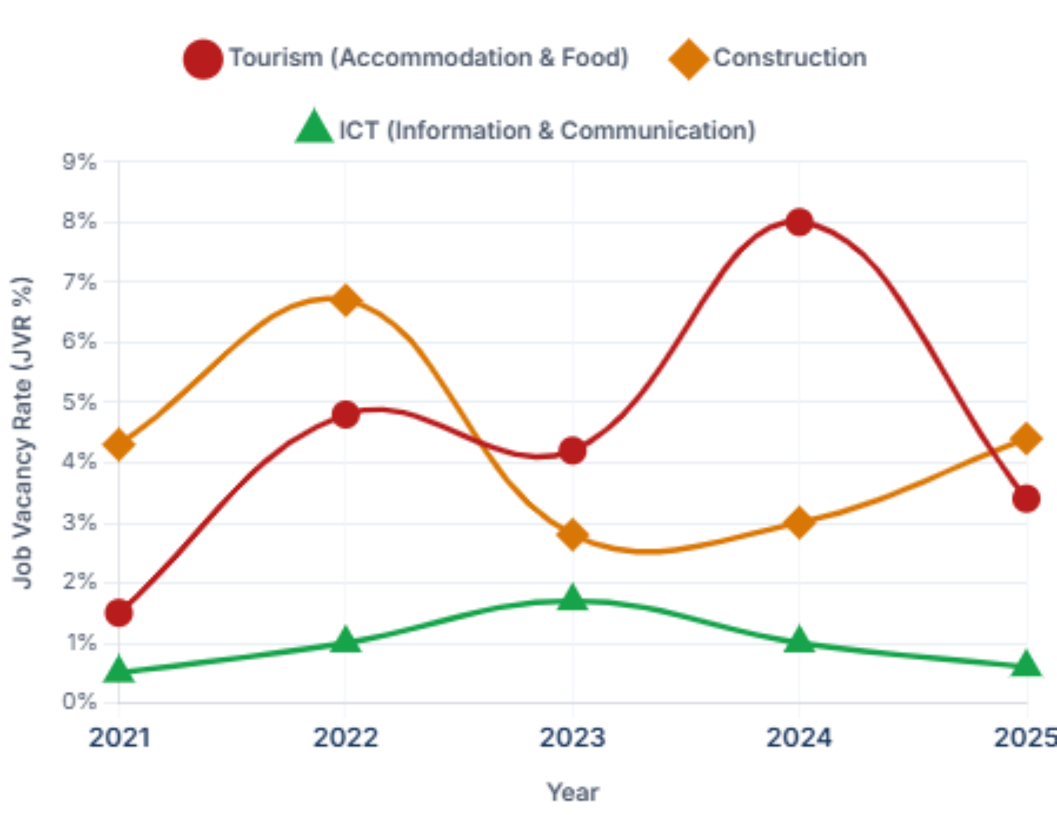
Figure 3: Job Vacancy Rate (JVR %) Evolution Across Key Economic Sectors in Greece (2021–2025)
Source: Researcher’s personal analytical synthesis derived from Eurostat’s Job Vacancy Statistics (jvs_a_rate_r2 & jvs_q_nace2), categorized by NACE Rev. 2 economic activities..

Table 1: Job Vacancy Rate (JVR %) in Key Economic Sectors: Greece (EL) vs. European Union Average (EU-27)
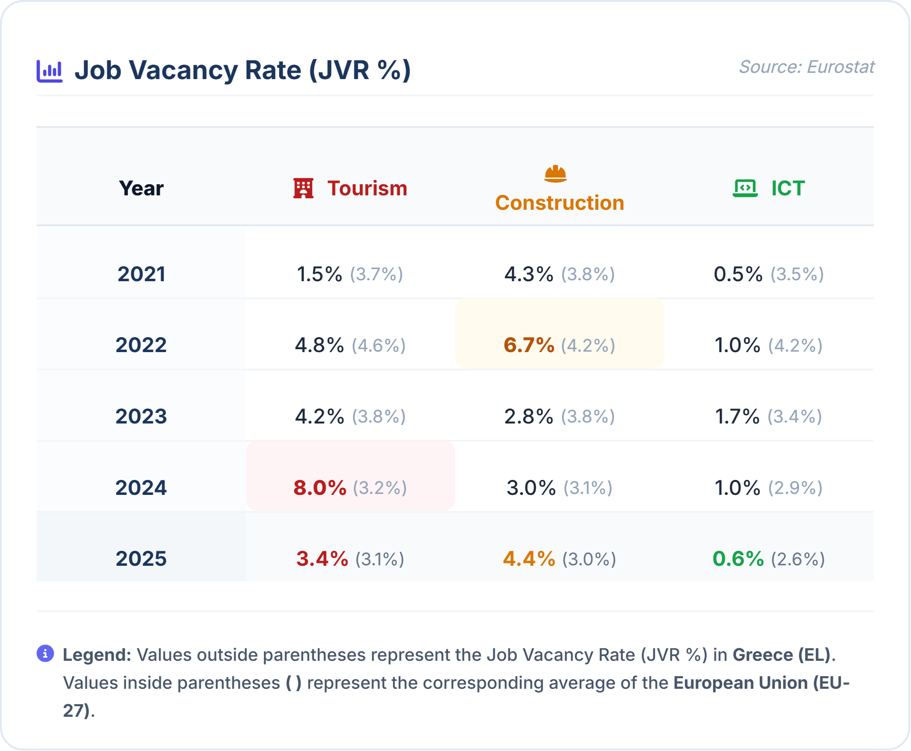
Source: Researcher’s personal analytical synthesis derived from Eurostat’s Job Vacancy Statistics (jvs_a_rate_r2 & jvs_q_nace2), categorized by NACE Rev. 2 economic activities.

The Bank of Greece institutionally corroborates the aforementioned skills mismatch. Analysing the Beveridge curve model (Bank of Greece, 2024a), a clear outward shift becomes evident. Job vacancies remain persistently high despite declining unemployment. This divergence indicates that the domestic workforce rejects the available manual positions. Finally, these empirical findings align perfectly with CEDEFOP and EURES (2024) projections. These agencies record 88 shortage occupations in Greece, predominantly comprising manual roles (cooks, craftsmen).

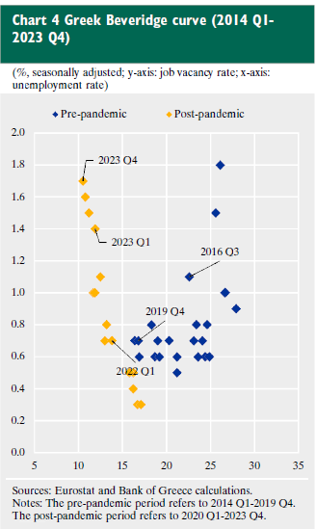
Figure 4: The Greek Beveridge Curve: Relationship Between Job Vacancy Rate and Unemployment Rate (2014 Q1–2023 Q4)
Source: Reprinted from Theofilakou, A., & Vasardani, M. (2024), "Recent developments and prospects of the Greek labour market", Economic Bulletin, Bank of Greece, Issue 59, p. 81. Data originally derived from Eurostat and Bank of Greece calculations.

Public Workforce Management Policies
This section traces the Greek state's response to diagnosed labour market tightness. Policy analysis reveals a dichotomous strategy. Implementing mass national temporary labour schemes addresses low-skilled vacancies, while simultaneously deploying brain gain initiatives to recover high-skilled professionals.

Νational Temporary Labour Schemes and Administrative Barriers
The primary institutional mechanism for fulfilling Greek labour market demands with third-country nationals is the national temporary labour scheme (Law 5038/2023). This mechanism constitutes an administrative act granting entry and residence to a foreign national for subordinate employment under a specific employer, which are biennially approved via a Ministerial Cabinet Act to establish the maximum volume of admissions.
The procedure entails two categories: regular migration (annual, renewable, and providing full social security across all sectors) and seasonal migration. The latter addresses temporary shortages in agriculture (remunerated via labour vouchers) and tourism or hospitality (providing standard social insurance). Authorities institutionalise these schemes either through the standard administrative channel of Decentralized Administrations or via Bilateral Labour Mobility Agreements (e.g., accords with Egypt and Bangladesh). Such agreements function as instruments of "migration diplomacy," theoretically anchored in a win-win logic. Greece seeks to bridge critical gaps in low-skilled sectors rejected by the domestic workforce by imposing an explicit return clause, the state thereby enforces circular migration.
Quantitative analysis of administrative data exposes a chronic divergence between manifested employer demand and state approvals. During the 2023-2024 biennium, employers submitted 379,165 requests to Decentralized Administrations. However, the Cabinet approved a mere 167,925 positions, translating to a 44.29% coverage rate. This generated a systemic deficit of 211,240 workers across the primary sector, construction, and tourism. This restrictive policy persists into 2025-2026. Despite a demand exceeding 300,000 positions, the approval ceiling contracted to 94,240 positions under Cabinet Act 35/2025, fulfilling a mere 31.4% of market needs.
Maintaining this state quota artificially perpetuates labour market tightness, serving three interrelated political economy objectives. First, restricting migrant supply exerts pressure to absorb the domestic inactive population. Second, the quota operates as an instrument of labour intensification and institutional deregulation. It actively promotes flexibilisation- exemplified by 13-hour daily shifts across multiple employers, six-day workweeks, and the removal of disincentives for working pensioners- thereby exacerbating precarity. Third, the inability to fulfill market needs through national temporary labour schemes inevitably redirects demand into the informal economy, consequently fueling undeclared work as a primary mechanism for suppressing production costs, particularly within the primary sector.
At the institutional level, the Greek market reveals its profound incompatibility with supranational planning. While the EU promotes mechanisms for attracting highly skilled talent, such as the EU Blue Card, the number of cards issued in Greece remains negligible -a single-digit to low double-digit number annually- (Eurostat 2026), proving that domestic demand structurally concerns the secondary, manual sector.
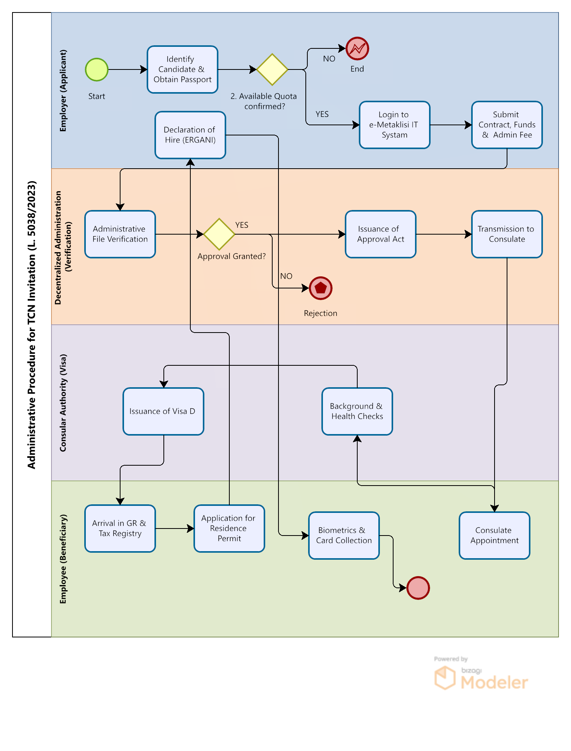
Figure 5: BPMN 2.0 Process Model of the Administrative Procedure for the national temporary labour scheme (Migration Code L. 5038/2023)

Beyond the quantitative deficit in state approvals, a profound "implementation gap" dictates migrant labour management, manifesting systemically across the successive stages of the national temporary labour scheme (Figure 4).
Red Tape and Institutional Rigidity: A chain of bureaucratic obstacles severely undermines the invitation procedure, both in countries of origin and within the domestic territory. Abroad, acute dysfunctions prevail. Understaffed or absent consular authorities, exemplified by the forced transit of Bangladeshi nationals to India (Dimitriadi, 2024), and protracted verifications by Decentralized Administrations systematically delay the issuance of National Visas. Consequently, this temporal lag frequently eclipses the seasonal needs of businesses.
Domestically, institutional rigidity merely undergoes a spatial transformation rather than a resolution. As qualitative field research corroborates (Key Informant Interview with a specialised legal practitioner, 2026), securing foundational legalisation documents (Tax ID, Social Security Number, housing contracts) demands substantial time. Coupled with systematic delays in issuing final residence permits, these administrative hurdles generate an extensive temporal void prior to full and legal employment.
Furthermore, Greece frequently operates as a "transit country". Following initial regularisation, migrants often abandon their posts, initiating secondary movements towards Central and Northern Europe, a mobility that fundamentally dismantles employer planning. Correspondingly, the operational efficacy of bilateral agreements proves exceptionally limited.
Finally, the procedure suffers from an absolute absence of modern digital matching institutions. Applying Bourdieu’s sociological paradigm, a dual systemic failure emerges: both small-to-medium employers and migrants lack the requisite "Digital Capital" to integrate into formal European digital platforms. This structural inability compels them to rely exclusively on their "Social Capital," mobilising informal, familial, or ethnic networks. Consequently, recruitment proceeds "blindly". Market actors base hiring decisions entirely on network availability rather than an objective evaluation of competencies. Ultimately, this informal mechanism fuels and perpetuates the skills mismatch phenomenon.

Brain Gain Policy: The Greek «Talent Pool»
During the prolonged economic recession (2010-2020), a severe 25% GDP contraction inflicted dramatic consequences upon the Greek labour market. An immediate consequence was the mass exodus of approximately 660,000 young and highly skilled professionals, triggering a severe brain drain. According to a OECD thematic report (2026, A Review of Greek Emigrants), this leakage of scientific personnel created a profound developmental deficit, systematically depriving the national economy of productive capital while exacerbating the acute demographic problem.
To counteract this structural disinvestment, the state implemented targeted repatriation measures (brain gain). Key institutional pillars included the establishment of the Hellenic Foundation for Research and Innovation (ELIDEK, Law 4429/2016), the "Knowledge and Partnership Bridges" initiative (2017), and the enactment of special tax incentives. Specifically, Article 5C of the Income Tax Code (Law 4758/2020) provides a 50% income tax exemption for seven years to individuals transferring their tax residence to Greece. Finally, authorities activated the "Rebrain Greece" digital platform to connect the diaspora with domestic technology enterprises.
However, policy evaluation demonstrates a stark divergence between institutional intentions and actual outcomes. The partial reversal of outflows in recent years stems from broader macroeconomic recovery rather than state interventions. Indicatively, Independent Authority for Public Revenue (AADE) data reveal that fewer than 4,000 approvals for Article 5C were recorded up to 2024 (Capital.gr, 2024), a figure corresponding to a mere 0.61% of total crisis-era outflows. Correspondingly, the Rebrain Greece platform achieved limited penetration.
As the OECD report confirms, fragmented digital platforms and restricted tax incentives fail to reverse the profound wage gap between Greece and the rest of the EU. Reversing the phenomenon necessitates a broader institutional upgrading of the productive paradigm, wage convergence, the consolidation of meritocracy, and a substantial improvement in working conditions.
Given the limited efficacy of national mechanisms, examining the supranational dimension of skilled workforce management is imperative; thus, the subsequent chapter analyses the European employment policy strategy and the architecture of the EU Talent Pool. This analysis aims to evaluate the degree of compatibility between these supranational tools and the structural pathologies and actual needs of the domestic labour market.

Chapter 4. European Policies for Augmenting Labour Supply Through Workforce Attraction
This chapter examines EU policy regarding third-country nationals, structuring the analysis across three pillars. The New Pact on Migration and Asylum prioritises legal pathways as an instrument to fulfill labour demands, while Guideline 6 elevates the utilisation of migrant capital into a primary catalyst for achieving broader socio-economic objectives. The convergence of these migration and employment policies crystallises in the EU Talent Pool, a platform that constitutes the preeminent institutional mechanism for attracting a highly skilled workforce to Europe.

The New Pact on Migration and Asylum
The architecture of the New Pact culminates in its fourth strategic pillar, which decisively shifts the policy focus from border management to institutionalising legal pathways for labour mobility. As the European Commission (2024) articulates, this strategy aims to "integrate migration into international partnerships", a concept structurally embodied by the EU Talent Pool. It represents the inaugural supranational platform facilitating international recruitment; through Talent Partnerships, the platform aspires to attract third-country nationals for employment within the European territory.
Consequently, the EU grants access to migration channels strictly contingent upon third-country nationals possessing specific skills and expertise absent from the European economy. Theoretically, this paradigm achieves a dual objective: οrigin countries benefit from reduced domestic unemployment and increased remittance inflows, while the European labour market fortifies itself against acute demographic pressures. By doing so, it extracts a "certified" and highly skilled workforce, fully capable of immediate integration into the productive fabric.
Regulation (EU) 2024/1351 legally crystallises this strategy. Transcending the narrow administrative logic of its predecessor (the Dublin III Regulation), it introduces the principle of a "comprehensive approach", institutionalising tailor-made partnerships. This framework grants Member States the flexibility to design bilateral agreements precisely calibrated to their domestic shortages. Ultimately, the EU aims to progressively substitute informal smuggling networks with transparent, state-led recruitment mechanisms. Should this implementation succeed, these institutional channels will selectively supply the European economy with its desired human capital.

Guideline 6 as a Regulatory Catalyst
A comprehensive understanding of the New Pact's external dimension necessitates its organic integration into the broader framework of European economic governance. Council Decision (EU) 2024/3134 constitutes the central institutional text, establishing the employment policy guidelines for Member States. Specifically, Guideline 6, titled "Enhancing labour supply and improving access to employment," transcends the conventional paradigm of exclusively activating the domestic population, now explicitly recognising exogenous mobility as a systemic prerequisite for European economic sustainability.
The Decision’s annex clearly articulates the premise that demographic aging and the demands of the dual transition (green and digital) have generated structural deficits that cannot be exclusively bridged by the domestic and EU’s workforce. The document states that "attracting talent and skills from non-EU countries through migration management [...] can also contribute to addressing skills and labour shortages". This reference elevates economic migration from a mere contingency measure to a structural macroeconomic instrument, urging Member States to incorporate migratory inflows into their national developmental planning.
Guideline 6 does not restrict itself to general declarations, but rather proceeds with a targeted mapping of cutting-edge sectors structurally incapable of functioning without an influx of foreign human capital. It explicitly mentions Science, Technology, Engineering, and Mathematics (STEM) disciplines, healthcare, and construction- sectors that remain absolutely critical for executing infrastructure and energy upgrade projects. Consequently, the ΕU acknowledges that "economic security" directly depends upon its capacity to attract skilled foreign personnel into these pivotal activities.
Finally, the Decision places significant emphasis on dismantling the administrative and technical barriers that impede the utilisation of migrant capital. It calls upon Member States to enhance opportunities for recognising and validating skills acquired outside formal education or abroad, deploying classification tools such as ESCO. This provision aims to eradicate the phenomenon of brain waste. Should Member States fail to implement these validation mechanisms, highly qualified migrants will inevitably remain trapped in low-skilled positions. This severely impacts both their integration trajectory and overall productivity. In conclusion, Guideline 6 delineates the broader strategic orientation that the EU Talent Pool is operationally designed to serve; this platform was conceptualised to render the skills of third-country nationals "visible" and immediately assessable by European employers.

EU Talent Pool: Bridging Migration and Employment
The New Pact on Migration and Asylum establishes the legal framework, while Guideline 6 (Decision 2024/3134) dictates the economic and labour necessity. Consequently, Regulation (EU) 2026/1047, establishing the "EU Talent Pool," operates as the operational arm. It structurally bridges public labour policies (the European Employment Policy) with those of migration. It constitutes the inaugural pan-European platform for international recruitment.
According to the Explanatory Memorandum (European Commission, 2023a; 2023b)., the initiative addresses structural labour shortages and bureaucratic recruitment barriers. These vulnerabilities intensify under the pressure of demographic aging and the "twin transition" (Green and Digital). Seeking international supremacy in Web 4.0 and virtual worlds, the EU confronts an acute shortage of ICT specialists across 60% of its enterprises. Furthermore, institutional fragmentation of national tools, rigidities in qualification recognition, and the absence of a robust EU "brand" severely impede international recruitment efforts.
The EU Talent Pool operates in complementarity with EURES, providing a digital platform for the automated matching of labour supply and demand. It exclusively targets non-EU third-country nationals and relies upon the voluntary participation (opt-in) of Member States (Article 3). Through "Talent Partnerships" (Article 12), the framework provides legal labour pathways for third-country nationals (e.g., from North Africa); in exchange, these origin countries are expected to cooperate in containing irregular migration.
The Regulation adopts a broad conceptualisation of "talent," incorporating 42 shortage occupations based on the ISCO-08 classification (Article 14 & Annex):
- High-Skilled (20 Occupations): This tier encompasses medical practitioners, environmental engineers, and ICT/STEM professionals, whose recruitment remains critical for the EU to bridge the technological gap and advance the digital transition.
- Medium-Skilled (21 Occupations): This category includes craftsmen essential for the green transition (electricians, plumbers, builders) and foundational service workers (cooks, waiters, drivers, and nurses).
- Low-Skilled (1 Occupation): This stratum is strictly confined to cleaners and helpers.
Nevertheless, the bureaucratic and executive dimension of the regulation remains profoundly ambiguous. Successful digital matching by no means guarantees the issuance of visa or a residence permit (Article 17). Consequently, the procedure risks encountering the "bottleneck" of consular dysfunctions and protracted verifications, meaning employers will inevitably continue to face systemic delays.
The Union de jure attempted to include secondary sector occupations necessitated by the European South (e.g., construction workers). However, this research postulates that the tool remains de facto elitist due to its digital architecture. Mandatory profile creation via Europass (Article 11), ESCO classification (Article 5), and algorithmic matching (Article 16) demand substantial digital and cultural Capital, as conceptualised by Pierre Bourdieu. For highly skilled professionals within the primary labour market, this procedure constitutes an organic habitus. Conversely, it operates as a structural filter -exacerbating the digital divide- for the unskilled migrant workforce. Simultaneously, domestic small and medium-sized enterprises (SMEs) inherently lack a robust digital recruitment culture.
Ultimately, authorities designed the EU Talent Pool primarily for the "knowledge-intensive" economies of Central and Northern Europe. Despite the de jure inclusion of specific technical professions (e.g., builders/craftsmen), the Annex completely excludes the primary sector (e.g., agricultural workers). Combined with the platform's rigorous digital architecture, this exclusion renders the tool de facto inadequate for addressing the massive demand for manual labour in Greece. Within this national context, unemployment steadily declines while the Job Vacancy Rate (JVR) in construction and tourism persists at historically high levels. Should this supranational architecture remain unaltered, Southern European countries may remain inexorably trapped in fragmented labour schemes.

Chapter 5. Conclusions and Policy Proposals
This study confirms its initial hypothesis: a structural mismatch exists between European planning for attracting highly skilled workers and the actual requirements of the Greek labour market. Synthesising institutional analysis with empirical data yields the following central conclusions:
Firstly, regarding the nature of demand, the Greek productive paradigm remains firmly oriented towards labour-intensive sectors. As the data indicate, demand does not primarily target the cutting-edge technologies of the Fourth Industrial Revolution; instead, it necessitates unskilled or semi-skilled human capital for agriculture, tourism, and construction. This reality confirms Piore’s dual labour market theory, whereby migrants are recruited to fill the structural voids of the secondary sector.
Secondly, the analysis establishes the institutional incompatibility of the EU Talent Pool. Although Regulation (EU) 2026/1047 de jure includes certain low-skilled occupations, the instrument remains de facto elitist. Its digital architecture presupposes substantial cultural and digital capital, effectively operating as an exclusionary mechanism (digital divide) for the average migrant worker. Interpretively, the EU appears to design policies tailored predominantly to the knowledge economies of the North. Indicatively, while 55,107 third-country nationals sustain Greek agriculture, the European Talent Pool completely excludes them. Consequently, fulfilling Greek labour needs will largely continue to rely on cumbersome national temporary labour schemes, meaning that the unmet demand ultimately fuels informal employment and precarity.
Thirdly, a stark paradox emerges: Greece operates simultaneously as an exporter of specialised scientific personnel and an importer of unskilled labour. From this perspective, the European policy of attracting foreign talent proves to be of secondary importance for the country. Instead, the paramount priority remains the repatriation of domestic human capital (brain gain).
Drawing upon the aforementioned research conclusions, targeted interventions can be formulated to facilitate both the entry procedures for third-country nationals and the repatriation of Greek citizens.
1. Administrative Rationalisation: The research identifies the implementation gap within the legislative framework as the most critical bottleneck. To expedite service delivery, Consular Authorities should establish electronic visa procedures (E-Visa). However, this solution alone proves insufficient. The Greek economy depends primarily on low-skilled migrant labour, a demographic frequently lacking the requisite digital capital to navigate electronic platforms autonomously; thus, digitisation alone risks engendering a new Digital Divide. Consequently, enhancing the efficacy of temporary labour schemes and reducing processing times necessitates comprehensive administrative reorganisation and the automation of consular procedures.
2. Redefining Talent Partnerships: European strategic objectives must shift from exclusively pursuing high academic specialisation towards bolstering medium-level vocational education and training (VET). Specifically, to address the acute labour shortages in Southern European member states like Greece and Cyprus, this study proposes institutionalising Skills Mobility Schemes. This recommendation aligns seamlessly with the policy directives of the MedMA framework (Fabbe et al., 2025). These schemes would link legal entry with the prerequisite acquisition of targeted technical certifications (e.g., in agrotechnology and the operation of modern agricultural systems). Such an approach facilitates the upgrading of the primary sector from unskilled to technically skilled labour, effectively converging with the underlying ethos of the EU Talent Pool. A realistic implementation paradigm involves forging tripartite mobility agreements among Greece, Cyprus, and Egypt, nations sharing common agricultural challenges. This strategy ensures mutual developmental benefits by establishing transnational training for the agricultural workforce while pragmatically utilising the EU Talent Pool platform.
3. Active Role of DYPA in Countries of Origin: This study recommends deploying Employment Counsellors from the Public Employment Service (DYPA) to Greek consular authorities in countries of strategic interest. Conducting on-site skills assessments will establish a reliable, state-managed pool of prospective workers, thereby substituting informal intermediary networks and bridging the digital divide for applicants.
4. Repatriation Strategy (brain gain): The outflow of specialised domestic human capital (brain drain) constitutes a "double fiscal loss" for the Greek economy, entailing the immediate forfeiture of both state educational investments and future tax revenues. Acknowledging the critical role of human capital in economic growth, Greece must develop an autonomous strategy focused on its diaspora. Transforming the Rebrain Greece initiative into a permanent institutional platform that provides comprehensive incentives (tax, housing, and family benefits) for the repatriation of Greek scientists is imperative. This strategic focus directly addresses the national paradox of simultaneously exporting highly skilled personnel while importing unskilled labour.
Furthermore, as emphasised in the relevant literature (Boeri), the repatriation of domestic human capital (brain gain) emerges as the optimal policy choice; it minimises cultural adaptation costs and maximises the immediate utilisation of scientific competencies. In this manner, positive externalities (spillover effects) and knowledge diffusion (Lucas) within the domestic productive fabric are rapidly enhanced.
Ultimately, this study underscores that a sustainable European employment policy cannot be monolithically designed around an elite pursuit of talent. For member states like Greece, resolving the structural mismatch requires a dual approach: rationalising legal migration pathways for the essential, low-skilled workforce, while forcefully prioritising the repatriation of its own scientific capital.

Bibliography
Act of the Ministerial Cabinet 35/2025. (2025). Determination of the maximum number of positions for dependent and seasonal work by employment specialty and highly skilled employment, of third-country nationals, for the year 2026 [In Greek]. Government Gazette of the Hellenic Republic, Series A, No. 241.
Bank of Greece. (2024a). Governor's annual report for the year 2023 [In Greek]. Bank of Greece Printing Works.
Boeri, T., & Brücker, H. (2005). Why are Europeans so tough on migrants? Economic Policy, 20(44), 629–703.
Boeri, T., & van Ours, J. (2021). The economics of imperfect labor markets (3rd ed.). Princeton University Press.
Borjas, G. J. (2016). Labor economics (T. Koutroukis, Ed. & Trans., 2nd ed.) [In Greek]. Kritiki Publications.
Bourdieu, P. (1986). The forms of capital. In J. Richardson (Ed.), Handbook of theory and research for the sociology of education (pp. 241–258). Greenwood.
Capital.gr. (2024, September 23). Towards new incentives for attracting foreign tax residents [In Greek]. https://www.capital.gr/oikonomia/3955182/pros-nea-kinitra-gia-proselkusi-xenon-forologikon-katoikon/
Cedefop. (2024). 2025 skills forecast: Greece. https://www.cedefop.europa.eu/en/publications/2025-skills-forecast-greece
Council of the European Union. (2024). Council Decision (EU) 2024/3134 of 2 December 2024 on guidelines for the employment policies of the Member States. Official Journal of the European Union, L, 2024/3134.
Dimitriadi, A. (2024). Greece in search of migrant labor force (Policy Paper #164/2024) [In Greek]. Hellenic Foundation for European and Foreign Policy (ELIAMEP).
Doeringer, P. B., & Piore, M. J. (1970). Internal labor markets and manpower analysis. U.S. Department of Labor.
European Commission. (2023a). Proposal for a Regulation of the European Parliament and of the Council on establishing an EU Talent Pool (COM(2023) 716 final).
European Commission. (2023b). Annex to the Proposal for a Regulation of the European Parliament and of the Council on establishing an EU Talent Pool (COM(2023) 716 final, Annex).
European Commission. (2024). Pact on Migration and Asylum. Directorate-General for Migration and Home Affairs. https://home-affairs.ec.europa.eu/policies/migration-and-asylum/pact-migration-and-asylum_el
European Labour Authority. (2024). EURES Report on labour shortages and surpluses 2023: List of shortage and surplus occupations [Data set]. https://www.ela.europa.eu/en/publications/labour-shortages-and-surpluses-europe-2023
European Parliament, & Council of the European Union. (2024). Regulation (EU) 2024/1351 of the European Parliament and of the Council of 14 May 2024 on asylum and migration management... Official Journal of the European Union, L, 2024/1351.
European Parliament, & Council of the European Union. (2026). Regulation (EU) 2026/1047 of the European Parliament and of the Council of 29 April 2026 establishing an EU Talent Pool. Official Journal of the European Union, L, 2026/1047. http://data.europa.eu/eli/reg/2026/1047/oj
Eurostat. (2026). Persons subject to EU Blue Card decisions by length of validity, age, sex, citizenship and size of employer [Data set, migr_resbc12]. European Commission. https://doi.org/10.2908/migr_resbc12
Eurostat. (2025a). Job vacancy rate by NACE Rev. 2 activity - annual data [Data set]. https://ec.europa.eu/eurostat/databrowser/view/jvs_a_rate_r2/default/table?lang=en
Eurostat. (2025b). Unemployment by sex and age - quarterly data [Data set]. https://ec.europa.eu/eurostat/databrowser/view/une_rt_q/default/table?lang=en
Fabbe, K. E., Karavias, M., Eshete, S., & Karoutsos, N. (2025). A Mediterranean perspective on current migration governance (Policy Brief, Issue 2025/19). Florence School of Transnational Governance & MedMA, European University Institute.
Hellenic Statistical Authority (ELSTAT). (2023a). Results of the 2021 Population - Housing Census: Employed persons by branch of economic activity and citizenship (Table A15) [Data set] [In Greek]. https://www.statistics.gr/el/statistics/-/publication/SAM03/-
Hellenic Statistical Authority (ELSTAT). (2023b). Results of the 2021 Population - Housing Census: Employed persons by citizenship and occupation (Table B10) [Data set] [In Greek]. https://www.statistics.gr/el/statistics/-/publication/SAM03/-
Ignatow, G., & Robinson, L. (2017). Pierre Bourdieu: Theorizing the digital. Information, Communication & Society, 20(7), 950–966. https://doi.org/10.1080/1369118X.2017.1301519
Karamesini, M. (2024). Notes (5): Institutional and radical approaches to the labor market [Unpublished material] [In Greek]. Department of Social Policy, Panteion University.
Karamesini, M., & Ioannidis, G. (2023). Unemployment and employment policy: Theories, typologies, design, evaluation [In Greek]. Hellenic Academic Libraries Link - Kallipos.
Law 4429/2016. Hellenic Foundation for Research and Innovation and other provisions. Government Gazette of the Hellenic Republic, Series A, No. 199.
Law 4758/2020. Curtailment of smuggling... incentives for attracting tax residents and other provisions. Government Gazette of the Hellenic Republic, Series A, No. 242.
Law 5038/2023. Migration Code. Government Gazette of the Hellenic Republic, Series A, No. 81.
Lucas, R. E., Jr. (1988). On the mechanics of economic development. Journal of Monetary Economics, 22(1), 3–42.
Ministry of Labour and Social Security. (2024). Joint Ministerial Decision No. 14761/2024: Determination of the maximum number of residence permits for work of third-country nationals for the years 2023 and 2024 [In Greek]. Government Gazette of the Hellenic Republic, Series B, No. 1390.
National Documentation Centre. (2017). "Knowledge and Partnership Bridges" initiative [In Greek]. https://www.knowledgebridges.gr/
OECD. (2026). Talent abroad: A review of Greek emigrants. OECD Publishing. https://doi.org/10.1787/729f06a5-en
Piore, M. J. (1979). Birds of passage: Migrant labor and industrial societies. Cambridge University Press.
Public Employment Service (DYPA). (2023). Annual report of the labor market needs diagnosis mechanism [In Greek].
Ragnedda, M. (2018). Conceptualizing digital capital. Telematics and Informatics, 35(8), 2366–2375. https://doi.org/10.1016/j.tele.2018.10.006
Solow, R. M. (1956). A contribution to the theory of economic growth. The Quarterly Journal of Economics, 70(1), 65–94.
Theofilakou, A., & Vasardani, M. (2024). Labour market tightness in the post-COVID-19 era. Economic Bulletin, 59, 77–100. Bank of Greece. https://doi.org/10.52903/econbull202459

