Judith Dellheim

A more German Europe, a more German EU(?)

The following text discusses three theses

- The capitalist mode of production, characterised by a socially and ecologically destructive pursuit of profit, growth and expansion, as well as competitive relationships, gives rise to tendencies that promote Germany’s quest for leadership within the EU. This is linked to its population size and composition, economic power and structure, size (I. in Appendix I), geographical location and configuration, deposits of mineral resources and available energy resources. Owing to the genuine symbiosis between means of production, technologies and weapons—including armaments technology—as well as between the organisation of labour, military organisation and the conduct of war, there is a corresponding growth in the tendencies that promote Germany’s quest for military leadership within the EU and as the European pillar within NATO. Contradictorily, Germany’s specific history, the socialisation and mentality of its population also play a part. Nevertheless, Germany’s pursuit of political, economic and military leadership within the EU and, above all, within the European pillar of NATO is not inevitable. It is further reinforced by the debate on the ‘autonomy’ or ‘sovereignty’ of the EU (see Appendix I).

- Germany’s drive for leadership explains five interrelated priorities of the government’s industrial and economic policy: supplying the economy with resources – namely, skilled workers and managers, the necessary military capabilities, energy, data and raw materials (1); deregulation and regulation, public procurement, investment and funding (2); technologies and technologies with military applications (3); start-ups within the industrial ecosystem (4) and infrastructure policy (5) . The contradictory interplay between those in government and those competing economically to boost the competitiveness of their companies and funds and to achieve ‘combat readiness’ gives rise to a phenomenon new to recent German history: The Minister for Economic Affairs (CDU) and the Minister of Defence (SPD) act jointly and in a coordinated manner when it comes to military matters or ‘security’, and have successfully ensured that this principle is also implemented in other ministries and administrative bodies. State intervention in ‘the economy’ – including state shareholdings – in support of military ‘capabilities’ is taking place without any lively public debate on the matter. This reflects a ‘paradigm shift’ , which goes hand in hand with deregulation: the ministers and their partners favour deregulation when it serves to accelerate desired processes – production for the defence industry and the lowering of democratic, social and environmental standards. This does not rule out contradictions in their views on democracy, social policy and the environment.

- The articulated will to lead displayed by those in power in Germany is not simply a matter of a small group’s ‘thirst for power’ – more or less guided by adherents of specific conspiracy theories – but rather the actions of capital elites, representatives of specific forms of financial capital or capital oligarchies, and their partners across all key areas of society. Nevertheless, there is no automatic link between the lawful interrelationships (see Thesis 1) and the concrete policies of those in power and those governing, who must grapple with German history and political, social, environmental and global problems. Despite all the official positive references to the EU and NATO, the government’s policy of seeking to lead tends to foster nationalist sentiments, which have been and continue to be further intensified by the specific ‘asylum and migration debate’. These sentiments are further fuelled by the manner in which the AfD is dealt with, a party that essentially shares the logic and culture of Trump and his supporters. At the same time, the AfD is striving to outdo all the ruling party’s defence spending plans and to emerge as the winner in the race to lower democratic, social and environmental standards.

The crucial question is whether the forces championing emancipation and solidarity in Germany will succeed in bringing about a change in policy and a different way of conducting politics, so that a sustainable solution to political, social, environmental and global problems becomes possible. These forces, too, are confronted with the fact that the enormous credit-financed arms deals and the massive redistribution processes in favour of military capability and global competitiveness are exacerbating economic crises. Whether the trade unions – in particular IG Metall – continue their alliance with the political, economic and military elites in support of ‘Germany as a business location’ and ‘war-readiness’ is of crucial importance for the strengthening of the emancipatory and solidarity-based forces.

The discussion here begins with a brief overview of the dominant geopolitical ideology in Germany and some connections both to prevailing politics in Germany and to the global role of the European Union (I). It then moves on to an examination of economic policies promoting military capability, with a focus on budgetary issues and industrial policy (II, see Appendix II). The discussion culminates in a number of conclusions aimed at a change of direction in social policy and an economic policy that promotes this (III).

- On the prevailing geopolitical ideology in Germany

The prevailing ideology, shared by leaders in politics, political science, economics and the military – not least EU Commission President von der Leyen (CDU) – is most succinctly articulated by the political scientist Herfried Münkler (a member of the SPD). Münkler himself has played a major role in both the core tenets of this ideology and its success. He loves to speak of the ‘geopolitical sandwich position’ into which ‘Europe’ – that is, the European Union – has found itself: caught between the US, or rather Trump, who is blackmailing it, and Russia, or rather Putin, who is threatening it. In his view, the struggle against these constraints is of key importance in the geopolitical conflict over Ukraine. According to Münkler, Germany, as the most populous and economically strongest EU country, must carry greater political weight within the EU and take the lead – so that, given the dramatic state of the ‘rules-based order’, the EU can influence global developments in its own interests as sustainably as possible. At the same time, he is striving to maintain the alliance with the US. The main ideas of Münkler and Germany’s leaders are as follows (see Appendix I for further context):
a) The rules-based order has collapsed; the era of global trade is over. In ‘Europe’ – that is, the EU and the states of its European NATO partners – the focus is on more weapons, armed forces and new technologies, but above all on ‘new thinking’ and a ‘change in mindset’ (Münkler). These are intended to take account of the return of empires with their centres and peripheries. The US is undergoing a transformation into a territorially consolidated empire on the American double continent, which intervenes globally according to its own needs.
b) Moscow seeks to control the Black Sea and the Baltic Sea, for which a subjugated Ukraine is a key building block. China has gained influence in Southern Europe through its infrastructure projects and loans and intends to exploit conflicting interests within the EU. The US runs the risk of ‘imperial overstretch in terms of security policy’ (Münkler), which ultimately creates new insecurity.
c) The EU must stand united and, in particular, prevent Putin’s imperial project. To this end, Germany must take the lead within the EU and, increasingly, within NATO as well. The E3 (Germany, France, the UK) and the Weimar Triangle (Germany, France,
Poland) are key building blocks for a contemporary European strategy. They are closely linked to the Nordic-Baltic8 (NB8 – Denmark, Finland, Norway, Sweden, Iceland, Estonia, Latvia and Lithuania). A political hierarchy within the EU and Europe is unavoidable.
d) A Europeanisation of NATO structures is necessary. This requires both ‘re-learning the imperatives of power politics’ (Münkler) and accepting certain imperial traits of a European leadership structure comprising Germany, the United Kingdom, France, Italy and
Poland (E5). In Germany, one must practise ‘leading from the front’ (Münkler) and be prepared to take greater risks, particularly with regard to Russia – for example, shooting down aircraft, supplying weapons to crisis zones, and Germany taking targeted unilateral action.
e) Strategic thinking must be practised in Germany. The idea of democratising the EU, whereby the voices of EU citizens carry greater weight, is misleading. A Member State that is a net contributor to the EU budget has more obligations than other EU members and therefore also needs more rights.
f) Because today’s world is becoming more like the world at the beginning of the 20th century, history must be re-examined and understood anew. This includes understanding Russia’s traditionally reactionary role in Europe and Zelenskyy’s commendable historical role, and using this insight to bring about a necessary change in policy in Germany and the EU. Geography, too, must be re-examined and understood in order to grasp the consequences of historical developments and current political strategies.

Human rights, global issues and socially and environmentally sustainable development are of secondary importance. What is crucial is how Germany – in what specific combination with partner countries, and using which geographical, economic and political concepts – can exert European and global influence. To this end, the question arises as to what needs to be done to ensure that members of society contribute as much as possible, rather than causing disruption. Münkler laments that no US president has followed the recommendations of the geostrategist Brzezinski on containing Russia . He focuses on the marginalisation, if not the destruction, of emancipatory potential.

It will come as no surprise that Münkler and the ideas he outlines enjoy the support of the leading capitalist elites in the business world, including the Federation of German Industries (BDI) and its member associations.

Their overarching aim is to exert the greatest possible influence on social, European and global developments, and to safeguard ‘normality’ – that is, resources, markets, spheres of influence and appropriate standards in the various technical, economic and international relations. To this end, they want the EU to exert a lasting influence on the development of the global economy and global society, in line with their own interests, as a global economic, military and regulatory power. It is no coincidence that Münkler’s supporters – or, indeed, those in Germany whose interests align with Münkler’s – are in many cases also committed advocates of the 2024 Draghi Report . This report, somewhat contradictorily, also continues the debate on EU autonomy and sovereignty. This debate, in turn, has been ongoing since the mid-to-late 1990s, driven by influential circles of capital owners, politicians, military figures and their partners in key areas of social life – within the state and public administration, in the judicial and security sectors, in academia, consultancy, culture, the media, accounting and lobbying. They have played a decisive role in the ‘turning point’ of 2022 and various ‘paradigm shifts’ in 2025/2026.

- On budgetary, fiscal and industrial policy in 2026

In the course of 2026, those in power implemented specific measures which have produced the strongest economic effects to date in terms of war-readiness. On the one hand, these effects relate to real changes in economic structures and economic policy practice. On the other hand, they involve destructive developments that have been triggered, intensified and accelerated, each with their own momentum. This further complicates or undermines the prospects for a societal or global shift towards socially and environmentally sustainable development. These measures relate primarily to budgetary, fiscal and industrial policy.

II.1. On the federal budget and the federal government’s fiscal policy

By 2026, Germany’s defence budget will have reached such a level that it will reshape NATO’s financial architecture, provide a dramatic boost to the arms industry in the EU and among European NATO members, and justify a geopolitical reassessment of Germany’s role . In 2026, Germany’s total defence expenditure will amount to approximately 108.2 billion euros.
This comprises a regular Bundeswehr budget of 82.7 billion euros and a contribution of 25.5 billion euros from the ‘Bundeswehr’ special fund.
This makes Germany’s defence budget the fourth largest in the world and the largest in the EU. This budget is almost twice as high as France’s for 2026 (57.2 billion euros) . What makes Germany’s enormous military budget for 2026 historically significant are five distinctive features (see Appendix II for illustration):
Firstly, there are the structural and political changes that have made the defence budget possible:
In 2022, the Bundestag approved the Bundeswehr Special Fund amounting to 100 billion euros, to run until 2028. In March 2025, Chancellor Merz secured the approval of the previous Bundestag (a general election had taken place in the meantime) to exclude defence and security-related expenditure exceeding one per cent of gross domestic product from the calculation of the debt rule.
Defence Minister Pistorius has set himself the task of creating a ‘war-ready’ Bundeswehr and aims to make it ‘Europe’s strongest conventional army’ by 2039. If this plan were to be implemented, it would represent the most significant shift in the balance of power amongst Europe’s conventional military powers since the end of the Cold War.

The second distinctive feature of the German defence budget lies in its structural changes. For instance, the procurement budget for 2026, at 22.4 billion euros, is almost three times as high as the amount spent on new weapons in 2025. 154 major contracts worth over 83 billion euros have been or are still being finalised between September 2025 and December 2026. This therefore represents a significant, long-term industrial and military structural change. The scale of this is illustrated by the 47,000 procurement contracts signed since the ‘Turning Point’ declaration in February 2022: a pace of contract award that overwhelmed the defence procurement bureaucracy and precipitated the passing of the Bundeswehr Planning and Procurement Acceleration Act (BwPBBG). In the last four years alone, defence contracts worth 111 billion euros have been concluded.
The third notable feature is the rapid growth in defence spending. According to the SIPRI database on military expenditure, in April 2026 Germany recorded a 24 per cent increase in defence spending compared with 2025. This is the largest percentage increase within a single year amongst the major NATO members. Defence spending rose by 60 billion US dollars in just four years, from 2022 to 2025 – from 56.2 billion dollars to 113.6 billion dollars. This almost complete doubling was driven by the aforementioned legislation, fuelled by a shift in public opinion. The regular Bundeswehr budget (excluding special funds) for 2026 grew by 32 per cent compared with 2025. This is the largest annual increase in the history of the Federal Republic of Germany. (In 2014, Germany spent 1.1 per cent of its GDP on the military; by early 2022, this had risen to 1.4 per cent, quickly growing to over 2 per cent and set to increase further towards 3.5 per cent.)
A fourth notable feature of the 2026 budget is the slight increase in the funds available for military support to Ukraine, amounting to 11.5 billion euros (approximately 12 billion including planned returns). However, this now essentially constitutes “direct German funding and investment in the Ukrainian defence industry, with the aim of specifically activating unused production capacity there. This funding is supplemented by joint ventures between German defence manufacturers and Ukrainian companies, with the aim of sustainably strengthening local capacity-building and reducing technological dependence on third parties.”
The fifth distinctive feature lies in the increasingly concrete focus on Germany’s leading role in ‘Military Power Europe’ and within the European pillar of NATO, where it has become the ‘hub of the Alliance in the heart of Europe’ for ‘contingencies’. Under this plan, around 800,000 soldiers from partner nations and approximately 200,000 vehicles are to be deployed and supplied whilst transiting through Germany within six months. This requires civilian partners – in road and rail transport, in transport and handling at seaports and airports, in protection and security measures, and in providing accommodation and catering for troops. Added to this are requirements for civilian companies to refuel and maintain vehicles, as well as to provide medical care . This includes the repatriation and treatment of those injured as a result of combat operations.
The 2026 investment in large, combat-ready surface combatants, designed for access to the North Sea, the Baltic Sea and the Atlantic, is the most ambitious single-year arms procurement initiative in NATO’s history outside the United States. The breadth of the armaments – ranging from Tomahawk cruise missiles and F-35A fighter aircraft to new naval frigates, armoured personnel carriers and a military satellite constellation – reflects the pursuit of maritime combat capability far beyond the Baltic and North Seas, and a leading role within NATO not merely as a land power.
The 92 per cent share of European or domestic procurement is a deliberate industrial policy decision. The aim is to systematically build up defence industry capacity in Germany, the EU and among European NATO partner countries. The most significant exception – amounting to 6.8 billion euros of the 83-billion-euro contract package – goes to US companies for the procurement of F-35A fighter aircraft and the associated munitions. This is about ensuring a precise fit within the framework of NATO’s nuclear sharing arrangement and interoperability with the Allies’ fifth-generation air forces.
The full 45th Armoured Brigade ‘Lithuania’ – organised in May 2025 as the Bundeswehr’s first permanent overseas deployment since the Second World War – is an expression of the determination to shape NATO’s eastern flank. This is further underpinned by the planned expansion of the brigade to 5,000 soldiers by 2027.
The launch of the German military space programme at the end of April 2026 – backed by a commitment of 35 billion euros by 2030 – demonstrates once again that Berlin’s military ambitions are far-reaching. A consortium comprising OHB, Airbus and Rheinmetall has been commissioned to establish a German military satellite network comparable to SpaceX’s ‘Starlink’. This is aimed at achieving strategic autonomy from the US in the areas of space-based communications, early warning and intelligence, and at securing a leadership role within NATO in Europe . Germany must assume a ‘leading role’ within NATO in space .

II.2. On industrial policy
Defence Minister Pistorius is the driving force behind a wide range of collaborative initiatives for and involving the military in Germany, the EU, NATO member states and far beyond. To this end, he is transforming working practices and bringing about a “paradigm shift” to enhance the Bundeswehr’s operational capability, focusing on “capabilities, effects, technology and modern doctrines” . According to his plans from May, the structures of the Bundeswehr Procurement Office are to be upgraded in order to keep pace with the enormous increase in order volumes in recent years, to promote innovation within the armed forces and to enable even closer cooperation with industry. The Bundeswehr Procurement Office is to become a central hub for “market and technology analysis” . However, the Federation of German Industries (BDI), with which the Defence Minister intends to cooperate as closely as possible, also called for a “paradigm shift” at the end of August in order to achieve a “substantial reduction in bureaucracy” . It should be assumed that companies act in accordance with the rules . This does not generally rule out consensus with Pistorius, but it also harbours the potential for conflict (see footnotes 33, 39/40). Three examples of progress in terms of cooperation for economic and industrial policy readiness:
- During 2025, the Minister of Defence (SPD) and the Minister for Economic Affairs (CDU) worked intensively to organise a ‘dialogue with industry to strengthen defence’. It was launched in early December 2025. The dialogue aims to “systematically bring together the sectors of the security and defence industry, as well as relevant civilian sectors – which have often operated in parallel to date – in order to create synergies … The focus is on building production capacity, strengthening the resilience of supply chains and making greater use of the dual-use potential of civilian and defence technology.”
The Industry Dialogue is thus an instrument of industrial, economic and military policy. The National Security and Defence Strategy treats companies as actors in “effective national and alliance defence” . In March, over 100 leading representatives from defence companies, their suppliers, associations such as the BDI and several of its member organisations, and representatives from other industrial sectors met with the , the Minister of Defence and the Minister for Economic Affairs. They discussed ways to procure military equipment more quickly and reliably and to drive innovation forward. The defence industry must expand its capacities, but also tap into new areas. In addition to the civilian industry, this applies in particular to start-up companies. These must be encouraged, empowered and therefore supported in order to enhance the defence industry. The focus is therefore on financing, procurement and market access. The Bundeswehr Innovation Centre has been established as a facility to bring together early-stage developments across various industrial sectors. In addition, the Act on Accelerated Planning and Procurement for the Bundeswehr has created favourable conditions for implementing a more efficient procurement system – from planning through to tendering and contract negotiations, right through to delivery to the troops.
The meeting in March also marked the launch of the Security and Defence Industry Connect Platform , which specifically connects end-users with strategic industrial partners in the German security and defence industry. It is a collaborative project between the Federal Ministry for Economic Affairs, the Federal Association of the Security and Defence Industry (BDSV) and the Federal Association for Materials Management, Purchasing and Logistics (BME). The BDI President was delighted that the platform would be of use to Ukraine and that 80 per cent of the 140 companies surveyed were prepared to work for the military .

- On the same day, and in close connection with the Industry Dialogue, the Alliance for the Future of Industry (BZdI) held a meeting – an alliance founded in 2015 comprising 19 partners from federal ministries, industry and employers’ associations, including, in particular, the BDI, the German Chamber of Industry and Commerce, as well as trade unions and the German Trade Union Confederation (DGB). Its aim is to strengthen the global competitiveness of Germany as an industrial hub, which is increasingly becoming a centre for the defence industry. With specific and direct reference to the Draghi Report, the Alliance’s Industrial Policy Position Paper of 13 March 2026 states: “Strong industrial value creation is crucial not only in Germany but also in Europe as a whole for prosperity, economic strength and our strategic autonomy. In view of the current geopolitical situation, global competition and the challenges posed by decarbonisation and digital
transformation, politicians, business and trade unions must act together to strengthen the industrial base in Germany and Europe.” The following are identified as key areas for action: improving framework conditions, securing a skilled workforce, promoting innovation, strengthening resilience, and driving Europe forward . “Strengthening resilience” means: “Enhancing the competitiveness of Germany as a centre for industry and raw materials
, driving forward the security of supply of primary and secondary raw materials, promoting the
circular economy, reducing dependencies on intermediate and end products, and
closer integration between economic, security and
defence policy.” To put this into concrete terms, the following is later called for: “Utilising military-civilian spillover effects, particularly with regard to high-
tech sectors” .
The partnership between employers and trade unions in the military industry is not new. IG Metall and the Federal Association of the Security and Defence Industry (BDSV) have enshrined it in joint policy documents . In 2026, the partnership was extended to include defence manufacturers within the BDI’s Federal Association of the Aviation Industry (BDLI) .

- The Defence Minister’s speech at the Hanover trade fair on 20 April 2026 is of fundamental importance. At this trade fair, defence companies were also exhibited on a large scale for the first time. Based on the idea that industrial strength is an essential prerequisite for the defence of democracy and security, security and defence policy aspects must be taken into account in every business value-creation strategy. The Minister identified ‘six core components’ for this :
- “Resilience as the backbone of value creation”, because “defence capability begins within the enterprise” .
- “Greater pace and faster scaling” , as this means growth without disproportionately high additional investment: “Where it makes sense and where it works, we must utilise and deepen European cooperation – this applies to both the state and the business sectors.” It is therefore a matter of a “clever interplay between national capacity to act and the European division of labour” .
- “Dual-use technologies as an opportunity” ; their consistent expansion holds enormous potential, as Germany is in a particularly strong position in this area.
- “Removing barriers, facilitating market entry for new players” , in order to encourage more companies to become players in military production.
“We are reducing regulatory hurdles, simplifying and speeding up procurement procedures, making requirements clearer and more predictable, and facilitating financing and upfront investments. The state bears responsibility here: reliable demand, clear priorities and favourable framework conditions for investment are required. The Federal Government is therefore creating the conditions to enable companies to fulfil their responsibility for our security” .
- “Cooperation at many levels” so that the potential for geopolitical application can be utilised across sectors and thus more intensively. The Federal Ministry of Defence is working closely with the Federal Ministry for Economic Affairs to better network companies in terms of security policy, and to generate and utilise shared potential.
The SVI Connect platform would be a good example of this. Another is the Bundeswehr’s Innovation Centre in Erding, an important interface between the Bundeswehr and the innovation ecosystem. Greater cooperation and openness to European partnerships are the order of the day.
- “Deepened partnership with Ukraine” . The Federal Ministry of Defence’s website states: “A particularly dynamic and forward-looking area of cooperation has opened up in collaboration with Ukraine and its defence industry. For the Bundeswehr and German industry, this results in immediate insights gained from feedback from the front line. The so-called ‘lessons learnt’ from high-intensity combat make it possible to observe Ukrainian weapon systems, as well as those manufactured in Germany, under real-world conditions and to optimise them accordingly.”
Ukraine, for its part, has a considerable industrial base and enormous innovative capacity, particularly in the field of cost-effective drone technology and digital combat operations. Joint ventures, such as those already in place between German and Ukrainian companies, create production and maintenance capacities directly on the ground. This not only shortens repair routes but also gradually integrates Ukraine into the European defence architecture. Ultimately, this symbiosis strengthens Europe’s security and demonstrates how defence capabilities can be bolstered through partnership-based action in a new era of geopolitics.” . Germany is currently Ukraine’s largest military ‘supporter’ and, together with the United Kingdom, chairs the international Ukraine Contact Group (UDCG), comprising 52 states. Germany also leads the UDCG coalition aimed at strengthening Ukraine’s air defence. Defence equipment for Ukraine procured with German assistance is now predominantly sourced from German and Ukrainian industry. The aid is predominantly financed through the ‘capability enhancement’ heading in the federal budget. The Ukraine Task Force, which has been in place within the Federal Ministry of Defence since 2022, also handles the logistical coordination of funds for Ukraine and clarifies who is supplying what, in what quantities and at what time, as well as which maintenance services and spare parts are required to maintain the operational readiness of the military equipment. The Task Force acts as the interface for coordination between the Ukrainian armed forces and industry. It is also involved in the training of Ukrainian troops. This takes place within the organisational framework of NATO or the European Union and, to a large extent, in Germany. Tens of thousands of soldiers have so far been prepared for war with the involvement of the Bundeswehr – ranging from the teaching of basic military skills to intensive training on weapon systems such as the Patriot air defence system, the Leopard main battle tank and mine-clearing systems. The focus is on the training of units and specialists. “Germany’s support for Ukraine serves its own security interests, but it also has a side effect. War is a driver of innovation; it forces the parties to the conflict to make creative use of their resources and accelerates technical developments. The Ukraine Task Force is closely monitoring how and by what means the war is being waged in Ukraine. Lessons are being drawn from this for operational command, for the development of new procedures and for the Bundeswehr’s equipment. Drone technology, for example, will shape the conflicts of the coming decades. The protection of critical infrastructure is also an issue that has only recently risen to the top of the political agenda as a result of the war in Ukraine. Through dialogue with Ukraine, the Ukraine Task Force knows where the trend is heading – and keeps the Bundeswehr leadership informed … The Ukraine Task Force aims to intensify defence cooperation and expand the strategic partnership. Ukrainian arms manufacturers are set to play an important role in the European defence industry in future, in order to enhance the joint deterrent capability.” It was therefore only logical that, at one of his meetings in Berlin with his Ukrainian counterpart , the Defence Minister also invited the Minister for Economic Affairs, the Minister of Finance, 40 representatives from the security and defence industry and a number of start-ups .

III. Some conclusions
The broad support for the Draghi Report within official German political circles stems, on the one hand, from the fact that a German leadership role in the EU and the European pillar of NATO goes hand in hand with Draghi’s focus on defence and on strengthening the EU’s influence in the global economy. Secondly, it stems from the perceived challenge facing the ruling political establishment to keep conflicting interests in Germany under control by accelerating the process of securing new economic and economic policy partners, resources and markets. Militarisation leads to a redistribution of wealth from the bottom to the top, social divisions and growing conflicts of interest. It promotes the erosion of democracy and repression. It means favouring specific industrial and economic sectors – and thus specific actors – over others. Through economic expansion, these problems are intended to remain tolerable for growing groups of actors, or to become so.
The economic and social problems are further exacerbated by rising public debt and the austerity policies designed to curb it. This debt exacerbates not only the aforementioned problems and contradictions but also financial and economic crises. To illustrate: according to calculations by the German Economic Institute (IW), the federal government plans to increase military spending by a total of approximately 95 billion euros between 2026 and 2030, when the year-on-year changes are added together . According to a simulation based on Oxford Economics’ Global Economic Model, thanks to this spending, gross domestic product in 2026 would be just 0.7 per cent higher than it would have been without the additional expenditure in 2026. In 2027, this effect rises to 0.9 per cent, but then levels off. By 2030, the additional GDP effect will total just over 96 billion euros. This means that for every additional euro spent, there is barely more than one euro of additional economic output. Additional infrastructure investment – for example, through improved transport networks, energy supply or digitalisation – can increase a country’s economic production potential in the longer term, but such effects are significantly smaller in the case of defence spending. A self-reinforcing growth process does not emerge. Regionally, however, higher defence spending can have significant effects – particularly in areas where defence companies and their suppliers are concentrated.
As early as 2026, nominal public debt in the IW simulation is 0.5 per cent higher than in the baseline scenario . As the economic impact of the expenditure weakens whilst the additional debt remains, the financing problem grows. The level of debt increases by 64 billion euros. The financing problem becomes even more acute if the assumed growth effects turn out to be lower than envisaged: higher debt would be offset by less additional economic output and tax revenue. This places an additional strain on the federal budget and has negative implications for Germany’s credit rating .
Even modest economic growth is destructive due to the existing economic structures and socio-political balance of power. Coupled with further military build-up, it dramatically accelerates the social and ecological destruction that is already taking place, as well as international conflicts, even leading to war. The responses of those in power are multiplying moments of crisis and crises in financial and economic policy. Above all, however, they are escalating violence and barbarisation, thereby making it impossible to resolve problems. The problems continue to grow as a result of the way those in power handle debt and budgetary expenditure, particularly expenditure on social and environmental issues and genuine international aid.
As the EU becomes increasingly Germanised, as the European pillar of NATO and thus NATO as a whole, all social, environmental, economic, peace-related, societal and global problems are growing. This further increases the responsibility of the Left – in particular the socialists in Germany – to bring about the necessary policy change. Here, an internationalist health policy is (once again) recommended to them, one that places the health of citizens, their children and grandchildren at the centre, thereby specifically addressing social issues, climate and ecology, and at the same time promoting peace and solidarity across all borders. Because this is a struggle to bring about change in social policy with health policy at its heart, opportunities for action must be sought within the contradictions between the interests of the stakeholders involved and those affected, and these must be politically channelled to achieve the desired effect. To this end, the ruling class’s budgetary, industrial, defence, security, foreign, social, economic and environmental policies must be continuously analysed and criticised in a way that is as politically effective as possible. The health of citizens, their children and grandchildren would serve as a sound starting point and, at the same time, a political platform for joint action by emancipatory and solidarity-based actors. Their international priorities would be the Paris Climate Goals, the SDGs 2030, collective security and, consequently, the achievement of structural non-aggression in Europe.

Appendix
Appendix I
I.
Country | Territory | GDP per capita
 | km² | euros, 2026
Germany | 353,260 | 53,520
EU-27 | 4,101,431 | 41,650

Country | Gross domestic product at market prices | GDP per capita | General government gross debt
 | bn euros | PPS | % of GDP, 2025
Germany | 4,470 | 47,923 | 63.5
EU-27 | 18,811 | 41,623 | 81.7

Country | Total population | Population projection
 | million, 2025 | million, 2060
Germany | 83.6 | 78.5
EU-27 | 450.6 | 434.3

Country | Industry
 | % of gross value added, 2025
Germany | 22.9
EU-27 | 19.4

Country | Exports | Imports | Foreign trade balance
 | million euros, 2025 | million euros, 2025 | million euros, 2025
Germany | 1,563,154.7 | 1,362,643.2 | 200,511.5
EU-27 | 2,643,760.5 | 2,514,425.2 | 129,335.3

https://www.destatis.de/Europa/EN/Topic/Key-indicators/Uebersicht.html

II.
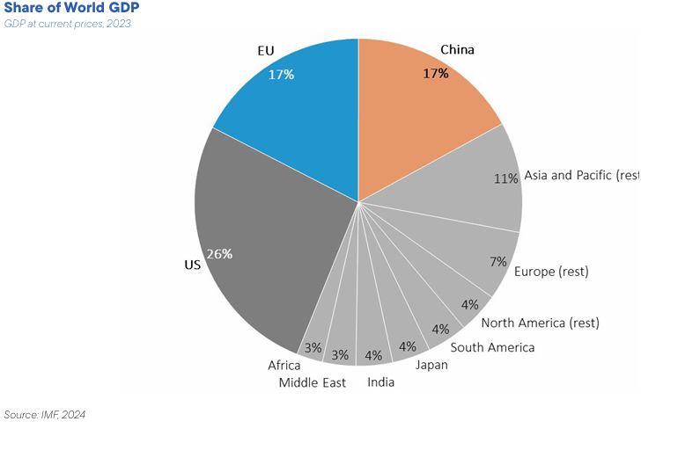
Country breakdown of EU exports and imports as a percentage of 100
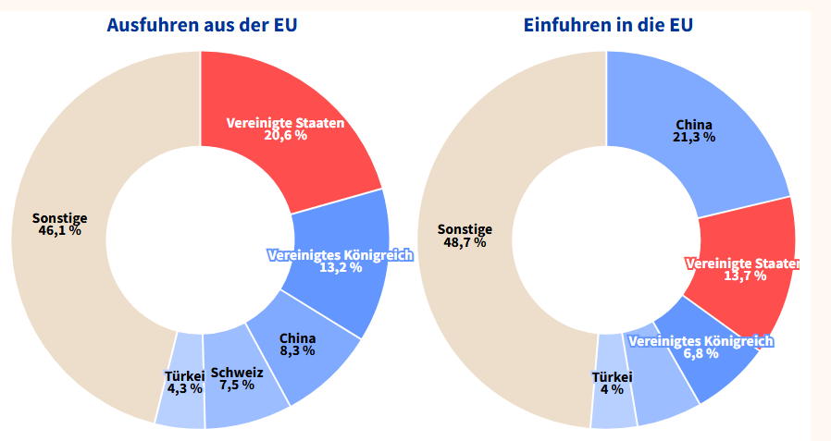

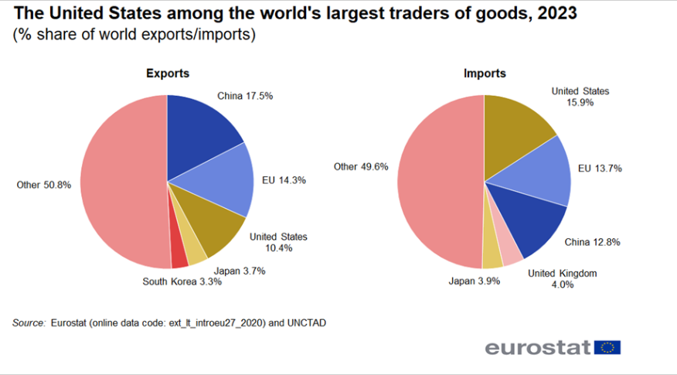
To illustrate the EU’s dependence on the US
- USA: 70 per cent market share of the EU’s LNG imports.
- Over 80 per cent of online search services, social media services, online retail transactions and software applications accessed in the EU, as well as 75 per cent of the cloud services used, originate from the US.
- The digital payment services used in the EU are provided almost exclusively by US providers.
- There are 38 US military bases in Europe
plus 2 key NATO bases
plus 7 further NATO bases.

See the economic policy position paper issued by the Federal Government, business and employers’ organisations, and trade unions on 13 March 2026: https://www.bundeswirtschaftsministerium.de/Redaktion/DE/Press releases/2026/03/20260313-alliance-for-the-future-of-industry-adopts-industrial-policy-paper.html and the speech by Defence Minister Pistorius on 20 April in Hanover https://www.bmvg.de/de/aktuelles/hannover-messe-pistorius-industrie-innovation-6093050
https://www.bmvg.de/de/mediathek/pistorius-zu-grundlagendokumenten-strategische-ausrichtung-6093072
Münkler, Herfried (2025): Power in Flux. Germany’s Role in Europe and the Challenges of the 21st Century. Hamburg: Rowohlt.
E.g.: Strobel, Günter (2025): Political scientist Münkler: ‘Things will never be the same again’. Interview with Herfried Münkler. Der Standard, 26 June 2025. https://www.derstandard.de/story/3000000 Literaturhaus (2026): Herfried Münkler guest at ‘Unter der Pyramide’. Literaturhaus Heilbronn. Latest news, 27 January 2026. https://literaturhaus.heilbronn.de/aktuelles/details/artikel/ herfried-muenkler-zu-gast-unter-der-pyramide.html (14 March 2026)
Münkler, Herfried (2025): Power in Flux. Germany’s Role in Europe and the Challenges of the 21st Century. Hamburg: Rowohlt, 261, 264.
https://commission.europa.eu/topics/competitiveness/draghi-report_en
Inspector General of the Bundeswehr Carsten Breuer: “The military strategy (dated April 2026 – J.D.) is based on the idea that Germany, as Europe’s largest economy, must and will assume a leading role within NATO – including in military terms – in the face of an increasingly complex and acute threat landscape. It is a sign of a paradigm shift and underpins our claim to shape the future.” https://www.bmvg.de/de/grundlagendokumente-strategische-ausrichtung/gesamtkonzeption-fuer-militaerische-verteidigung-aus-einem-guss-6092138, p. 6.
https://theworlddata.com/germany-defense-budget-statistics/
Ibid.
https://www.bmvg.de/de/aktuelles/eu-verteidigungsminister-beraten-weltraumsicherheit-6147480
https://www.rnd.de/politik/europa-als-militaermacht-joschka-fischer-fordert-radikalen-kurswechsel-XCNNHJAP6VEKTOZABUM5BG5CXI.html
https://www.bmvg.de/de/aktuelles/sicherheitspolitik-verteidigung-geht-alle-an-6099238
Ibid.
https://theworlddata.com/germany-defense-budget-statistics/
How the Bundeswehr aims to ensure security in space
https://www.bmvg.de/de/mediathek/pistorius-zu-grundlagendokumenten-strategische-ausrichtung-6093072
Ibid.
https://www.bundeswehr.de/de/meldungen/reformagenda-ruestung-bundeswehr-stellt-sich-neu-auf-6105988
https://bdi.eu/de/articles/querschnitt/mittelstand/buerokratieabbau-bleibt-schluesselthema-fuer-die-deutsche-industrie
Ibid.
Ibid.
https://www.bmvg.de/de/aktuelles/dialog-industrie-staerkung-verteidigung-6081190
https://dserver.bundestag.de/btd/20/143/2014318.pdf, p. 5.
https://www.svi-connect.com/
https://www.bmvg.de/de/aktuelles/dialog-industrie-staerkung-verteidigung-6081190
https://www.bundeswirtschaftsministerium.de/Redaktion/DE/Dossier/buendnis-zukunft-industrie.html
https://www.bundeswirtschaftsministerium.de/Redaktion/DE/Pressemitteilungen/2026/03/20260313-buendnis-zukunft-der-industrie-verabschiedet-industriepolitisches-papier.html, p. 1.
Ibid., p. 2.
Ibid., p. 9.
Ibid., p. 9.
https://www.igmetall.de/presse/pressemitteilungen/verteidigungsindustrie-zukunftsfaehig-machen
https://www.bdli.de/meldungen/bundesweiter-aktionstag-ig-metall-und-bdli-fordern-strategische-erneuerung-beim
https://www.bmvg.de/de/aktuelles/hannover-messe-pistorius-industrie-innovation-6093050
Ibid.
Ibid.
Ibid.
Ibid.
Ibid.
Ibid.
Ibid.
Ibid.
https://www.bmvg.de/de/themen/ruestung/ruestungskooperationen-bei-beschaffung-und-nutzung-6096796
https://www.bmvg.de/de/aktuelles/sonderstab-ukraine-im-verteidigungsministerium-6139884
https://www.nato.int/en/news-and-events/articles/news/2025/11/26/nato-and-ukraine-announce-new-joint-initiative-to-accelerate-defence-innovation-unite-brave-nato
https://www.experten.de/id/4951449/95-Milliarden-Euro-mehr-fuer-Verteidigung-Warum-daraus-kein-Wirtschaftswunder-wird/
Without additional defence spending
This has provided a brief summary of the text referred to in footnote 45.
https://www.consilium.europa.eu/en/infographics/eu-us-trade/ https://www.cnbc.com/2026/02/13/four-charts-europes-reliance-us-digital-infrastructure.html?msockid=2d0355e5f9886a3f0e3540a7f8716b00 https://euvsdisinfo.eu/report/europe-completely-dependent-on-us-in-security-politics-and-economy/ https://www.bruegel.org/policy-brief/europes-dependence-us-foreign-military-sales-and-what-do-about-it

